

**BSc (Hons) Computing Systems**



**Dynamic cover-based system for Unity Game AI Players**

**Student Name: Leo Groza**

**Student Number: B00727232**

**Supervisor: Tendai Mhlanga**

# Acknowledgements

I would like to thank Tendai Mhlanga, the stakeholder, project supervisor and the creator of *Patient Zero,* for his continuous support throughout the project and especially for allowing me the opportunity to work on his personal development.

I would also like to thank the Course Director, Anwar al-Haq, for his patience and for guiding us in these last three years, and to my friend and last of my colleagues, Radu Prajescu, all the gratitude for supporting me all the way to the final year.

I would not be able to complete the project without the support of all these people and my family, and for that I am really grateful to you all.

# Disclaimer

The project is presented from a developer point of view. Snapshots offered in the development process display methods responsible for the functionality of the projects that are hidden from the user during game play.

At the end of the development process the methods displayed in the project snapshots, e.g. Field of View, Pathfinder, Ray-Cast Edge Detection methods will not be available for display during run-time as their rendering process will be switched off.

# Abstract

Unity is a real time multiplatform game development engine responsible for 45% of all the games in the world. It can be used for different types of projects starting from mobile games, console games, simulations, web projects, films and more. It supports almost every platform available including AR and VR hardware.

A free, personal version has been released to the public to serve as a learning platform for beginners and enthusiasts and following the release a large number of games have been developed for the game market. The fast development pace seen in the past years has led to a standing issue: games have become highly complex and for the best game experience, the last game releases demand the latest hardware updates.

The purpose of the project is to research methods to obtain the best hardware performances while running a game software. To be specific, to temper with the foundation of multithreading and develop phases to house thread exchanging hardware in a game development software.

Table of Contents

Acknowledgements 2

Disclaimer 2

Abstract 3

Table of Acronyms 7

Table of Figures 8

Chapter 1 – Project Introduction 1

Project Report Structure 1

1.Introduction 2

1.1 The Need for Game Engines 3

1.2 Game Engine Issues 4

1.3 System Performance Overview 5

1.4 Project Background 6

1.4.1 Field of View (FOV) 8

1.4.2 A* Pathfinder Method 9

1.4.3 Edge Detection 10

1.5 Project Scope 12

2. Aims and Objectives 15

2.1 Aims 15

2.2 Objectives 15

2.3 Development Background 16

2.4 Testing 16

2.4.1 Development Scene 17

2.4.2 Types of Testing 20

Chapter 2 - Literature Review 21

1. Software Development Life Cycle 21

1.1 Software Development Life Cycle Stages 21

1.2 Software Developments Life Cycle Models 22

1.3 Project Life Cycle Implementation 28

2. Gantt Chart 29

3. Risks 31

Chapter 3 – The Unity Engine 33

1. Unity Game Engine 33

1.1 Unity Engine Features 34

1.2 Unity Interface 36

1.3 Common Assets Used in Unity 39

1.3.1 Game Objects 40

1.3.2 Transforms Component 40

1.3.3 Components 41

1.3.4 Rigidbody Component 42

1.3.5 Mesh Component 43

1.3.6 Prefabs 43

1.3.7 Audio Component 44

1.4 Scripting 44

1.4.1 Script Anatomy 45

1.5 Navigation 46

1.6 Unity Profiler 47

1.7 Unity Game Engine Version 49

2. C# Programming Language 50

2.1 Visual Studio 51

2.1.1 Features 52

3. Project Development Hardware 53

3.1 Initial Hardware Specifications 53

Chapter 4 – Initial System 55

1. System Implementation 55

1.1 AI Profiling 55

1.2 Navigation 61

1.3 Multithreading 63

1.3.1 Entity Component System 64

1.3.2 Hybrid ECS 66

1.4 Current Scene 67

2. Initial Unity Profiler Measurements 69

Chapter 5 - Results 74

1. Development Shortcomings 74

1.1 Pathfinding 74

1.2 AI Agent Dynamic Cover Locations 81

1.3 Threading 86

2. Unity’s NavMesh 93

2.1 NavMesh Functionality 94

2.2 Building a NavMesh 96

3. Cover-Based System 97

3.1. Dictionary 97

Chapter 6 – Discussions 100

1. Results from NavMesh Implementation 100

1.1 NavMesh Performance 103

2. Dynamic Cover-Based System 110

3. Multithreading Objective and Unity Job System 115

3.1 C# Multithreading 115

3.2 Job System 117

3.3 Job System vs Multithreading Performance 119

3.4 Create Individual Sequences of Instructions - Threads 124

3.5 Overhaul Project Results 131

Chapter 7 – Conclusions 134

1. Introduction 134

2. Reflection 135

3. Future Development 135

Bibliography 137

# Table of Acronyms

VR ……………………………………………………………………………………………Virtual Reality

IOS…………………………………………………………………………………………..Macintosh Operating System

CPU………………………………………………………………………………………….Central Processing Unity

AI…………………………………………………………………………………………….Artificial Intelligence

GPU…………………………………………………………………………………………Graphic Processor Unit

FOV………………………………………………………………………………………….Field of View

2D……………………………………………………………………………………………Two Dimensional

3D…………………………………………………………………………………………..Three Dimensional

SDLC……………………………………………………………………………………….Software Development Life Cycle

SRS………………………………………………………………………………………….Software Requirements Specifications

POC…………………………………………………………………………………………Proof of Concept

GUI…………………………………………………………………………………………Graphical User Interface

FPS………………………………………………………………………………………….Frames Per Second

UI……………………………………………………………………………………………User Interface

OOP………………………………………………………………………………………..Object Oriented Programming

IDE…………………………………………………………………………………………..Integrated Development Environment

ECS………………………………………………………………………………………….Entity Component System

AOT………………………………………………………………………………………..Ahead of Time

I/O…………………………………………………………………………………………..Input/output Operations

# Table of Figures

Figure 1 - Patient Zero View of sensor processing implementation 5

Figure 2 - Patient Zero Grid view of sensory processing implementation 6

Figure 3 - Basic representation of the Field of View method 7

Figure 4 – Patient Zero - AI Field of View 8

Figure 5 - Grid representation of A* Pathfinder method 8

Figure 6 – Patient Zero – A* Pathfinder 9

Figure 7 - Basic Edge-Detection method 10

Figure 8 - Patient Zero - Edge Detection method 10

Figure 9 – Assigned cover locations by the edge detection method. 11

Figure 10 - Overview of a single-threading and multithreading process 12

Figure 11 - Alien Landing (by Leo Groza) - Example of game loop start following the initialisation phase. 13

Figure 12 - Testing environment of the project 16

Figure 13 – AI Target on a high ground game object 17

Figure 14 - Static scene game objects 17

Figure 15 - Shield-man soldier 18

Figure 16 - Soldier AI game object 18

Figure 17 - Typical representation of the Software Development Life Cycle 20

Figure 18 - Waterfall Model 22

Figure 19 - Iterative Model 24

Figure 20 - Spiral Model 25

Figure 21 - Initial project Gantt Chart 28

Figure 22 - Project Gantt Chart 29

Figure 23 – Unify Community Portal 33

Figure 24 - Unity game engine payment plans 35

Figure 25 - Unity Interface (Scene developed by Leo Groza) 35

Figure 26 - Project Window of the interface 36

Figure 27 - Interface Scene View 36

Figure 28 - Interface Hierarchy Window 37

Figure 29 - Interface Inspector Toolbar 37

Figure 30 - Unity Interface Toolbar 38

Figure 31 - Primitive game object created in Unity 39

Figure 32 - Transform Component Window 40

Figure 33 - Game Object Cube with Components 40

Figure 34 - Rigidbody Component Window 41

Figure 35 - Capsule Collider Component 42

Figure 36 - Mesh Renderer Component 42

Figure 37 - Prefab implementation in a game scene 43

Figure 38 - Listener and Audio Source 43

Figure 39 - Initial Script content 44

Figure 40 – Basic Grid representation of the A* Pathfinder method 46

Figure 41 - Unity Profiler Window 47

Figure 42 - CPU Usage Profiler 48

Figure 43 - "Hello World!" program in C# 50

Figure 44 - Visual Studio 2010 Interface 51

Figure 45 - Unity Profiler measurement for initial hardware specifications 53

Figure 46 - Soldier AI game object 54

Figure 47 - Component Model in Unity 54

Figure 48 - Hierarchy in Unity game engine 55

Figure 49 - General Development of a character 55

Figure 50 - Basic quad-based mesh 56

Figure 51 - Character Animator component 56

Figure 52 - "Move ()" method in a simple character animation script 57

Figure 53 - Animations and connections for Patient Zero AI object 57

Figure 54 - AI FieldOfView initialisation in the Control script 58

Figure 55 - Method to determine target in the FieldOfView script 59

Figure 56 - Code snippet from the FSoldier.cs script 59

Figure 57 - Code snippet from the Soldier.cs script 60

Figure 58 - A* Pathfinder method code snippet 61

Figure 59 - MonoBehaviour approach for game objects 62

Figure 60 - Data linked to a Transform component 62

Figure 61 - ECS Jobs diagram 63

Figure 62 - Player development in ECS 64

Figure 63 - C# Job System diagram 65

Figure 64 - Difference between standard scripting and Hybrid ECS 66

Figure 65 - Hybrid ECS implementation for Patient Zero 66

Figure 66 - Update () method in the initial system 68

Figure 67 - Game View of the initial measurements 69

Figure 68 - Developer's view of the initial measurements 69

Figure 69 - Unity profiler overview for individual processes 70

Figure 70 - Game view of a scene with four AI soldiers 71

Figure 71 – Developer’s view of a scene with four AI soldiers 71

Figure 72 - Implementation drawback for four AI agents 72

Figure 73 - Main thread view along with individual threads completion time 72

Figure 74 - Unity profiler measurement for a scene with five AI agents 73

Figure 75 - 50x40 Nodes grid size with node radius of 0.5 74

Figure 76 - 50x40 Node grid size with node radius of 1 75

Figure 77 - Rendering process measurement for a grid the size of the game scene 75

Figure 78 - A* Pathfinder route in a grid edged by a game object 76

Figure 79 - Error in the A* Pathfinding algorithm 77

Figure 80 - A* path triggered by the target 77

Figure 81 - High level ground problem 78

Figure 82 - General programming for climbing stairs 79

Figure 83 - Necessary game-object to determine an AI agent to climb stairs 79

Figure 84 - General AI programming to reach a target situated on high-level ground 80

Figure 85 - Demonstrations of the game scene not being dynamic 80

Figure 86 – Pre-set game objects detected by the A* pathfinding method 81

Figure 87 - Ray-cast thrown by the AI agent 82

Figure 88 - Code snipper to determine cover locations 83

Figure 89 - Top view of game scene cover locations 84

Figure 90 - Cover locations that cannot be used at run-time 84

Figure 91 - Cover locations instantiated outside the game scene 85

Figure 92 - Cover locations instantiated at run-time 85

Figure 93 – Example of creating Threads 87

Figure 94 - MagicThread coroutine example 91

Figure 95 - Logical processor number count, and assigning a thread, example 92

Figure 96 - Native navigation system in unity 94

Figure 97 - Carving around static game objects on the navigation mesh 95

Figure 98 - Off-Mesh Links example 96

Figure 99 - Overview of a Dictionary class 98

Figure 100 - NavMesh view 100

Figure 101 - Navigation surface baked on high -level ground 101

Figure 102 - Code snippet to determine the path of the Shield agent on a NavMesh 102

Figure 103 - Shield soldier walking towards the target 102

Figure 104 - MonoBehaviour Control Script 103

Figure 105 - NavMesh Performance with a single AI agent in the scene 104

Figure 106 - Profiler Overview for system performance 105

Figure 107 - MonoBehaviour NavMesh performance with four AI agents in the scene 106

Figure 108 - Profiler overview for system performance with five AI agents in the scene 106

Figure 109 - NavMesh performance on a Hybrid ECS framework 107

Figure 110 - NavMesh Performance on Hybrid ECS framework 107

Figure 111 - NavMesh performance Profiler on Hybrid ECS framework 108

Figure 112 - Hybrid ECS NavMesh performance with four AI agents in the scene 109

Figure 113 - NavMesh Performance on Hybrid ECS framework in a scene with four AI agents 109

Figure 114 - Visible cover locations - rendering mesh active 110

Figure 115 - Reduce the number of cover locations with an "If" statement 110

Figure 116 - Total number of cover locations after script update 111

Figure 117 - Cover location number before and after 111

Figure 118 - Total number of cover locations in the scene 112

Figure 119 - Code snippet - AI agent initial field of view (fov) + AI agent cover location instantiation field of view (fovSoldier) 112

Figure 120 - Ray-cast detecting the Shieldman character + view of cover locations instantiation area 113

Figure 121 - Primitive code snippet to determine and walk towards a cover location 113

Figure 122 - Instantiation of a dummy cover position 114

Figure 123 - AI agent running to cover 114

Figure 124 - Wall-time frame rate 117

Figure 125 - Insight of ParallelFor jobs 118

Figure 126 - Worker threads scheduling 118

Figure 127 - Variables to dictate objects 120

Figure 128 - C# Job 121

Figure 129 - Game cube instantiation 121

Figure 130 - Game objects disposal functions in the LateUpdate() method 121

Figure 131 - Cube Movement Job component 122

Figure 132 - Cube Movement game scene 122

Figure 133 - Unity Profiler while not using Job System 123

Figure 134 - Unity Profiler while using Job System 123

Figure 135 - Process Explorer from Microsoft 125

Figure 136 - Process Queue Threading 126

Figure 137 - Comparison measurement in multithreading attempt 127

Figure 138 - Simple Multithreading to draw the field of view of the AI 127

Figure 139 - Simple Multithreading Results 128

Figure 140 - Environmental Core thread implementation 129

Figure 141 - Environmental Core Multithreading result 129

Figure 142 - Error detected in Unity Interface Console while attempting multithreading 130

Figure 143 - Process Queue multithreading result 130

Figure 144 - Final rendering performance measurements 132

Figure 145 - Unity Profiler final rendering performance measurements 132

# Chapter 1 – Project Introduction

# Project Report Structure

The purpose of the structure is to explain the structure of the report. A description of the chapters and their content is described shortly.

Chapter 1. Introduction:

In the introduction, a general explanation of the importance and value of game engines in current market is presented. Broad functionality, general overview, issues and basic performance is discussed. The background of the project, the methodologies on which the project is focused, development scene, AI objects and the aims and objectives of the project are presented.

Chapter 2. Literature Review:

A short explanation of the Software Development Life Cycle is presented along with the software development life cycle model implemented in the development of the project. The initial Gantt Chart and a revision is discussed along with the risks of the development process.

Chapter 3. Unity Game Engine:

The chapter presents a description of the Unity game engine, brief history and features along with components and functionalities on which the project is focused. A brief description provides insights about the C# programming platform and the project development tool, Visual Studio.

Chapter 4. Initial System:

Implementation of the current system is reviewed, the AI game objects are profiled and presented. Unity features proposed for future implementations are presented together with the initial measurements of the system.

Chapter 5. Results:

The drawbacks of the current implementations are presented, related to the aims and objectives of the project

Chapter 6. Discussions:

Presentation of the new features implemented in the system along with the Unity Profiler measurements for each implementation. Results comparisons between implementations are presented in this chapter along with advantages and drawbacks.

Chapter 7. Conclusions

The final chapter covers the conclusions drawn at the end of the project, reflections and future development based on the finalisation of the project.

# 1.Introduction

In the past ten years, in the global economy, the video game industry has established itself as a significant contributor. Compared to different domains in the entertainment industry such as music or film production, limited instruction and tutoring have managed to create value for companies and consumers in the context of games, available on different devices such as consoles, mobile devices and computers. As an example, the game “Call of Duty” released in November 2011 has seen a revenue of $400 million in the first day in the United States and a further billion in the first two weeks.(Huan and Jia, 2016)

The industry has grown exponentially over a period of twenty-five years and has been characterised through a high mark of dynamics and invention. Games can be played on interactive networks or on different platforms such as tablets or mobile devices. The development of the game industry has led to innovations in different areas of public entertainment, different products can offer cross entertainment, a game can become a movie or separate type of merchandise. More people would rather play video games instead of going to a movie. Players can earn and spend money in e-sports which take place on live TV, they have the possibility of spending earnings by purchasing virtual goods or enhancing their games.

The game industry has pioneered different type of technology in the development process, technology which is applied today in different fields from molecular biology to military training, virtual showrooms and product presentation.

Gaming is seen in the present day as a habit. It encourages logical development, practical concept learning and provides entertainment. It has all been possible with the rapid development of technology. New games are released every year, quality and innovation is obtained with complex computer software that is obligated to improve with every release. Every new challenge released leads individuals to spend a vast amount of time in front of the computer or television to attempt to overcome a challenge and reach an objective. This turning point has been reached with the development of game engines. Game engines have changed perceptions in game development, the game development itself has become less important compared to the idea of the game and how the developer can elaborate a game based on an idea. (Helgason, 2012)

The game engine concept is relatively simple, it has been developed to minimise what is called common game methods such as physics, programming, artificial intelligence and rendering process and provides functions and frameworks necessary for development control to allow the developer space and time to focus on features that can make its software unique. A game engine has replaced the concept of reinventing the wheel while developing a functional software, it has eased the video games development process by being very flexible and oriented for a specific game range. Game engines have developed over a period of twenty years, the first game engine released, *Doom,* supported only 2 dimensions (2D) game frames and evolved supporting fully 3-dimension game frames (3D), multiplayer and online gaming, mobile platforms and artificial intelligence.

There are a large number of game engines on the market, game engines that became a free version, others open source but at this point many remain proprietary. Several game engines have made an impact in the industry over the past several years but the most popular among the public is Unity Game Engine, the first game engine to release a free personal version to the public together with game building tutorials. It has been welcomed by independent developers and small development teams as it become a starting point for personal game development. It rapidly become very popular, a complete software which minimises the need for complex programming and intricated game object relations to be constructed in developing a functional software.

Unity 3D has several advantages in game developing. The complex, internal relations between game objects are presented and managed in different views and in terms of programming a developer can chose between JavaScript, Boo and C# scripting languages which makes the engine accessible to a greater number of developers. In Unity 3D the resources can be exported or imported in packages that allows shared development work between different projects. It is a brilliant development environment in terms of graphic design and integrates a diversity of features to produce 2D and 3D games. It can be run on different operating systems such as Mac and Windows, the game developed can be posted on a variety of platforms, mobile, Android, PC and even on the. With the advantage of multi-platform release and rapid development it allows developers to greatly reduce development and deployment cost.(Huan and Jia, 2016)

## The Need for Game Engines

The most complex side of game development has always been engineering. Engineering was focused optimisation of the software at a low level, concentrating on the functionality of the code and developing smart methods whenever this has been a possibility. Processes have become less complex with the development of game engines in the last decade. The main aim is to simply obtain functionality of the code to produce a functional product similar to the expected requirement. Developing a game in the past is a very different experience compared to the process of the present day. While developing a game in the past, in the process, workflow problems were the most encountered ones. While developing a game from scratch, developers usually were bound to lose a vast amount of time with the compile and debugging tasks as in many development processes it could have taken up to half an hour to compile while developing a game from scratch. Many organisation begun to use third party applications to tackle the problem, where the build process was spread around on multiple machines but this was not the answer to all the problems, as the fix of one problem has led to the increase of the start-up time. (*Game Development FOCUS*, 2004)

The rapid computer game expansion is pushing to the development of constantly improved software and increase of hardware potential. Today, computers can easily simulate virtual reality and display near to reality sceneries in real time over the network. A large number of computer games are inspired by old-style games, but most computer games offer scenes from fantastic worlds or stage reality seen as a game, fact that has caught the attention of the movie industry. The video game sector became a must for different areas of the entertainment industry. (Paar and Herwig, 2014)

The first game release on a mobile device happened in 1997 when Nokia launched ‘Snake’. It was the starting point for mobile games development that has infiltrated everyday life with a striking speed. Gradually, mobile and video games increased in complexity and the need to develop a performant software in a relative short amount of time called for platforms to be put in place to reduce development time, eliminate the need to write every software from scratch and feature cross-platform tools to support availability for different operating systems.

Game developing is a tedious process, even the most experienced developers require assistance from game engines to provide them with some elements that will come to aid in the development process. Programming skills are an important part of a game development process, but the implementation of game engines reduced the limits imposed to individuals with non-programming skills in game development. Programming skills and scripting are often quite difficult to master, each scripting language offers infinite possibilities to compile a package, but game engines offer the possibility to actually develop a functional software without the knowledge of code functionality behind the user interface. Game engines offer the possibility to learn concepts that support different programming languages in game development and allow junior developers without any experience to develop personal multiplatform games. There is a continuous development process to minimise the need to use programming languages in game engines to gain the ability of learning and building a game with limited amount of lines of code.

Game engines have attracted many enthusiasts with easy to use features such as *Drag and Drop, Tutorials, Tools and Editors.*  Each of the features have reduce the need for extensive coding needed to attain a certain functionality. (Harshfield, Chang and Rammohan, 2015)

* *Drag and Drop* feature reduces significantly the development process time and the amount of errors. It implements a simple click interaction function which helps even the beginner developer to obtain great functionality without or with just optional or minimum scripting knowledge.
* *Tutorials* developed and aimed for enthusiasts with low or no skills in game development. Tutorials will generate present the general ideas of how thing can and should function in a game development software.
* *Tools* are aimed to come in use for novice developers with no background, with sample games, the top methods to a good game development. Tools bring game samples that can be taken apart to show the functionality and allow developers to view the concept around development.
* *Editor* is a powerful design software implemented in game engines that gives the developers the opportunity to obtain and modify the source code of the game from the creator and transform it to suit their requirements. It is designed to develop games with portability to all the popular platforms.

Multiplatform export is another feature offered by a game engine that allows a beginner developer to easily convert and export the software to a different platform such as Android, PC, Mac, Linux allowing them to be a part of Android and IOS application store along with built-in support. Digital technologies development created opportunities for consumers to become part of the media production and distribution process rather than product delivery endpoint. Digital technologies development created opportunities for consumers to become part of the media production and distribution process rather than product delivery endpoint. Game engines are defined as a creativity platform and has become a portion of the contemporary game culture. (Nieborg, 2008)

## 1.2 Game Engine Issues

The continuous development of game engines does bring negative aspects as well. If, in the development process a game engine will be used, the process itself will be visible shorter, allowing the developer more time to focus on the visual aspects of the game, to improve the visual aspects and behaviour of the game rather than learning ubiquitous techniques of programming and actually getting a better understanding of the functionality of the main core process. To build a software from scratch instead of using a game engine will take the developer through an essential learning curve. Indeed, it is a slow process and quite an expensive one. The amount of information to be processed is immense and at the end of the process there is not much to show that can be very different from using a game engine but the knowledge acquired during the is priceless and probably the most important thing to be named is that the software will be exactly as the developer has intended it to be without any limitations or obstructions imposed by the game engine.

Using a game engine will supress the skills which can be acquired in a software development process while considering all the features offered by a game engine, developing a software from scratch can highly increase the developers programming skills, even if there are no longer in demand of the market due to game engines it will confer the developer a higher position in the field.

Despite all the improvements gained in the industry with game engine development the common problems found in a game development process stand against a fit workflow process which can eventually lead to a project cancelation. Taking in consideration the fast development pace imposed by a game engine, many projects fail to determine the actual project scope, emerging requirements can lead to substantial changes in the architecture of the software and cause massive faults. Game development enthusiasts typically push towards the development of the final product without considering the massive workload necessary for a functional software and build it without any reflexion towards different aspects of the final product, issue also known as crunch time.

The major problem of game engines is of a technological nature. Technology stands at the base of each game, reason why game development companies stand as leaders in the cutting-edge technology for graphical computation. The cutting-edge technology increases development risks especially when beginners start developing on a new platform without having the basic knowledge in consolidating and delivering a software intended for a specific purpose and with unique features. (Petrillo *et al.*, 2009)

## 1.3 System Performance Overview

Developing software with the aid of game engines can be very challenging and optimisation of a software is one of the major challenges. Optimisation as a methodology is pushing towards the developed software to be fully functional and as effective as possible, capable of obtaining the optimal functionality. The goal of optimisation is to save as many CPU (Central Processing Unit) cycles as possible so they can be used for different methods therefore saving several clock cycles that might boost the average frame rate. The process will allow the game engine to spend the extra CPU cycles on more complex operations, improving the speed, performance and functionality of the software.(Damon William, 2012)

Optimisation is obtained in every software while carrying out different improvement actions on the software’s functionality. Every optimisation action carried out can improve significantly the efficiency of the software, but optimisation is part of the design process and needs to be carried out through the development process. There is also a negative aspect of optimisation happening at a far earlier stage of development where developers tend to analyse each aspect of the game engine to make sure every requirements of the future development can be supported. Also called as micro optimisation, this is the level where the architecture and specifications of the game engines are examined and where most developers fail to understand that optimisation is best implemented during design instead of optimizing before software shipping.

In the context of optimisation, two different opinions dominate game personalities in regard to software performance. The opinions relate to the code developed and how performance is affected considering the length of the code. In theory, if the number of actions to be executed and lines of code to be read by the compiler is minimal, the machine should not have any problems executing actions in a record time but if the number of lines of code is large but well designed with a class hierarchy the compiler will take the same time to execute or even less without the need to go through the whole code. The baseline is, while developing a software, in some cases writing more lines of code can reduce the redundant CPU and system memory work and maximise multithreading.

The key procedure in CPU optimisation is reducing the instruction execution process and enable multi-threading. In the process the main focus, in a game engine, reflects on the Artificial Intelligence and the Physics Engine. These are driven by complex algorithms and in the event of poor synchronisation, if an algorithm is related to memory performance, dividing the task over multiple threads will not increase performance. Multi-threading will not increase memory performance, instead it will make the process more complex. As a drawback, in poor multithreading synchronisation a cache miss, dragging resources from the system memory, will execute several times slower that the slowest process creating latency and data dependency. (Preisz, 2019)

## 1.4 Project Background

Patient Zero, the project background, is a 3rd person shooter currently in development in Unity game engine. The structure of the gameplay is driven by a storyboard written to drive all the actions, in the game, to an explicit ending.

A grid stands at the base of all the game frames. Every object in the game is positions on the grid at specific coordinates, and the real-time location, either static or mobile, will be calculated by the AI with a number of sensor processing implementations.

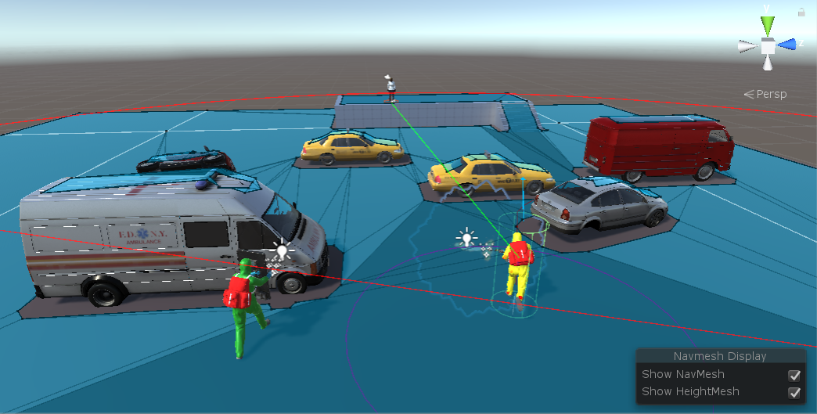

Figure 1 - Patient Zero View of sensor processing implementation

These implementations serve as gameplay pathfinding, ray-cast enemy detection, static game objects edge detection and field of view detection where the game scene is exposed to the AI. The field of view method is the most important one, as all the detection methods named above are designed to begin with the exposure of the game scene. The complex representation of the AI sensory implementation presented above can be reduced to a basic grid representation.

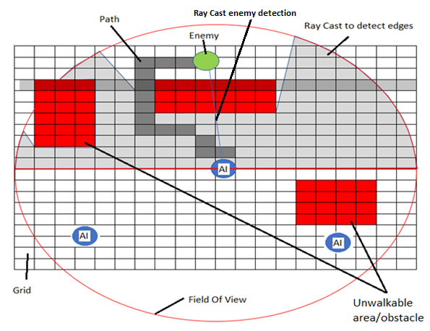

Figure 2 - Patient Zero Grid view of sensory processing implementation

During gameplay, in a scene, the AI game object discovers its way to the target using a pathfinder algorithm, in our case, A* Pathfinder. Every AI game object implements its own A* Pathfinder method to calculate a route towards the target in real-time. Each pathfinder algorithm is calculated per frame meaning that a game scene with multiple AI objects will have a major impact over the rendering capabilities of the Graphic Processor Unit (GPU) and will reduce considerably the Central Processing Units (CPU) features. Having all the pathfinder algorithms run in the main thread, dynamic object detection in the game scene is possible meaning that if an object is placed in the game scene at run-time the AI will be aware of it, but the process is highly taxing for the CPU. To control the impact over the CPU capabilities game developers will reduce the complexity of the dynamic game scenes.(Lux, 2016)

Every action, calculation, process in a software, also called threads, take place in the main thread. The main thread is the first action to start when a program is executed. It allows the creating and accessing individual threads and it is the last action running before the completion of the program. An individual thread is the process execution flow of an action. For complex software, where intricated operations are involved, the best functionality is achieved by creating different execution paths, each path executing a specific action. Single thread programs allow the completion of one action at a time, but multiple thread programs have the ability to execute multiple processes at one time by dividing each process, thread, into smaller threads. This is the base of modern computer software development.(*C# Multithreading*, 2017)

In a game software the complete set of computations allocated for each individual game object run in the main thread. Every process assigned to a game object start in the main thread and at completion the result of the process must be synchronised with the main thread. In a game scene at run-time, each AI, has three main methods attached that will run constantly through the process to the point where the scope of the AI game object is completed. These basic sensory implementations methods are used during game play and development to profile the AI game object establishing its position in the game scene, surrounding objects, distance from the target and course of action to be taken.

### 1.4.1 Field of View (FOV)

The field of view method is equivalent to a sight simulation procedure for an AI. The method is updated with every game frame to assure game scene detection and target detection in real time, it allows the AI to detect every obstacle in its sight while moving towards the target. The method triggers the ray-cast target detection and obstacle detection process. Once the target is detected it will automatically trigger the pathfinding method to construct a path towards the target and to cover locations along the path.

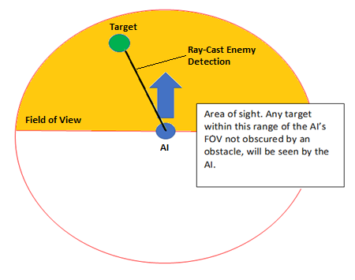

Figure 3 - Basic representation of the Field of View method

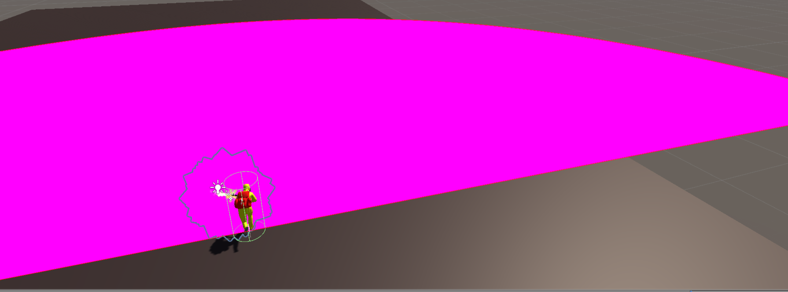

Figure 4 – Patient Zero - AI Field of View

### 1.4.2 A* Pathfinder Method

A* Pathfinding is a computer algorithm designed to establish the shortest route between two points. It is a programming algorithm intended to iterate throughout the whole grid starting with the location of the AI and determine all the existing paths to the destination point.

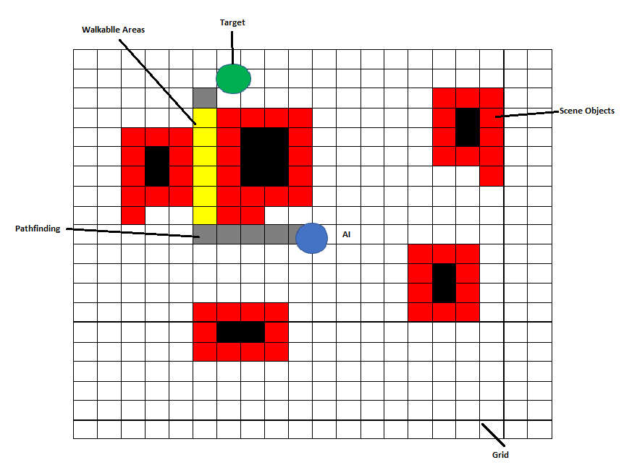

Figure 5 - Grid representation of A* Pathfinder method

It is a passive method and it is triggered in the moment the target is detected in the field of view of the AI. It is a real-time method calculating the grid attached to the AI in the game scene, with the AI being positioned directly in the centre of the grid. It is designed to be dynamic and calculate the game scene while objects are added at run-time.

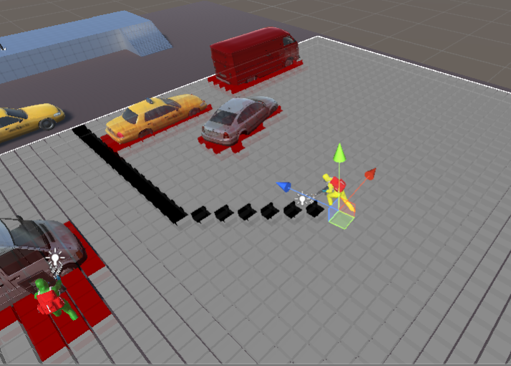Figure 6 – Patient Zero – A* Pathfinder

### 1.4.3 Edge Detection

The map of the game scene, at run-time, is constructed based on the edge detection algorithm. The purpose of the edge detections method is to uncover all the obstacles in the game scene to be used by the AI, in game play, as cover locations in a firefight with the target. Initial method development consisted in empty game objects attached with a script and getter methods to be placed in the scene at design time as cover locations then added and sorted in an array placed in the script of the AI. The getter method contained a Boolean value that retuned true is the locations was available and false if the location was occupied by another AI. If the Boolean value returned by the getter method was false, the AI would iterate through the cover location array to find the first item to return a true value and engage the location triggering the getter method to change the Boolean value to false. The use of the algorithm was implemented for objects added to the scene at design time limiting the capability of the AI to use game objects introduced in the scene during run-time.

The edge detection algorithm involves casting hundreds of ray-casts in the field of view of the AI. Each ray-cast is positioned in the vicinity of the next one. Having a large number of ray-cast thrown by the AI determines an accurate scene presentation with the disadvantage of highly consuming the resources of the CPU. The edge detection ray-casts are designed to be kept within boundaries of the field of view of the AI. As the AI follows the path towards the enemy all the game objects and cover locations that can be used by the AI are revelled.

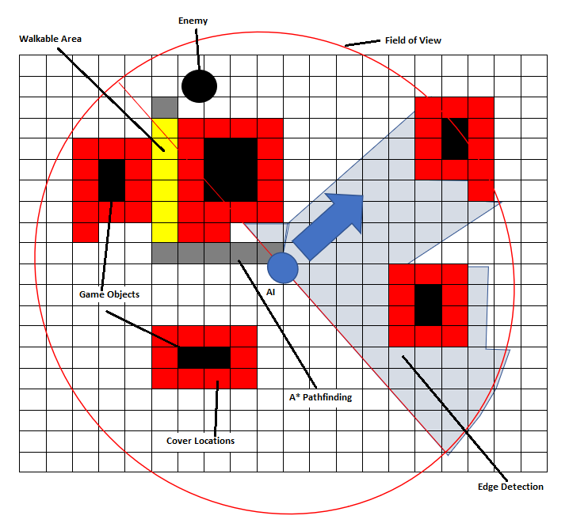Figure 7 - Basic Edge-Detection method

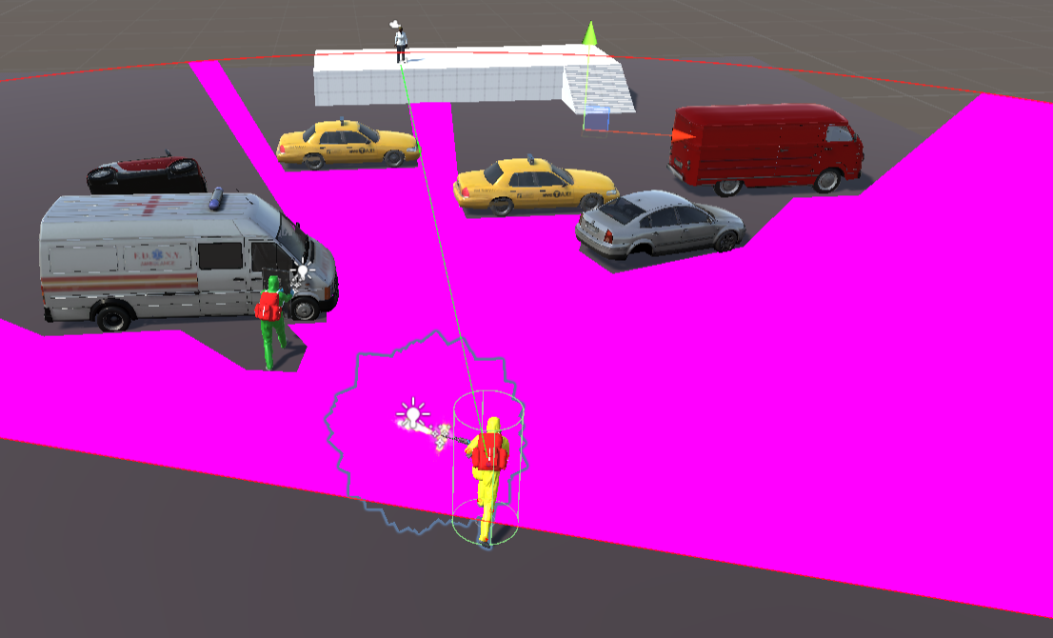

Figure 8 - Patient Zero - Edge Detection method

The field of view of the AI triggers the edge detection method to find all the game objects in the scene and assign every possible cover position for a game object which are hidden from the field of view of the enemy.

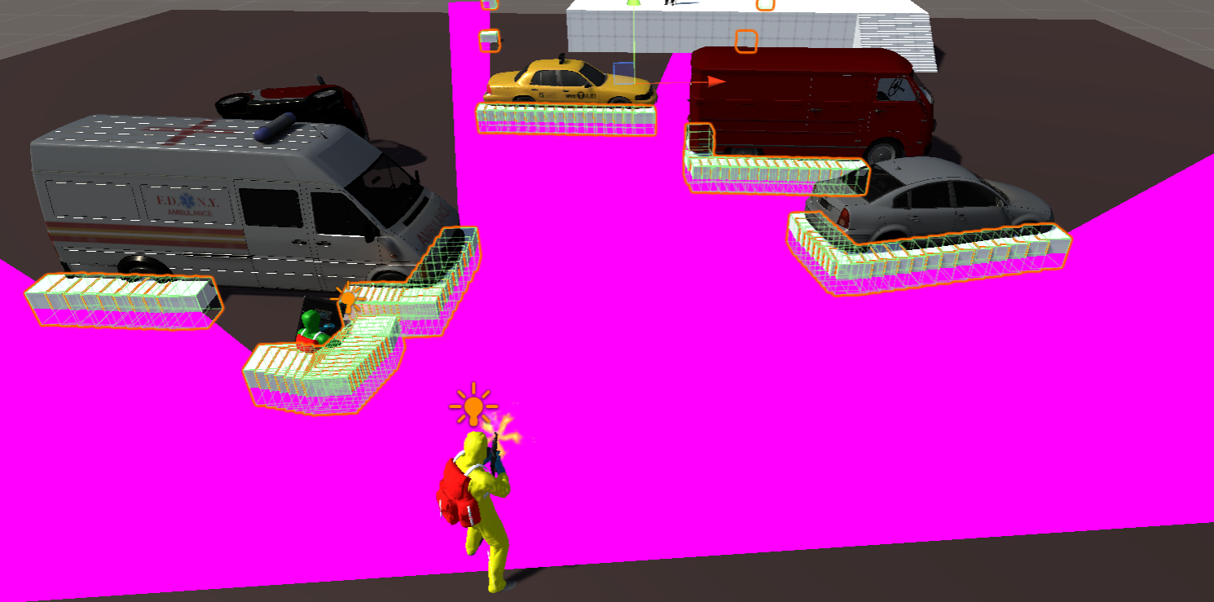

Figure 9 – Assigned cover locations by the edge detection method.

## 1.5 Project Scope

The time to complete a process on a device capable of only single-thread processing is dependant of the amount of computations the CPU must perform to complete the process, considering the functionality of a single-thread processing system where one process is executed at one time and one result is displayed at another time.

On a device that supports multithreading, multiple processes can run concurrently taking advantage of the CPU’s abilities to process multiple threads at the same time. At the start of the program, in multithreading a default thread is created by the machine, the *Main Thread*, where all the small individual threads assigned to handle future tasks are created. All the threads created in the main thread will run concurrently and must synchronise the result with the main thread at the process completion. Multithreading is suitable for software containing several tasks designed to run for a long time but for software with small threads designed to complete in short periods of time, the capabilities of the operating system and the CPU will be highly taxed. (*OPERATING SYSTEM CONCEPTS NINTH EDITION*, 2012)

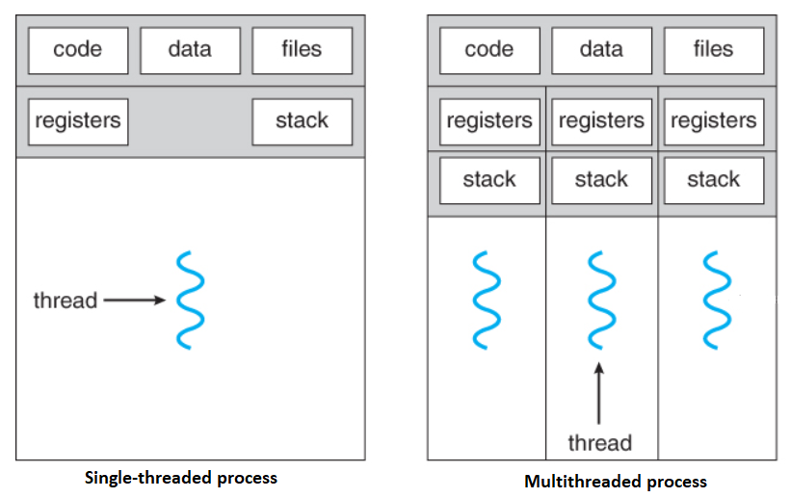Figure 10 - Overview of a single-threading and multithreading process

There are several types of game engines on the market and there are limited rules of functionality required to be measured as game engine. (Halpern, 2018)

Multiple game engines on the market implement a similar set of features to allow a common functionality such as:

* Rendering Engine – to support 2D and 3D graphics;
* Collision detection supported by a Physics Engine;
* Sound play supported by an Audio Engine;
* Game logic implementation supported by scripting;
* Animation handling capabilities;
* Game world object modelling to define game world properties;
* Network access for multiplayer features;
* Memory management;
* Multi-threading for game logic simultaneous execution;
* Artificial intelligence to serve for computer opponents and pathfinding.

The best functionality in a game engine can be achieved by separating the main-thread game processing logic from the individual game logic threads. To improve the software functionality and game frame rendering, small overlapping individual threads must be eliminated from the main thread to decrease CPU resource usage.

The core of a software developed in a game engine is a programming procedure named a game loop. The loop is composed of a sequence of processes designed to implement real-time simulations. The processes must be executed between game frames displays, usually around 33ms. Primer to entering the loop, an initialisation of all the necessary resources is mandatory. The input assembly process must be immediate to give the user a quick response sensation while accumulating the state changes of input devices as a response to hardware input events. Hardware state changes are translated as game actions that will be passed in following update stage. The following step is to run the actual game simulation such as game logic, physics engine simulations and enable AI behaviour.

In a basic game engine, the game simulation must be done in two steps:

* The first phase will use the current input over the current game state to calculate all possible game state updates based on the input provided;
* The second phase all the interactions between game entities, game collisions are detected and resolved.

The update following the simulations will only be applied to entities used in the game ignoring the rendering process of the game objects. The final task before entering the game loop is to render to screen and audio the update of the initial game scene. The observable parts of the game scene are created, animations are applied to the visual aspect of game entities. The lighting effects and game scene texture are considered sideways with generating the game sound field. Every output of this stage is transformed in data structures with the purpose of delivering rendering data for the graphic and sound hardware in a fairly efficient manner.

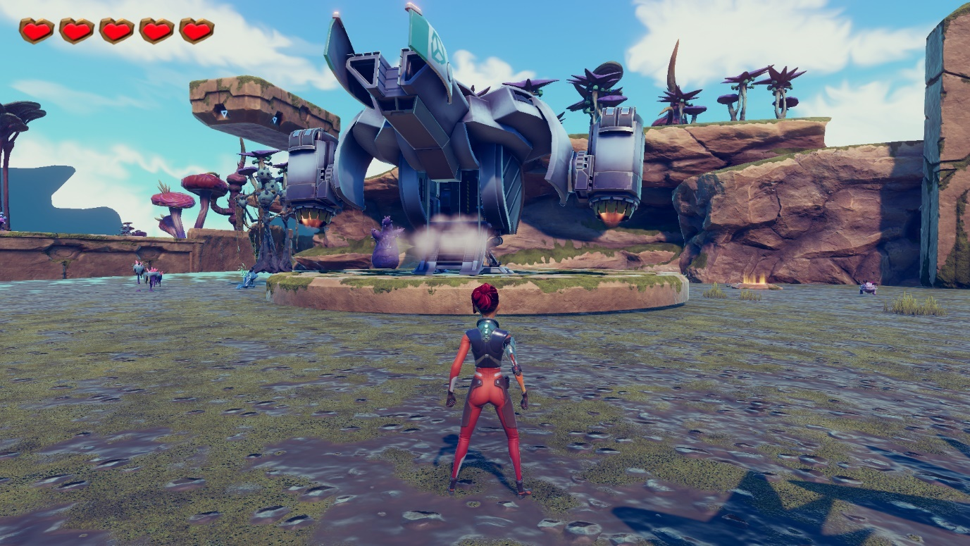

Figure 11 - Alien Landing (by Leo Groza) - Example of game loop start following the initialisation phase.

Defining the functionality in a game, resulted in developing a standard modularisation of engine functionalities.

The game engine functionalities have been separated into:

* Process scheduler;
* User input;
* Resource management;
* Game scene management;
* Rendering module;
* Sound management;
* Physics engine;
* Network connection.

Each game engine functionality require large amount of resources, generating a queue scheduled by the main thread, for CPU and GPU resources.(Tulip, Bekkema and Nesbitt, 2019)

The initial scope of the project is to temper with the foundation of multithreading and create possibilities of developing single individual threads to begin separately from the main thread and only synchronise with the main thread at the end of the process. A functional method can improve the rendering capabilities of the system and remove the high number of threads generated by the main thread queuing for resources at the CPU. A good result can increase the efficiency and portability of games software minimising the need of hardware upgrades for each new game release.

# 2. Aims and Objectives

The aims of the project stand to research and advance the development process in a game engine to improve the overhaul effectiveness of the software, obtain the maximum efficiency and create new guidelines for a healthier development process.

## 2.1 Aims

1. Review the multithreading objective in relation to Unity Jobs System, a newly implemented multithreading system for Unity Game Engine.
2. Attempt in removing functionalities for AI game agents from the main thread and create individual sequences of instructions that will only synchronise with the main thread at the end of the process.
3. Transform the Ray-Cast Edge Detection framework to develop AI dynamic cover at run-time to eliminate the implemented framework of pre-set positions.
4. Investigate conceivable improvements for the current implemented coordination framework, A* Pathfinder, and propose new, efficient AI coordination frameworks to be implemented in the software; e.g. AI game objects designed to provide close cover while approaching target.

## 2.2 Objectives

1. Evaluate single-threading, multithreading and Unity Jobs System to establish differences, pros and cons, increase understanding in functionality, possible improvements or modifications to target a coding method that will allow the development of individual threads separately from the main thread and evaluate the functionality of the result.
2. Unity Game Engine provides AI game objects basic functionality to simulate a living organism. The basic AI programming includes standard pathfinding algorithm, target detection function and game scene rendering. To improve game play simulation, the functionality of the AI game object must be upgraded to create a state similar to environmental awareness where the AI can perform an efficient scan and use of the game environment and completing processes without supplementary guidance from the user.

## 2.3 Development Background

Patient Zero, the development subject of the project, is a game developed in Unity game engine. The development of the game is based on Unity 3D technology, technology capable of developing 2D and 3D online games and animations, virtual scenes and interactive development tools. Unity 3D provides powerful integration tools and incorporates a number of components, such as game objects, intended for 2D and 3D game development. Unity 3D is intended for use on various platforms such as Windows, Mac, mobile platforms and it is capable of developing software proposed for the web reflecting its advantages as a lightweight software with rapid progress and multi-platform release.(Huan and Jia, 2016)

## 2.4 Testing

The positive attributes of a tested software are:

1. Completeness – is the algorithm functioning as per the intended purpose?
2. Correctness – does the algorithm have any errors?
3. Performance – is the algorithm effective in producing the result?
4. Resource usage – is the algorithm efficient in producing the result?
5. Stability – does the algorithm handle any unexpected data or syntax errors?

There are several techniques to test a software developed in a game engine:

1. Game play – one of the most common methods to start development testing;
2. Build testing – features developed must not be presented as finished until built and tested into a development environment. Prior to assigning code and assets to a feature integrated into an environment it must be tested for functionality;
3. Test planning – prior to development, in the requirements gathering stage, a testing plan must be established to anticipate all testing possibilities during the development process;
4. Reduce the feedback sequence – developers must assure the time period between implementing, upgrading, removing a feature and testing the result is as short as possible. The methodology guarantees fast and efficient testing performed frequently and increase the productivity of the development process.
5. Resource and performance – establish the minimum satisfactory level of performance, the minimum aimed frame rate, maximum memory usage and game object features; ­­
6. Test driven development – is the most common technique in development testing, it depends on the replication of a rapid development sequence. The overhaul aims of test-driven development is to create unit tests wherever is possible otherwise develop integration tests which do not demand vast amount of resources to maintain and process.
7. Output testing – is the most economical testing methods, it involves the visual inspection of the algorithm and output to confirm if the proposed game logic is achieved.
8. Graphical testing – is possible once a complete rendering process is available. With graphical testing screen captures from different builds or functionality of the software can be compared to determine a result. Graphical testing is a common practice for software with instant rendering capabilities.

### 2.4.1 Development Scene

The proposed game, Patient Zero is a game in development. The total size of the game, to date, is 93.2 GB. One of the main issues to be addressed, in the requirement gathering stage, raised questions about the possibility of carrying out the development process of the main aims and objectives inside the actual game. Patient Zero is designed to be a complex 3D shooter, with an intricated subject and a complex scenario where the multilevel gameplay follows a written scenario. The debate has been rotating around the level to be used in project development, what functions must the level contain to suit the development and the minimum number of scripts in the level, to provide basic functionality and keep a minimum level of complexity. Game scenes with high levels of complexity require extended functionality testing just for a simple implementation of an algorithm for example to find a specific game object in a dark, crowded scene.

After meetings with the stakeholder, taking notice of the positive attributes of a tested software and the software techniques needed to test a project in a game engine, the appropriate outcome was to build a new simple game scene where existing assets, scripts, design and features can be incorporated from Patient Zero, where the requirements of the project can be developed without affecting the game and at the end of the project the scene can be used as a base for a new level development.

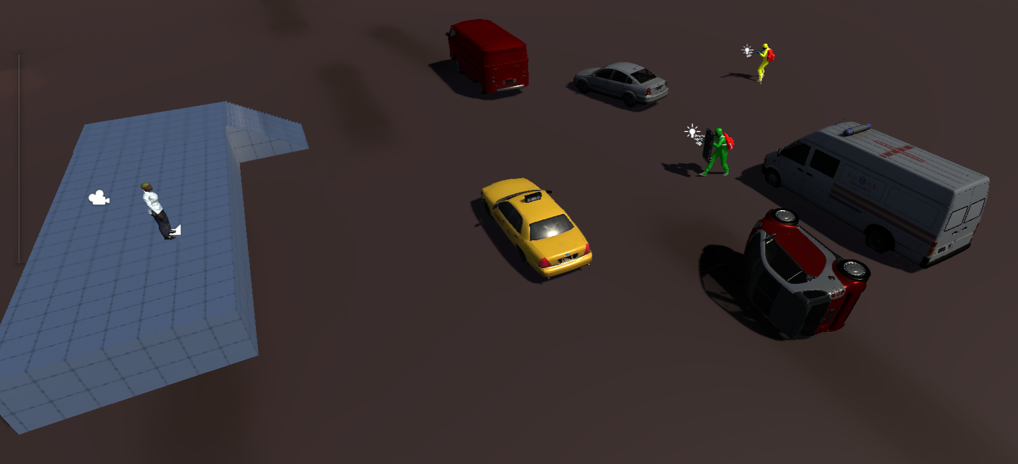

Figure 12 - Testing environment of the project

The simplicity of the scene creates a perfect environment for the development of the project. The scene is created on a ground plane which in the initial stage of the project has been constructed on a grid. The scene is composed, on the ground plane, of six game objects and three AI game objects, each design for a purpose.

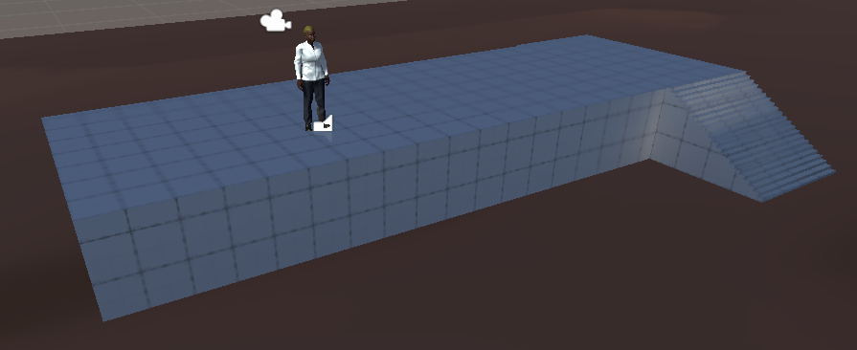

Figure 13 – AI Target on a high ground game object

The gameplay target is a simple AI game object with limited functionality. Implemented from Patient Zero, the purpose of the game object in the scene is to serve as target for the soldier AI, as a destination point for the ray-cast enemy detection method and as a destination position for the AI’s pathfinder algorithm. Towards the end of the project, the features of the AI enemy target will be activated to increase the degree of complexity for the field of view methods implemented in the AI enemy soldier, it will be able to distance itself from the soldier AI in a dynamic target search. The target AI stands on a high ground game object complete with a stair detach, game object intended to upgrade and test the functionality of the field of view method and the pathfinder algorithm.

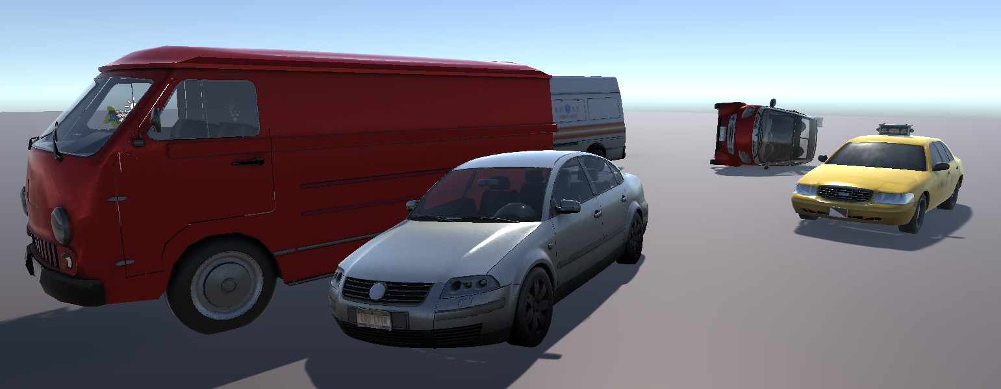

Figure 14 - Static scene game objects

A number of seven game objects rendered as day by day vehicles are implemented in the scene. Imported and implemented in the scene as static, different height, size and position game objects they serve as scene obstacles to test and improve the pathfinder algorithm and AI cover locations, triggered and generated by the field of view algorithm of the AI, along the path to the designated target.

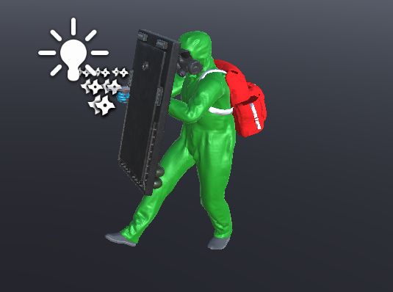

Figure 15 - Shield-man soldier

The AI shield-man game object is designed for the game scene to follow a path towards direction of the target and provide cover fire during fights and cover location within the proximity location of the target. It has a limited functionality and it is designed to develop and improve dynamic cover-based locations in the game.

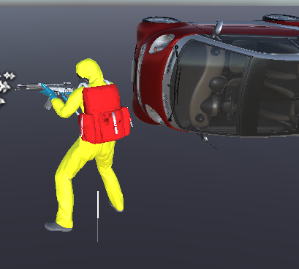

Figure 16 - Soldier AI game object

The soldier AI game objects stands as the development base for the project. The aims and objectives of the project are connected to the AI game object. It is the most complex game object on the scene, every algorithm necessary for the project development is applied to the AI soldier game object beginning with the field of view, ray-cast edge detection and field of view algorithm. Every implementation, modification and upgrade are designed to be applied and modify the behaviour of the AI soldier game object.

### 2.4.2 Types of Testing

Having determined the aims and objectives and the developing background of the project, two testing methodologies have been selected to support the testing process during the development process:

1. Manual testing;
2. Automated testing;
   1. Unit test;
   2. Integration test.

Every alteration or upgrade added to the functionality of the game must be regularly tested. Newly developed algorithms must be tested individually for the specific game object and once the proposed functionality has been achieved it will be tested at run-time with the remaining game objects and algorithms in the environment.

Manual testing a development process involves forming a plan to detect any software flaws. It is a low cost, simple process, implemented at the start of most software developments aimed to repeat the same process regularly, code inspection and functionality. A very good solution to begin with but with the increasing complexity of the development process methods must be explored to replace the methodology with automated testing.

Unit testing is a taxing method but well suited for complex code, where reliability of the code is highly important. In unit testing code blocks are tested individually and remotely determining the design of the code for unit testing to have functionality as an individual unit creating a positive outcome for the design of the entire software.

Integration test is comparable to unit testing on a larger scale. In integration testing a large number of code units, or as part of a system, are tested as a complete unit. Integration testing is considered as the final part of system testing because it comprises the complete system without any simulation units. Not as taxing as unit testing, considering that all the development restrictions imposed by isolation in unit testing are removed, it is designed to test systems that can be disposable without affecting the complete system.(Kerningham, 1999)

# Chapter 2 - Literature Review

# 1. Software Development Life Cycle

A Software Development Life Cycle (SDLC) involves a series of processes planned to advance and adapt a software product. It is focused on designing, developing and tests software based on the expectations of the stakeholders, completion time and estimative cost. (Goyal & Ram, 2014) SDLC is the acronym for software development life cycle and stands as the definition for every mandatory step in a development process of a software. It explains the methodology for software quality improvement and it is an elaborated plan designed to improve and adapt a development process.(D. Banker, B. Davis and Slaughter, 2000)

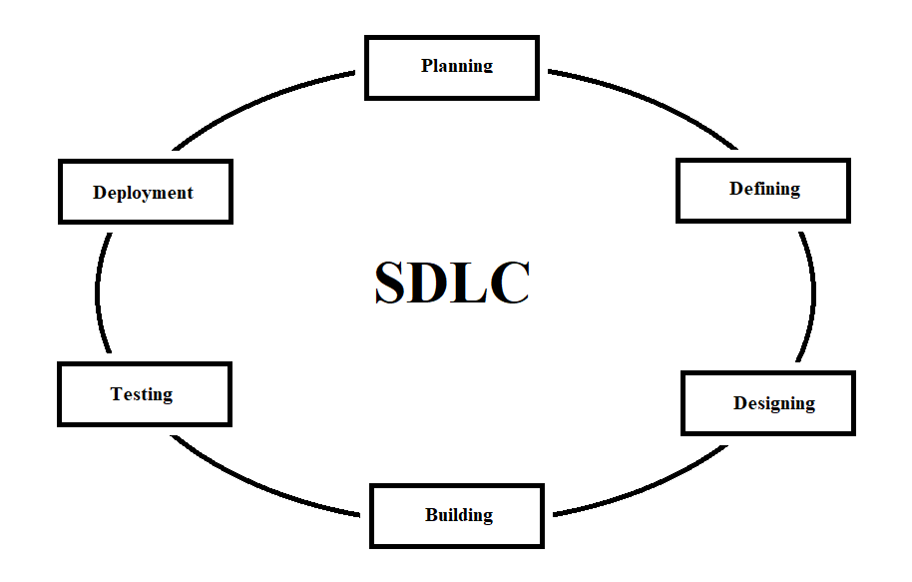

Figure 17 - Typical representation of the Software Development Life Cycle

## 1.1 Software Development Life Cycle Stages

The software development life cycle incorporates six typical development stages:

1. Requirement analysis and planning stage – the most important stage in software development life cycle. The project requirements are analysed and discussed, input from customer and various sources e.g. field experts, is used to create a development approach plan, and determine the operational and technical feasibility. The planning stage identifies the requirements and requirements development process, the necessary technical processes for a successful project development and requirements implementation.
2. Defining requirements - following the requirements analysis process, the product requirements definition stage is developed to set the exact product specifications to receive the approval from the stakeholders. All of the product specifications will be documented in a Software Requirement Specification (SRS).
3. Product proposal and architecture – based on the software requirements specification document, proposals for the design and architecture of the product will be developed based on the requirements, robustness and time constrains. The document defines the complete architectural construct of the product, complete with any internal modules or external third-party modules that must interact with the product.
4. Product development – the stage marks the beginning of the product, software development following the specifications of the design document. The product development must follow the guidelines imposed by the organisation and the development tools imposed by the type of the development product.
5. Product testing – a completions of the typical stages of the software development life cycle, a majority of testing is completed during the development stages of the SDLC, and this stage is focused on testing in areas where products faults and errors have been reported. Testing is repeated in the areas to the point it SDLC standards.
6. Maintenance and market deployment – once the testing stage of the SLDC is completed the product or segments of the product, depending of the marketing strategy, will be released to the market to capture feedback and based on the feedback the product can be released complete with the enhancements suggested by the targeted market segment.(Tutorial.com, 2014)

## 1.2 Software Developments Life Cycle Models

A number of software development life cycles are designed, implemented and followed during a development process, also called models, they present a unique set of processes, specific to a type of development process, to be followed for a successful development.

According to McLeod (2007) the common SDLC models followed in development are:

* Waterfall Model;
* Iterative Model;
* Spiral Model;
* Big Bang Model.

1.2.1 Waterfall­­ Model – is the first SDLC model to be introduced, referred to as a liner development model. A simple model to understand and implement, the development model is separated into different tasks, where to begin a stage the previous one must be completed, the result of one process stands as input for the next one.

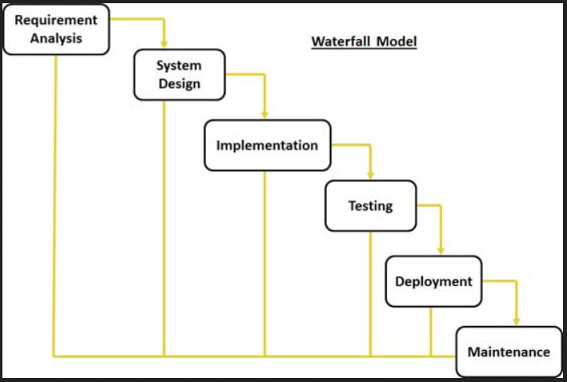

Figure 18 - Waterfall Model

The Waterfall model is constructed based on the following linear stages:

* Requirement gathering and analysis – the requirements of the development process are documented in a requirement specification document.
* System Design – requirements gathered in the first stage are studied and the architectural design of the system is constructed. The architecture will determine the overhaul hardware and system specifications and define the architectural structure.
* Implementation – the result of the system design process serves as input for the initiation of the development process, small programming units are developed to be integrated in the next stage of the process. Every unit is subject for testing prior to serve as input for the next stage, process defined as unit testing.
* Testing and integration – every individual unit developed in the implementation, and tested, is integrated in the larger system. The testing stage ends with post integration testing for software functionality, failures and faults.
* System deployment – at the end of the testing stage, where all the functional or non-functional features of the system are tested, the system is released to the customer or on the market.
* Maintenance – the issues resulted with the release of the software to the stakeholder must be resolved with patches. To enhance the functionality of the software, software updates are released, maintenance services are carried out for the environment of the stakeholder.

##### 1.2.1.1 Applications of the Waterfall Model

Every development process requires a suitable SDLC approach considering the differences between processes based on internal and external influences.

The Waterfall model is suitable for the following circumstances:

* Fixed requirements, clear and documented;
* The definition of the products is constant;
* The technology is not dynamic;
* The requirements are clear;
* The project requires a small development process;
* Extended capitals are accessible.

##### 1.2.1.2 Advantages and Disadvantages of the Waterfall Model

Advantages:

* Schedule possibility for each stage of the development process;
* Good process documentation and process result;
* Simplicity in arranging tasks;
* Process stages are well defined;
* Stages are completed one at a time;
* Suitable for small projects;
* Simple and understandable process.

Disadvantages:

* Functional software is not produced until a late development stage;
* High risks;
* Not suitable for complex projects;
* Not suitable for time consuming projects;
* Not suitable for projects with continuous requirement changes;
* Poor progress measurement ability;
* Changing project target can end the project;
* Software integration is done at the end of the project which can led to technological challenges and architectural impediments.(Blodyk, 2017)

1.2.2 Iterative Model – the iterative approach begins with modest implementations of a small number of software requirements and the process is iteratively improved to the point when a complete system is developed and ready for deployment. The iterative approach is focused on projects where development begins with the implementation of only a small number of requirements and gradually the system is reviewed to identify further requirements to produce a new software version with each implementation of the model.

During a development process more than one software iteration can be enhanced at one time, a process defined as an incremental built. The incremental model divides all the requirements into various builds and with each iteration the development process passes through requirements, design, implementation, design and testing stage. Each iteration release ads new features for the previous release and the process is continuous until the system is fully developed according to the requirements.

Requirements validation, testing and verification of each iteration against the initial product requirements is the key for a successful implementation of an iterative development life cycle. As the development process passes through several development cycles, implementation testing must be conducted and extended to validate every release of the software.

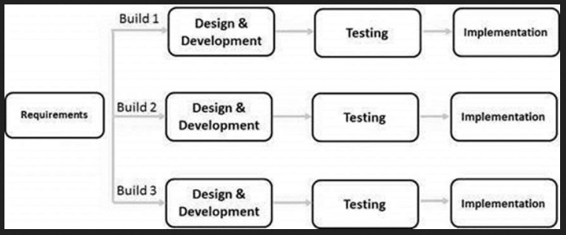

Figure 19 - Iterative Model

##### 1.2.2.1 Applications of the Iterative Model

The iterative and incremental approach is typically implemented in the industry for development processes with the succeeding scenarios:

* Clearly defined requirements for the complete system;
* Software enhancements may be enhanced by the software development process;
* Innovative technology is implemented and studied during the development process;
* The software is subject for time-to-market release constraint;
* High-risk aims are present and objectives that are subject to change in the development process;
* Skills may not be available but are planned to be acquired during project development.

##### 1.2.2.2 Advantages and Disadvantages of the Iterative Model

Advantages:

* Early functionality of the system at an early stage of development;
* Parallel development possibility;
* Possibility of measuring progress;
* Less taxing in requirements change;
* Every incrementation provides a functional product;
* Small iterations ease the testing process;
* Risks, issues identified in iterations can be easily resolved and can be utilised during the following iteration;
* Early functionality facilitates customer feedback and evaluation.

Disadvantages:

* Unsuitable for small projects;
* System design issues can be encountered by not having all the requirements from the start of the project;
* High management attention required;
* Extended resource package may be required throughout the development process;
* The progress of the project is highly dependent of the risk analysis stage;
* Not a suitable model for change of requirements;
* The deadline of the project may be unknown.(Burnett, 2012)

1.2.3 Spiral Model – a model resulting from the sum of the iterative model approach combined with the systematic aspect of the waterfall approach. Determines incremental releases of the product through each spiral or iteration of the development process.

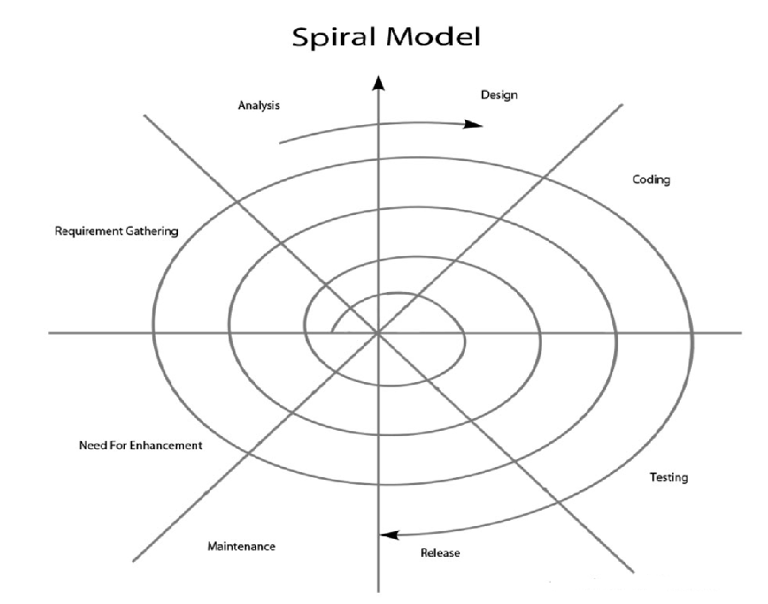

Figure 20 - Spiral Model

Four development phases are identified in the Spiral Model:

* Identification – the stage begins with product requirements gathering at the base of the spiral. The stage includes a continuous communication between developers and stakeholders and requirements understanding;
* Design – the design stage determines the architectural design of the product at the baseline of the spiral and the final design of the succeeding spirals;
* Construct - the development process of the product begins at every spiral. A proof of Concept document (POC) is developed to receive the feedback of the stakeholders;
* Evaluation – the technical functionality of the product is measured, risks and estimations are monitored, following the build tests for the first iteration the stakeholders provide software evaluation feedback;

##### 1.2.3.1 Spiral Model Applications

The spiral model is intensely used in software development as it involves minimum risks for developers and customers while the complexity grows with the development of the software.(*SDLC Spiral Model*, 2019)

The typical implementations of the Spiral Model are:

* High risk projects;
* Long-time projects based on possible alterations of requirements over time;
* Requirements ambiguity from the stakeholder’s side;
* The complexity of the requirements is high;
* Major changes are anticipated throughout the development process;

##### 1.2.3.2 Advantages and Disadvantages of the Spiral Model

Advantages:

* Requirements may be added in the development process the moment they become accessible;
* The model permits the extensive use of prototyping;
* System functionality can be seen in the early stages;
* The development process may be developed in small units improving the risk management process;

Disadvantages:

* The deadline of the project cannot be predicted in the early stages of development;
* The development process can continue indeterminately;
* A large number of development stages can lead to unnecessary documentation;
* Highly expensive for small projects.

1.2.4 The Big Bang Model – is a software development life cycle that does not follow a typical process. It requires very little planning, suitable for small projects with a limited number of developers, only requires funding for the start of the project and the output can or cannot be as per the requirements of the stakeholder.

##### 1.2.4.1 Big Bang Model Applications

The Big Bang Model is suitable for small applications where all the resources are focused on the development of the project eliminating the in large extents the planning required for project development. If any changes are needed throughout the development the whole process may need or not to have a full development revision.(*SDLC Big Bang Model*, 2019)

##### 1.2.4.2 Advantages and Disadvantages of the Big Ban Model

Advantages:

* The model is very simple to implement;
* Limited planning required;
* Limited amount of resources required;
* Good learning curve for novice developers;
* Allows elasticity in project development.

Disadvantages:

* High development risks;
* Not suitable for object-oriented development projects;
* Not suitable for extended projects;
* Highly taxing on misunderstanding the requirements.

## 1.3 Project Life Cycle Implementation

The research concerning the different software development life cycles implementations presents the contrasts of the advantages and disadvantages between different process models, depending on the initial requirements of the project.

Reviewing the definition of the aims and objectives for the proposed project, the implementation required for the software development life cycle must unveil faults and issues for early prototyping attempts.

The target of the proposed project is to develop software improvements in the current functionality of the development background, Patient Zero. The development process is driven by the functionality issues uncovered and the improvement possibility determined by reviewing the system as a whole, in association with the current market trend.

A need of improving the functionality by learning can be found throughout the process. The model must allow result evaluation at the end of each process and the analysis possibility of interdependencies between software units to identify the next suitable action for development improvement.

The Iterative Model is the suitable SDLC to be followed in the development of the project as it allows early progress measurement, parallel development, early stage risk identification and early development feedback. Another aspect taken in consideration for SDLC model implementation is the size of the project and the fact that it is at a middle stage of development, complex functionality has been achieved and research must be conducted to “learn” the current functionality and determine improvements in the attempt to improve functionality above the market standards.

# 2. Gantt Chart

In the initial stage of the project a Gantt Chart has been designed to set a development timetable and to present the dependencies between process stages and the development time schedule. For every development stage of the project a development time frame has been allocated in accordance with the complexity of the process. The Gantt Chart would provide insights about the development pace of the project with the overhaul allocated completion time.

Figure 21 - Initial project Gantt Chart

As seen in the initial Gantt Chart the initial start of the project has been set for the 15th December 2018. The initial submission date has been approximated for the 24th May 2019 allowing a total of 160 days for project development. The stage of the development process presented in the Gantt Chart are designed to be completed similar to a learning process as the project involves development through learning.

The Gantt Chart stages are separated in groups according to the project completion milestones presented in the chart. There is a total of four milestones throughout the development process, each milestone standing as an achievement of a sequence of stages completed.

Changes have been added to the development process and to the Gantt Chart timetable as the actual submission date for the project has been set for the 10th of May 2019.

The project has had a late start and it is subject to an earlier submission than approximated. Research has been conducted in accordance the aims and objectives of the project and impediments have been encountered linked to the fast development pace of the development background of the project, Unity Game Engine. The market demands constant improvement for the functionality of the game engine, determining basic Unity game engine implementations to become obsolete and no longer in use.

The development of the process involves several stages designed to serve as a learning curve for project development. Due to time constrains and several external factors that had an influence in the slow development of the process several stages of the project designed to serve as a learning curve have been removed and implemented in the stages that require such development skills.

Along the development process, in the Gantt Chart, stages have been added following the research conducted over the aims and objectives of the project and all the newly encountered implementation of Unity Game Engine features designed for continuous improvement.

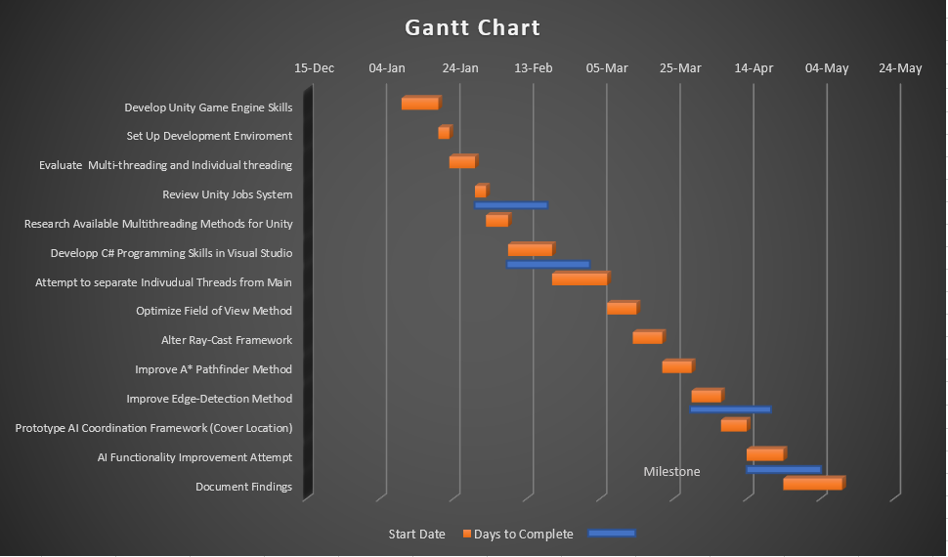

Figure 22 - Project Gantt Chart

Due to the late project start and an earlier submission date, a revision of the Gantt Chart has been mandatory. Development stages have been rearranged without tempering with the aims and objectives of the project. In the updated Gantt Chart, the total completion time of the project is reduced to 120 days, 40 days earlier than initially established. Stage development time has been reduced and, where possible, several stages have been summed together to obtain extra time for project development. The following stages: *Develop C# Programming Skills*, *Familiarise with Visual Studio Platform* and *Develop Coding Skill*s (*specific for Unity game engine*) have been summed as a single stage, allocating extra time for the rest of the stages in the development process.

Following research focused on new features added to Unity’s game engine functionality, development stages have been added to the process e.g.: Research available multithreading in Unity. Improvements have been made in the multithreading for Unity’s game engine, several implementations are in use at the current date, and further research must be conducted to understand functionality and, if suitable, possibilities of implementing the features in the current project.

Development stages have also been removed from the project, e.g.: Increase frame size for programming flexibility. In the initial stage of the project, frame rate testing has been conducted with the use of an external monitor. The frame rate readings had been satisfactory but quite high compared to the stand-alone device, reason why it has been decided that the project development will be carried out on a standalone device.

# 3. Risks

The development process is designed to begin with simple processes and progressively rise towards aims and objectives development. The development process of the project contains an assembly of programs and methods with many relations and dependencies. Jiang and Klein (1999) discover a number of risks that can affect budget customer satisfaction and system performance. In order to avoid process development failure, the first step is to identify factors that can led to the failure or cancelation of the project. (Kwak & Stoddard, 2004)

A critical factor in project development is the submission date of the project. The development time has been reduced due to a late start and continuous influence of external factors. The success of the project is difficult to predict because of the continuous game engine feature improvements and updates. The fast development pace established by the game development market determines many implementations and current algorithm methodology to become obsolete in a short period of time, weeks.(Bethke, 2002)

Developing and tempering with the functionality of a software is a sensitive process. The proposed development background, Patient Zero, is a software in development targeted towards console gaming. The complex functionality of the game, developed to date, implies a mandatory learning curve to be achieved for the development process of the project.

To develop a software from the initial stage towards the end is a very different process compared to enhancing the functionality of an existing software. Building a new software is a process that involves many different functions such as a version control, code quality and compilation. Basic activities such as workspace development and update, creating an environment to run processes and capture the input and output data and to assure the functionality of a process is done in the version control function. Code quality is a function developed to check the general quality of the code such as architecture, complexity, comments, unit testing and duplication. The compilation function in a development process exchanges the source files for executable objects through a compiler. In a development process designed to enhance the functionality of the software the developer must have knowledge about the functionality, the programming platform implemented, the architecture, the general build tools of the software or implement development stages in the initial stages of the project to acquire knowledge necessary for project development.

Common software development risks which apply to the current development process:

* Scheduling – the nature of individual software development projects generates issues in estimating development time;
* Limited management experience – taking focus from the mains objectives can delay the development process;
* Data loss, work corruption – project delay due to loss of data, hardware failure;
* Requirement growth – issues, such as the fast development pace of the industry, can develop risks if the requirements must be amended throughout the development process;
* Specification breakdown – the ambiguity of the requirements in the initial stage of the project may cause struggles;
* Gold plating – adding unnecessary features to the development process;
* Procedural risks – simple activities can be delayed with improper implementations and conflicts between priorities;
* Technical risks – reducing the functionality of the software to compensate time-to-market schedule;
* Not satisfactory for the customer – the final product may not suit the needs of the stakeholder;
* Risks that cannot be avoided – software redundancy is a risk that cannot be controlled. The increase in software complexity in the industry the risks linked with software redundancy have grown. These risks cannot be avoided but they may be planned.

# Chapter 3 – The Unity Engine

# 1. Unity Game Engine

The Unity game engine development begun in Denmark, developed by Unity Technologies. The first game released by Unity Technologies was in 2005 named Gooball.(Haas, 2014) It was a turning point for the organisation, which wanted to give the game engine a possibility to be released on the market, reinvested all the profit in refining the engine for its initial release in 2005. The first release targeted the IOS platform but following its success four years later a version for Windows was available. Unity game engine was the first software released with a free version for personal use.

In 2007, after a continuous development, a new release of the game engine included features such as terrain engine, Unity Assets Server, real-time shadow rendering system, web streaming and a new code-based GUI.

Previous to Unity, Adobe Flash, was one of the few options that would allow developers to publish on the web. The browser game industry was enhanced by the 3D graphic acceleration hardware added by Unity and the support provided for C and C++ plugins to allow developers to extend the functionality of the game engine outside the designed area.

In 2009, at the Game Developers Conference, Unity has released the first Window version including features such as low-level debugging, audio filters, deferred rendering and editor unification and development was carried out for a Flash deployment feature.

In 2012, the release with the biggest impact on the market, Unity 4 was released, including alongside 2D support, features such as Flash deployment, Shuriken particle system and animation technology.

The current implementation of the Unity game engine consists of a custom rendering engine developed on the NVidia PhysX physics engine and .NET libraries, an opened source of the Microsoft library implementation.

The Unity game engine development has been possible with the involvement of independent developers and game enthusiasts. While releasing a free personal version has been just a marketing solution, independent developers and game enthusiasts had a lot of involvement in the development of the game engine. Webpages, Blogs and Forums specifically targeted towards the Unity game engine and game development gather thousands of developers looking for new ideas, trying to resolve a development issue or just simply sharing their achievement. One of the first Unity forums to be recognised is Unify Community, <http://wiki.unity3d.com/index.php/Main_Page>, a Wikipedia of Unity Technologies.



Figure 23 – Unify Community Portal

Another factor contributing to the game engine development is the complete documentation, released by Unity Technologies, of all the features included in Unity along with game development tutorials and support forums, available for every subscription, including the free, personal subscription.(*Unity - Manual: Unity User Manual (2018.3)*, 2018)

The high number of game developers attracted negative aspects for the image of Unity Technologies. (*Unity: Good Enough for Bad Games : Games*, 2018) Being the first game engine to release a free version complete with documentation, accompanied by the simplicity of evolving a game, attracted the development of a number of games that have been branded, alongside with the game engine, as bad games by a large number of gamers in the industry without considering the involvement of independent developers and lack of control in the process.

## 1.1 Unity Engine Features

Benefits of using the Unity game engine:

* Documentation;
  + Unity Technologies provides complete documentation with its game engine along with tutorials, development examples and examples of the API integrated in the core of the engine;
  + The release of the documentations has pivoted the software productivity increase compared to available game engines on the market that only provide partial documentation for personal versions.
* Community;
  + A vast online community stands to assist individual developers and enthusiasts;
  + Unity developers are devoted in building game engine features at the request of the users;
  + A number of API implementations of the game engine has been developed at the request of developers.
* Drag and Drop Feature;
  + The Unity Editor is extremely easy to use, the content is displayed in a tree, in the editor, and can be added to the development environment in a drag and drop style;
  + The game objects are listed separately in the editor and every object can be competed with scripts written in C# or JavaScript, as well as physics or rendering proprieties;
  + Scripts can determine game object behaviour, develop user interfaces and accomplish tasks.
* Physics;
  + The physics properties develop game object features such as gravity, drag, collision detection and have functionality in game object assembly, e.g., joints;
* Rendering;
  + Through the rendering process shaders and texture attributes are applied to the visible game objects;
  + Unity rendering engine is based on a simplified language, compiled on DirectX 9 or OpenGL, to be available for multiplatform deployment.
* Distribution;
  + Software developed by Unity can be compiled for IOS, Windows, mobile platforms or intended to run in a web browser through plugins, similar to Flash Adobe distribution.
  + There is no restriction in software distribution in Unity as games developed in Unity are not considered as copies of existing software that would require a licence.
* Costs;
  + A low-cost game development process is one of the benefits using the free version of the Unity’s game engine.
  + Free assets, game characters, scenes, features and game functionalities can be acquired from Unity’s Asset Store, Standard Assets, and completed by the documentation provided.
  + There are three payment plans for the Unity game engine depending on the revenue achieved from the game development process. Each plan additionally brings new features in development such as training resources, assets and direct development support from Unity Technologies.(Craighead, Burke and Murphy, 2007)



Figure 24 - Unity game engine payment plans

## 1.2 Unity Interface

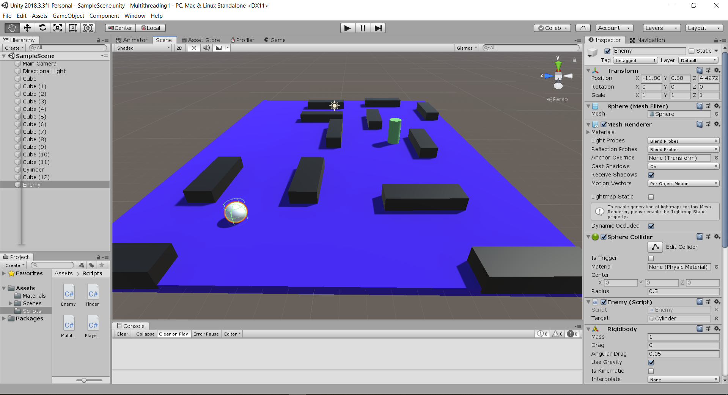

Figure 25 - Unity Interface (Scene developed by Leo Groza)

The Unity interface is constructed in rearrangeable, tabbed windows that can be grouped, detached and docked. Every developer has the possibility of arranging the interface to a display suitable to the development carried out.

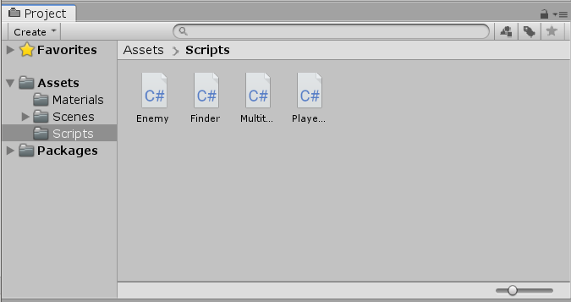

Figure 26 - Project Window of the interface

The Project window displays all the assets available in the development process starting from Animations, Textures, Characters, Scenes and Scripts, Audio and Text files. When importing an asset to the development process they will appear in the project window.

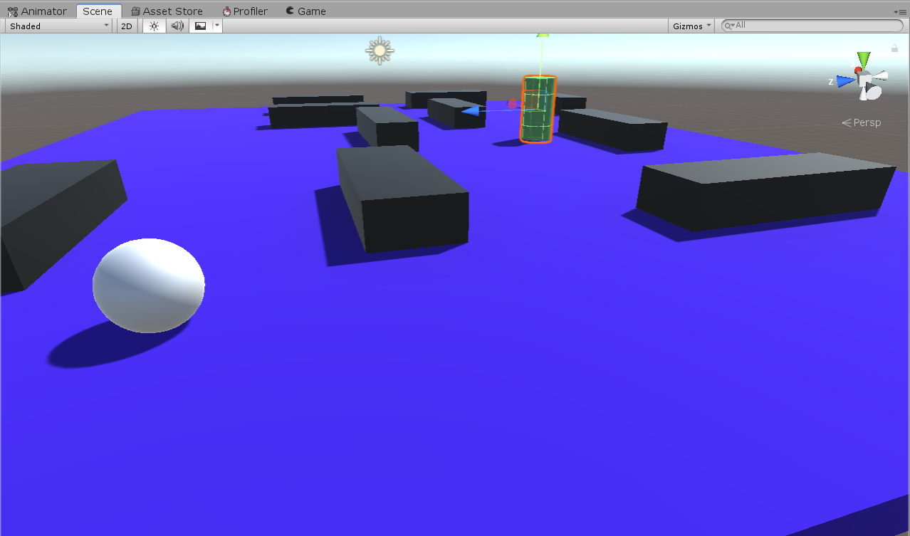

Figure 27 - Interface Scene View

The scene view is designed for scene visual navigation and editing. It can be view from a two dimensional, 2D, or three-dimensional, 3D, perspective according to the development process type. A scene is defined as the base object of a game. All the logic and objectives of the game are developed in methods and attached to a game object to create an interactive stage play.

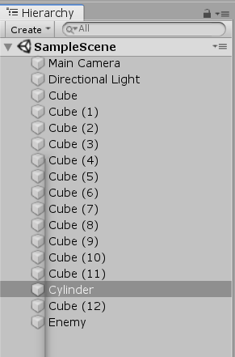

Figure 28 - Interface Hierarchy Window

The Hierarchy window is a tree representation of each game object in the scene. Every object introduced in the scene has an entry in the hierarchy tree which reveals the connection structures between every object in the scene.

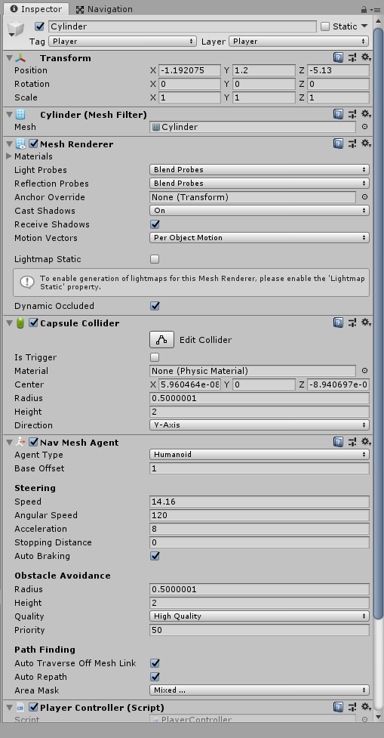

Figure 29 - Interface Inspector Toolbar

Every attribute of the current selected object is displayed in the Inspector Window. The layout of the inspector will vary depending on the current type of the object and the number of features implemented for the object.



Figure 30 - Unity Interface Toolbar

The interface toolbar is the access to the feature functionality of the game objects. Tools for basic scene manipulations, view of the game objects, size and position, are presented on the left-hand side of the toolbar. The control buttons, Play, Pause, Step-control are displayed in the centre of the toolbar while the right-side buttons provide links to Unity Cloud services, User account and the layout editor menu that allow a user to create and save its custom layout.

## 1.3 Common Assets Used in Unity

* Model Files;
  + Basic image file types are supported by the Unity software such as BMP, JPG, GIF and

Photoshop PSD files;

* + The software can support different 3D files developed in 3D modelling software with the implementation of Unity’s FXB 3D modelling software plugin;
* Animations and Mesh;
  + The Unity software can import any type of game object architectural design, mesh, and develop meshes with its own implementation of the 3D modelling software, Unity ProBuilder;
  + Along with the meshes imported from external sources, animation may or may not be imported depending on the needs of the developer.
* Audio files;
  + Audio files can be imported in Unity assets and saving the current state will compress the files to a specific format.
* Standard Assets;
  + Standards assets used in Unity refer to:
    - 2D Game Objects;
    - 3D Game Objects;
    - Cameras;
    - Characters (game object characters);
    - Environment;
    - Utilities;
    - Vehicles (3D game objects);
    - Effects;
    - Particle System.
* Unity Packet Manager;
  + A range of assets can be installed via Unity Packet Manger (UPM) including development tools, plugins and different type of libraries;
* Primitive Objects;
  + Unity game engine is developed to suit any 3D model created using a modelling software, but a number of primitive game objects such as a cube, sphere, cylinder and plane can be created directly in Unity;

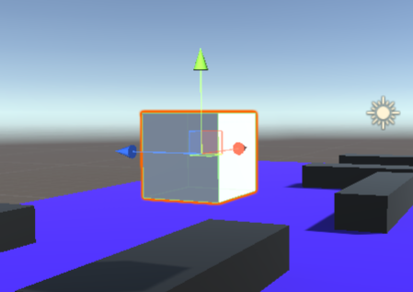

Figure 31 - Primitive game object created in Unity

### 1.3.1 Game Objects

The most important notion in Unity is that every object in the scene is a game object, starting from primitive game objects, lights, cameras or special effects. Individually, a game object, does not accomplish any task, without any attributes to implement functionality the purpose of a game object is to serve as a container for components.

By default, in Unity every game object is instantiated with a Mesh Renderer component and a Mesh filter, for the sole purpose of drawing the surface of the object and, a Collider component to represent the total physical volume of the object.

### 1.3.2 Transforms Component

The transform component determines the scale, position and orientation of a game object. The transform component is added by default starting with primitive game objects to dictate their position in the environment. The orientation, scale and position of a game engine is measured in comparation with the transformer parent, otherwise it is measured at the size it has been imported. The main drawback, in using a transform component, is that a transform component cannot be altered, removed from the main thread, or referenced as a memory location due to its default implementation in the Unity engine.

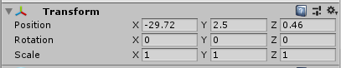

Figure 32 - Transform Component Window

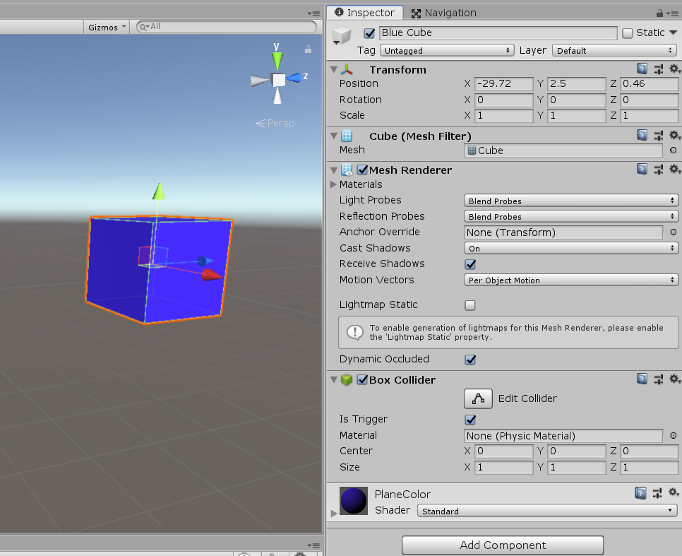

Figure 33 - Game Object Cube with Components

### 1.3.3 Components

Components define the behaviour of a game object at run-time. A component is the functional piece of every game object. Every object can contain many components but by default every game object is instantiated with a transform component to determine its location in the scene. The Inspector will display every available component attributed to a game object. One of the advantages of components is that once you add a component to the game object the editor can be used to adjust those properties while building a game or using scripts when running a game.

A component has two main properties:

* Reference;
* Value.

A component can contain a single reference value, such as the file attached to the game object, and several values that result from the game object file implementation.

There are several components that can be added from the Component Browser:

* Mesh;
* Effects;
* Navigation;
* Audio;
* Scripts;
* Rendering;
* Physics.

### 1.3.4 Rigidbody Component

Rigidbody components will define the game objects to run under the law of physics, such as gravity. A Rigidbody can implement torque and be affected by external forces to behave in a realistic manner. It determines the game objects to implement an expected functionality in collisions and joint movements. The difference between a transform and a Rigidbody is that the transform cannot be influenced by force or torque. A game object cannot be affected by the physics engine without the implementation of the Rigidbody component.

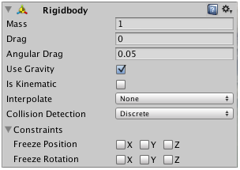

Figure 34 - Rigidbody Component Window

The main implementation of the Rigidbody component is through scripts and the use of animations determines a ragdoll effect.

#### 1.3.4.1 Collider Component

The collider component must be added to the game object alongside the Rigidbody component to allow the occurrence of collisions. The interaction between two rigidbodies will not be calculated as a collision unless both of the objects have a collider attached.

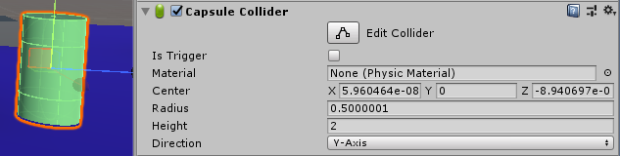

Figure 35 - Capsule Collider Component

Several types of colliders are available in Unity such as: Box Collider, Sphere Collider, Capsule Collider, Mesh Collider, Wheel Collider and Terrain Collider.

### 1.3.5 Mesh Component

The Mesh Component displays a very large part of the texture of 3D environment. The Mesh filter acquires the mesh, texture, from the assets and distributes it to the Mesh Renderer component to be displayed on the screen and the position specified by the Transform component of the object.

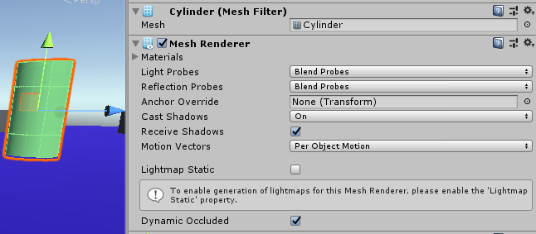

Figure 36 - Mesh Renderer Component

### 1.3.6 Prefabs

The Prefab feature, in Unity, enables the possibility to develop, create and use objects, attributed with components, as game assets that can be reusable in different scenes. Prefabs stand as a template for a new object instance in a scene. While developing a game object to be used in different scenes, the best methodology is to convert the object into a prefab which will keep all the copies synchronized throughout the development process without having to rebuild the game object for every instantiation. Every modification added to the prefab will reflect in every instantiation without cancelling any improvement added separately to an instance of a prefab.

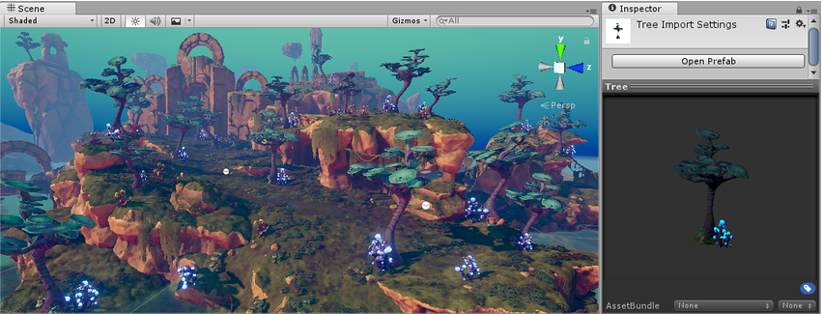

Figure 37 - Prefab implementation in a game scene

### 1.3.7 Audio Component

The audio component is in control of background music and sound effects in a game scene. The Unity software can import audio files in a standard format and, the features implemented in the audio component, allow sound effects and sound filtering. The functionality of the audio component is based on integrating in the scene an audio listener that determines the origin of the sound, in the game scene, and will replicate it to be send in the game scene as a result of the Doppler effect. To The audio component is generally attached to the camera in the game scene, there must be only one audio component in the scene, and it can simulate any type of sound with audio filters.(*Unity - Manual: Audio Overview*, 2019)

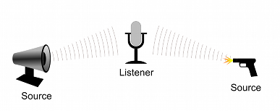

Figure 38 - Listener and Audio Source

## 1.4 Scripting

Scripting is a mandatory component in game development. All the games need scripts to respond to inputs, external factors and to determine the actions to be taken as an event response during gameplay. Scripts are also used to create graphical effects, to control game object behaviour and to develop a custom-made AI. The behaviour of a game object is controlled through components and scripts added to components. Unity game engine allows development of custom components through scripting.

The programming language implemented natively in Unity is C# which is a standard language in the development industry similar to Java or C++.

### 1.4.1 Script Anatomy

In Unity, a script defines the interactions between the script’s game object and the internal functionality of the game engine, class named MonoBehaviour. MonoBehaviour is a blueprint to create components to be attached to game objects. Every attachment of a script to a game object creates a new instance of the component defined by the blueprint, technically developing a new component for the game object.

The traditional idea of a program, where in a loop the code is iterated until a process is completed, is not implemented in a Unity script. In Unity the editor will pass the functionality control of a process to a script which calls functions that are instantiated in the script. Once the function process has been executed the functionality control is passed back to the editor. The processes are called event functions and are activated by the editor in response to actions taken during run-time.

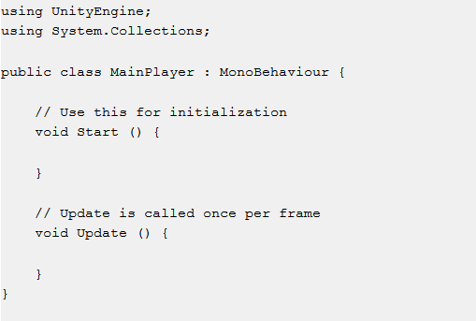

Figure 39 - Initial Script content

In every initial script, two functions are defined:

* Start;
* Update.

The Start function is called by Unity at the beginning of each game loop to initialise all the components used during game play. In Unity there is no constructor to initialise a game object. The structure of the game object is defined by the Editor and it is initialised during game loop, discussed earlier in the project.

The Update function contains code to handle game frame updates for game objects. The can include movement, responding to the input provided by the user and every functionality necessary for run-time gameplay. To obtain functionality, in the Update method, variables must be defined and connection between game objects must be established before game play initialisation.

Different types of functions have been defined to be used in the initial script for accuracy and animation purposes depending on the type of the game to be developed. The FixedUpdate function works in a similar way to frame rendering and it is called before each physic update for accuracy purposes, taking in consideration that frame updates do not have the same fervency as frame updates. The LateUpdate function is implemented to complete any animation process involved in the game environment and it mostly targets the game scene view at a turning point during run-time.

A script does not have to be specific to a game object. Once written it can be attached to multiple game objects, to implement the same functionality, by dragging the script asset to the game object inspector panel or by adding a new component from the inspector submenu of the game object.

## 1.5 Navigation

The most common navigation system implemented in game engines is the A* Pathfinding algorithm. The basic implementation of the algorithm is for three-dimensional pathfinding. Developing a navigation system for a game software is a challenging issue. Challenges such as moving obstacles, physics or change of the current environment create issue for game objects implemented with the A* Pathfinder algorithm. (Nobel-Jorgensen, 2011)

The general idea of the A* Pathfinder algorithm is to determine the shortest path between two points in an environment at the lowest travel cost. Pathfinding algorithms are developed on the base of net search algorithms, a node collection connected between links. Every link in the net has a value which is the travel cost incurred if the algorithm passes through that link and the algorithm is developed to iterate through the links of the node to find the path with the lowest travel cost or connection links.

The overhaul performance of a pathfinder algorithm depends of the distance between the original location to the target location also called a heuristic. For the pathfinder algorithm to establish the shortest distance between two point the heuristic has to provide the remaining distance between all the path determined to establish the optimal path.(Leigh, Louis and Miles, 2007)

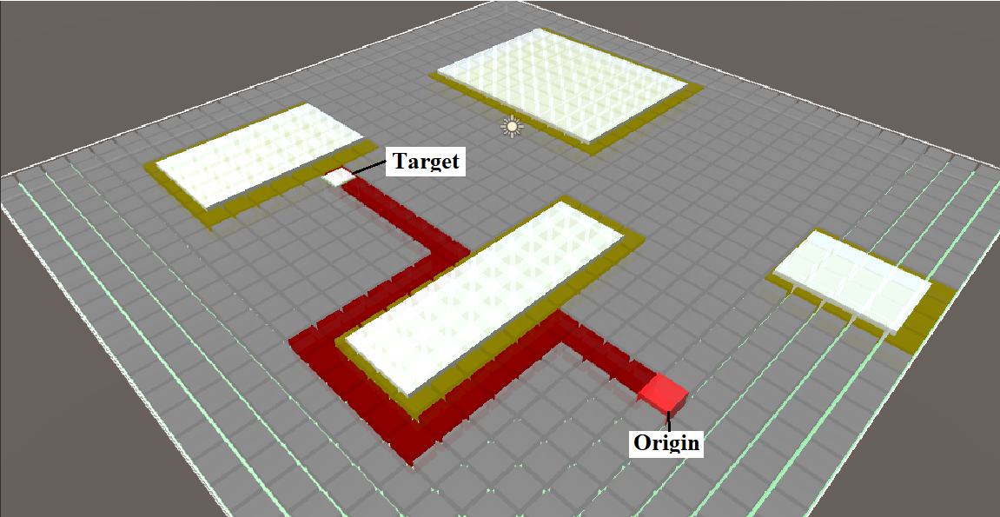

Figure 40 – Basic Grid representation of the A* Pathfinder method

The grid representation illustrates the implementation of the A* Pathfinder from an origin point to a target point over a surface constructed on a grid and populated by non-walkable objects. The pathfinder algorithm will calculate the shortest distance between the two landmarks, market by a red colour, taking in considerations the heuristics and the game objects implemented on the surface of the grid.

## 1.6 Unity Profiler

Every software development process must have a profiling tool to present general information about the software, the performance, functionality and possible improvement, issues and methods to eliminate issues.

The progress of the current project will be measured with Unity Profiler a powerful tool developed by Unity to provide insights about the functionality of different parts of the software. The Unity profiler can measure the performance of the game at game play. The information provided by the profiler can trail issues responsible for performance drop.

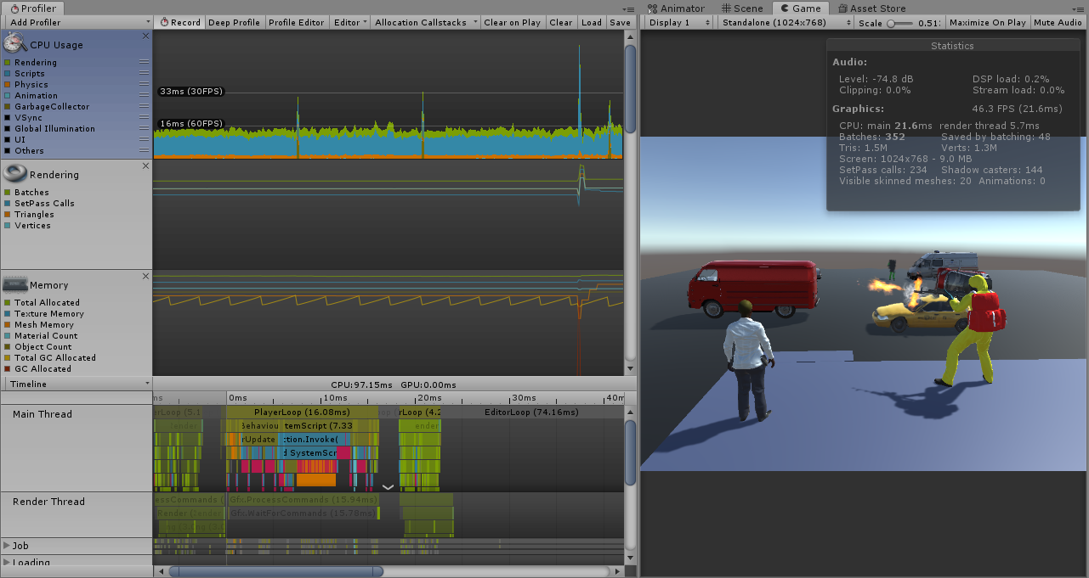

Figure 41 - Unity Profiler Window

The standard performance measurement in a game is the Frame Rate. A frame rate is the definition of an image in the game that has been drawn on the screen. Frame rendering is the process of drawing a frame on the screen and the frame rate of a game is measured in frames per second (FPS).

The optimal frame rate differs for every type of game. The current frame rate targeted by the current market games is 60 FPS, in general a frame rate of 30 FPS is considered acceptable for games where quick reaction is not mandatory such as puzzle games. Games with a frame rate under 30 FPS are considered as an unpleasant experience because they are not consistent, any frame update can be visible for the user. Unity editor must perform a number of different tasks with every frame rendered such as reading input from the user, draw a snapshot of the current frame on the display, perform calculations and execute scripts. In addition, loop calculations that may occur in a single frame such as physics calculations, must be completed. If the task cannot be completed in an acceptable time frame the frame rate of the game will drop.

A development environment, where the game performances are poor and improvement attempts are conducted, is perfect scene to record accurate data while the game is at run-time. The profiler can read information about different aspects of the game such as CPU usage, rendering, networking and audio process. While using the Unity profiler it is very useful to measure the performance across many frames as some issues can be constant and others may appear for a single frame and gradually can improve or deteriorate.(Dickinson, 2015)

The Unity profiler allows the CPU usage measurement, a view of the processes which take the highest CPU time to complete. Based on the information provided it can be determined which are the other profiles that must be viewed to determine any performance issues.

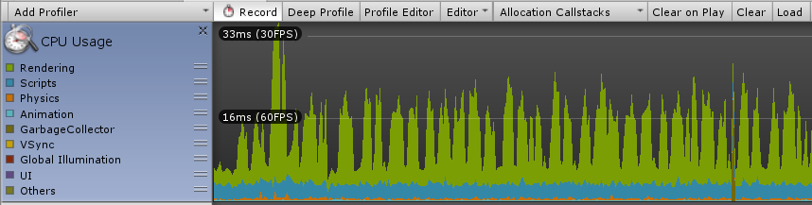

Figure 42 - CPU Usage Profiler

The CPU profiles provide details for CPU usage for the following features:

* Rendering process;
* Scripts;
* Physics;
* Animation;
* Garbage Collector;
* VSync;
* Global Illumination;
* UI;
* Others.

During measurements, the profiler offers the possibility of hiding information that is not of any interest to eliminate information overlapping.

## 1.7 Unity Game Engine Version

The is a visible technological advancement in game engine technology. The fast development pace determines the deprecation of small features in a matter of weeks. The Unity game engine is in continuous development with game engine software updates released every two, three months. New features are released with every update, determining the deprecation of random previous implemented features.

The 3rd person shooter, Patient Zero, is in a continuous development that has begun in 2015. Game engine software updates attract mandatory modifications needed in the structure of the game to eliminate all the errors following the updates that led to feature deprecation, if the system has passed over several updates. To avoid issues throughout the development process, the Unity software update feature has been blocked, denying access to new features.

Mandatory features, for the development of the project, will be added from external sources, such as blogs and tutorials, and research is carried out to find the best solution for software upgrades, while trying to eliminating the work needed to re-construct parts of the game before the compilation process.

The current version of Unity’s game engine, used in development, is Version 2018.3.3f1 Personal with Microsoft Visual Studio Tools for Unity 3.9.0.3 enabled. The version is constructed on the single threading methodology, every process must start in the main thread and must return upon completion, to be updated.

The new version, Unity5, is based on the concept of multithreading and operations such as physics and rendering are allocated to different processor cores. At the end of the development process, after attempting the completion of all the aims and objectives, the Unity engine will be updated, redundant features will be removed, and the results of the project will be compared with the results obtained with the update of the game engine.

# 2. C# Programming Language

The Unity engine is designed to offer possibility to developers to program their software in the IDE:

* Unity JavaScript;
* C#;
* Boo.

The languages have fast compile time and run on Mono, an opened source version for Microsoft .NET platform developed to write software for diverse platforms, .NET applications.

The language implemented in the development of the project is C#. C# is an object-oriented programming (OOP) language developed for Common Language infrastructure, meaning executable code and run-time environment designed to be functional over different platforms. It is a widely popular programming language that comprises a vast number of statements, it is the language used in the development of a large part of the .NET framework, a programming model that comprises over 2000 predefined development classes, and implemented for Windows and Internet applications.(Doyle, 2015)

C#, has a strong similarity with Java, and is a programming language widely implemented in the industry due to the following features:

* Modern, OOP language;
* Component oriented;
* Structured language;
* Efficiency in development;
* Compilation possibility on different platforms;
* It is part of the .NET Framework.
* Multithreading simplicity;
* Windows integration;
* Conditional statements compilation;
* Boolean conditions;
* Programmed garbage collection;
* Typical libraries.

C# code files can be developed in basic text editors, such as Notepad, and compilation can be done using command line compilers, integrated in the .NET framework. Development tools such as Visual Studio, Visual Web Developer and Visual C# Express, are provided by Microsoft, capable of handling simple command line applications to complex software.

As an object-oriented programming language, C# implements component-oriented programming, used to create and use software components. Modern software designs are based on software components presented as separate, independent functionality packages, offering a programming model with component proprieties, events and attributes that incorporate their own documentation. (Hejlsberg, 2011)

C# is a unified type system programming language. Includes primitive variables such as int, double, Boolean inheriting from a single object type and allowing common type operation sharing, where values can be stored and adapted in a consistent way.

The traditional program used to introduce a new programming language is “Hello World”.

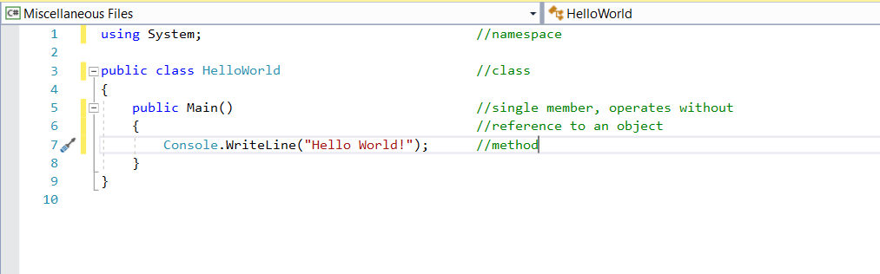

Figure 43 - "Hello World!" program in C#

The organisational concept in C# are:

* assemblies,
* members,
* namespaces,
* types.

A program written in C# declares types than contain members and are ordered in namespaces. A class is an example of types; methods, events and properties are members. Once compiled, everything becomes a package called assembly, saved in “.cs” files. The executable code is contained by assemblies and the information in metadata. The source code of a program, in C#, can be stored over several files and the compilation process concatenates all the files in a group before processing. (*Introduction - C# language specification | Microsoft Docs*, 2017)

## 2.1 Visual Studio

Visual Studio, as the scripting tool used in project development, is an iteration of the continuous development of integrated development environments (IDE). Every development iteration optimised the software for two categories of developers; .NET application developers and native C++ application developers.

The first predecessor of Visual Studio was BASIC, released in 1975, a programming language where the computer had to iterate through the code line by line. One of the major accomplishments achieved, since the first release, has been the progress achieved in development environments aimed to increase developer’s efficiency in building software in a platform and language of their choice. In the era of the 32-bits, IDE’s have been released as development tools, new features have been released such as a code editor and primitive IntelliSense to aid programmers debug and application in a certain scenario. The tools have been completed with user interface and drag and drop functions that would bring developers a new set attributes for control and implementation. Originally, every programming language benefited from its own integrated development environment but in terms of graphical design and simplicity, Visual Studio was recognised as the most advanced. (Randolph, 2010)

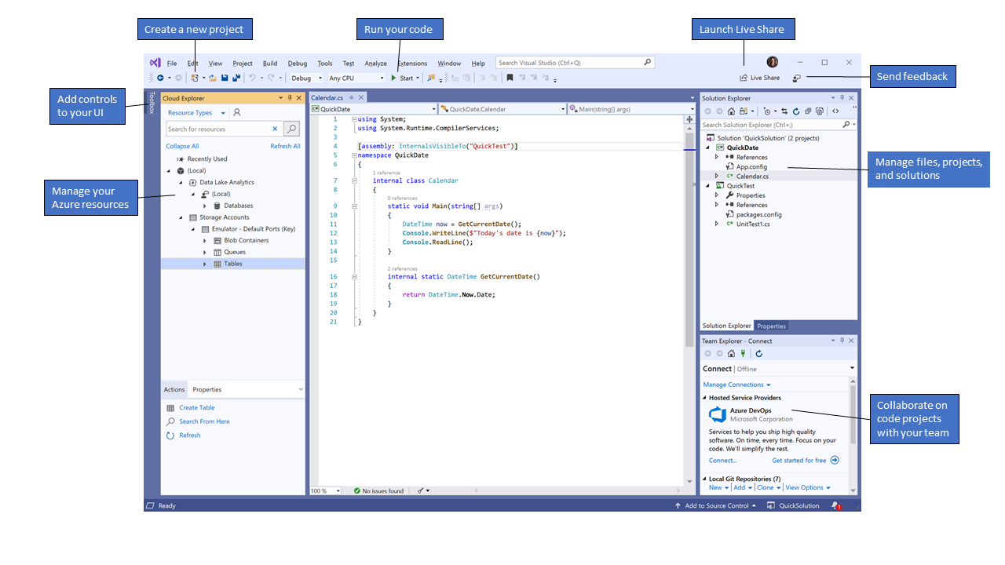

Figure 44 - Visual Studio 2010 Interface

The Visual Studio tool gives the programmer the possibility to edit, debug, build and publish a code, it is designed as software rich in features such as graphical design, compilers and code completion tools focused on improving the software development process. The interface of the software is designed to allow the users to easily organise the code, navigate, edit or design a user interface.

### 2.1.1 Features

A number of features improve the productivity and efficiency of the Visual Studio platform:

* Quick actions;
  + Underline, highlight the error and problems in the code, allows the developer to discover and fix potential problems before the compilation process, and can provide additional information about the error;
* Code formatting;
  + Style settings, analysis is applied to the code to be reviewed before the compilation process;
* Refactoring;
  + Changes the order of the parameters in the code, removes one of code, from the file, to be built in a new method and rename a variable throughout the file;
* IntelliSense;
  + Designed as inline documentation for the editor, shows code information in the code and can complete small parts of code for the programmer;
* Search box;
  + Considering the large number of features developed in Visual Studio, a search box is needed to find the functionality required for the development process. The search box displays all the result related to the enquiry and additional online support;
* Live sharing;
  + Feature that offers the possibility of instant, secure sharing over a number of sharing platforms such as localhost, voice and calls;
* Call Hierarchy;
  + A useful feature for changing, removing a method or tracing an error;
* CodeLens;
  + Feature developed for code referencing, code changing, unit testing and link errors in the editor;
* Definition;
  + The link of a function or type to the location where the definition for the type of function has been implemented;
* Peek definition;
  + A definition subset that displays a method explanation in the code file;

# 3. Project Development Hardware

Patient Zero, the development background, is a project in development. The scope of the current project is to temper, attempt to improve functionality in different features of the current game. The progress is measured, throughout the project, with the Unity Profiler, a Unity game engine feature.

To obtain accuracy in measuring the progress, it is mandatory that the hardware used in the development of the project will not be upgraded, downgraded during the development process. Any modification brought to the hardware will cancel the measurements taken to that point in the process.

## 3.1 Initial Hardware Specifications

The hardware specification, set to be used in the development of the project, was initially a HP ENVY X360, 15.6” Intel Core i7-7500U (4M Cache, 2.7 GHz), 8GB DDR4 2133MHz, 1TB Seagate SATA HDD with an onboard Intel HD Graphics card. The average measurement, in frames/second, displayed by the Unity Profiler for the initial hardware implementation was 30.3 frames/second (FPS), where a majority of the resources were taken by the rendering and the scripting process. A good starting point for the development of the project but with a major compilation-time drawback. Running the Unity engine software and compiling scripts with Visual Studio, had a direct impact on the rendering capabilities of the device, where 40% of the resources generated by the hardware were allocated to the built-in touch screen display. To gain time efficiency in the development process a hardware upgrade was mandatory.

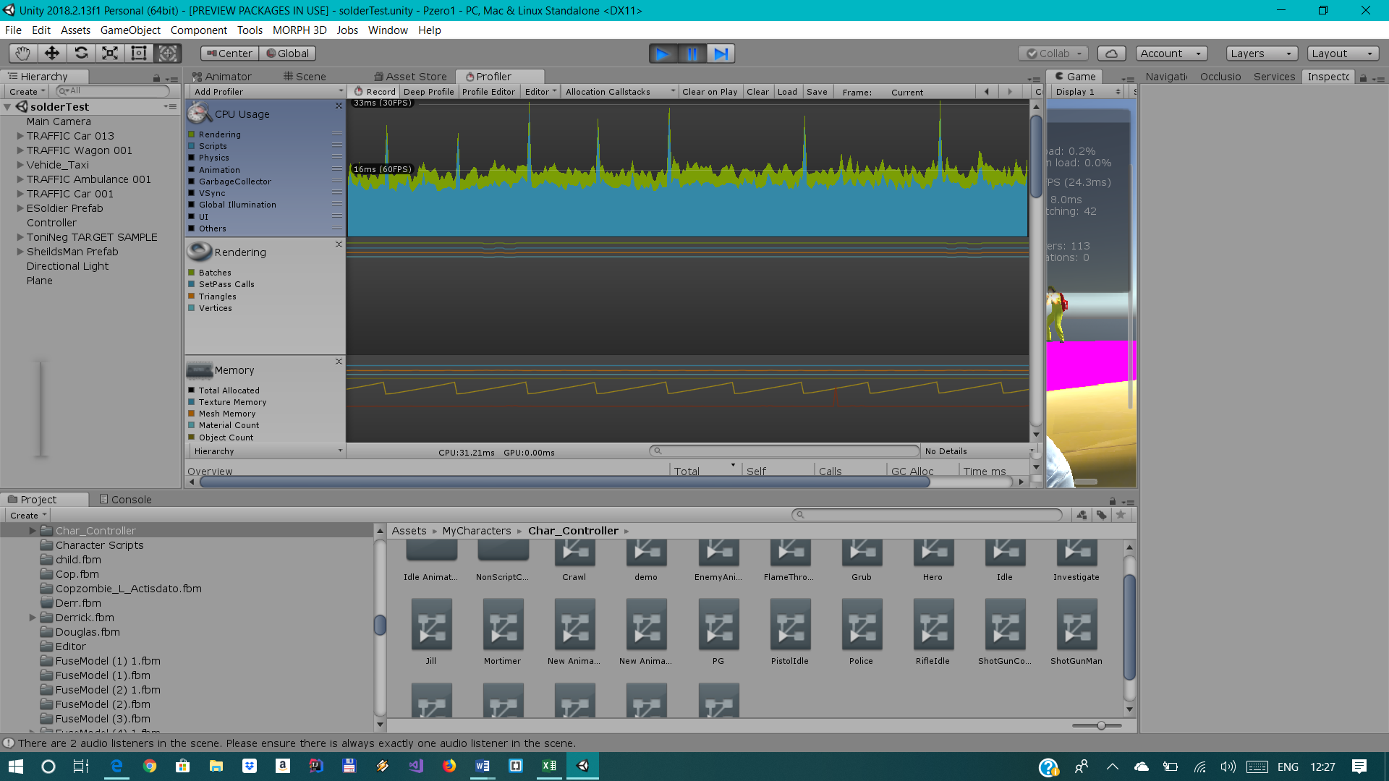

Figure 45 - Unity Profiler measurement for initial hardware specifications

Following an upgrade, the device used for the project is a HP ENVY X360, 15.6” Intel Core i7-7500U (4M Cache, 2.7 GHz), 16GB DDR4 2133MHz, SSD Samsung EVO 500GB. The onboard video adapter is an Intel Corporation compatible, Intel® HD Graphics 620 – 1GB Adapter RAM.

On a general performance benchmark, the X360 ENVY has an average performance score of 10.110 points behind a Dell Inspiron 15”, Intel Core i5-8250U, 8GB RAM and a Lenovo Yoga 720, Intel Core i7-7700HQ, 8GB RAM with scores of an overhaul of 12000 points. The X360 ENVY will generate a graphic performance of an average of 54 FPS, offering a good performance for average games. Not a suitable tool for software demanding performance but fairly good for game development in Unity.

# Chapter 4 – Initial System

# 1. System Implementation

## 1.1 AI Profiling

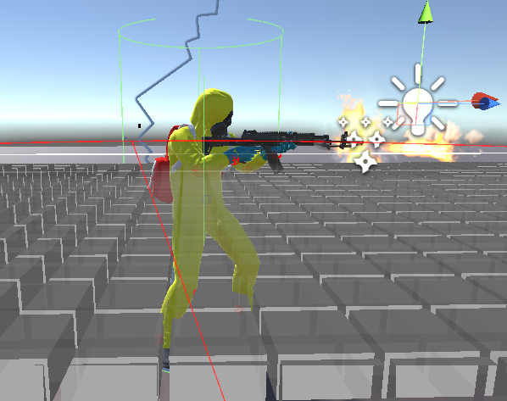

Figure 46 - Soldier AI game object

# 

The functionality of different entities in a game scene is based on a component model. Every entity in the scene is a game object with the attributes of a container. The role of the container is to incorporate different components, attributed to a game object, such as functions that are accessible through an interface.

An example of components are scripts which are responsible for the logic functionality of an object, a second example is a Rigidbody, a component responsible for the direct interaction of the character, game object, with physics such as gravity. A game object, in Unity, can implement a number of native, predefined components, and also foreign components developed initially strictly for the Unity game engine, such as A* Pathfinder algorithm. (Xie, 2012)

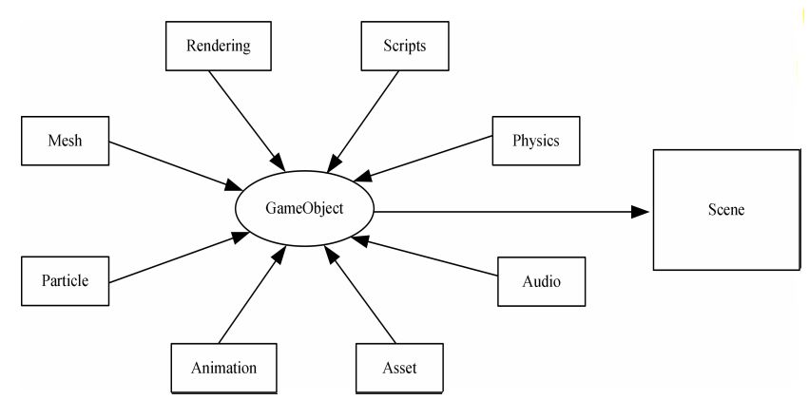

Figure 47 - Component Model in Unity

In Unity, game objects are organised in a hierarchy, a game can be structured in one or more scenes and every scene can be populated with a one or several game objects. Information about position, scale and rotation is implemented in every game object and the functionality is constructed by scripts and components.

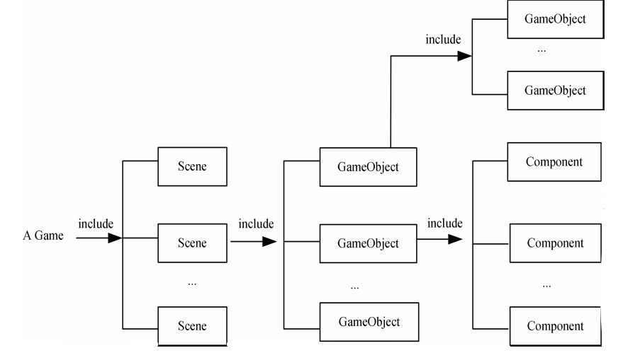

Figure 48 - Hierarchy in Unity game engine

The construction of an AI game object is based on a simple 3D object, in case of characters a cylinder, with the mesh renderer, capsule collider and mesh filter removed and replaced with simple low poly character, to fit to the general form of the AI.

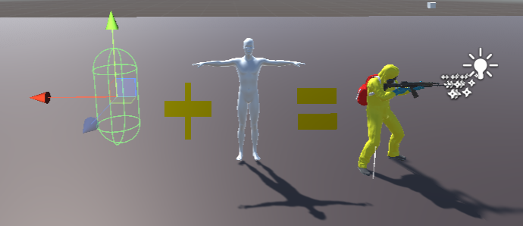

Figure 49 - General Development of a character

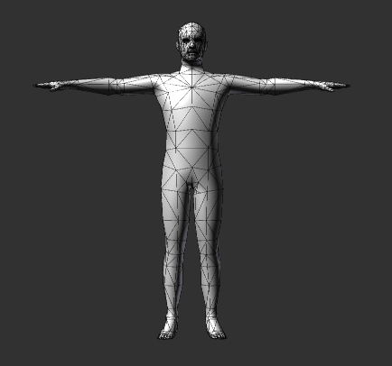

Figure 50 - Basic quad-based mesh

Every character created in a game engine must comply with a set of rules. For example, the textured surface of any game character is divided in polygons and the number of polygons is limited to quality of the game and the platform target. The detail level of the character is given by the number of polygons in the construction of the character. For a game targeted for Xbox 360, the maximum number of polygons for a game character is 40.000, while the average number used in modest games is 15.000. (Ward, 2008) For Patient Zero, the number of polygons in a game character has been maintained to a minimum in an attempt to reduce the resource taxing.

Preceding the character development, to obtain animation, the developer has to specify what animation must be used and how the animation will be used for different body components of the character. Every character has its own custom-built animations, such as an avatar and animator controller scripts, implemented for different action, and through a simple drag and drop function into the Unity Animator component, the animations will be applied to the character during game run-time. The built-in animations can be modified, changed or enhanced depending on the animation required and the type of the game.

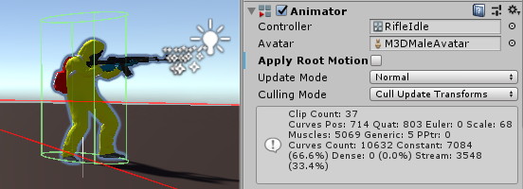

Figure 51 - Character Animator component

To simulate human-like behaviour for low poly character animations, such as the AI game objects in Patient Zero, scripts must be attached to the game character. A simple animation script comprises approximately 200 line of code written to connect the user input, movements of the character with the physics engine.

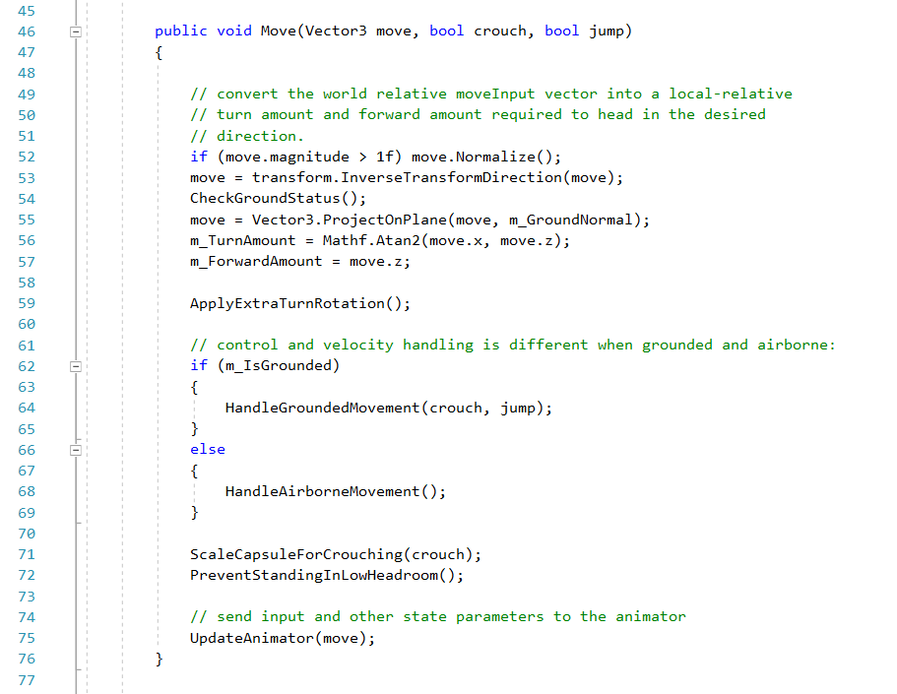

Figure 52 - "Move ()" method in a simple character animation script

In terms of AI equipment, gear, the best solution is a Cloth component native to Unity that provides solution for fabric simulations. It must be a native solution, to work with the physics engine, otherwise additional scripting is required to obtain a real-time rendering solution. Once equipment is added to the character, the cloth component will implement the physics properties of the character without affecting or improving in any way the functionality of the character.

Through the Unity Animator component, animations and behaviours can be added or modified for every AI in the game. The Animator component displays every animation implemented for the character and the connection established between implementations, and the animation script attached to the character will adjust the implementation accordingly depending on the situation.

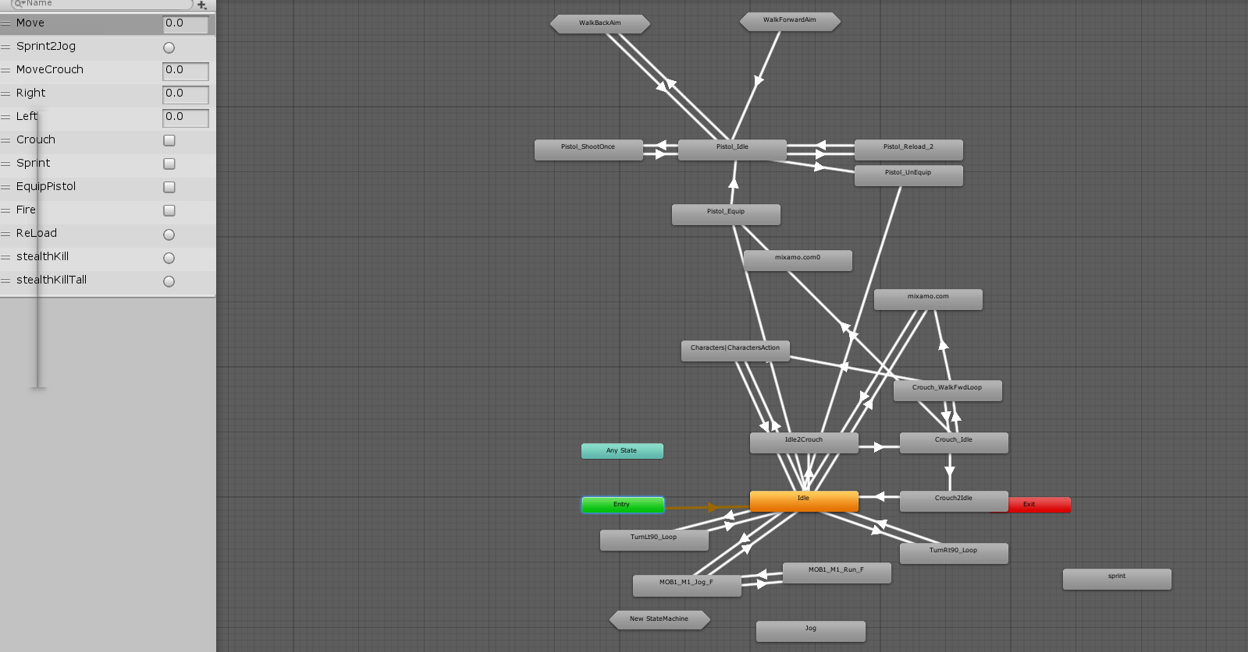

Figure 53 - Animations and connections for Patient Zero AI object

The construction of the AI character is based on a Rigidbody component and a Transform component to develop a behaviour limited by the laws of physics and to be bound to a location in the game environment. The behaviour of the AI is enhanced by external scripts and functions.

The functionality of the AI soldier object in Patient Zero is driven by scripts that control and trigger AI object features depending on the game environment. The “Control.cs”, “FieldOfView.cs”, “Pathfinding.cs”, “SystemScripts.cs”, “Soldier.cs” and “FSoldier.cs” are written to control the functionality, behaviour and trigger functionality of the AI.

The “Control.cs” script triggers the “FieldOfView.cs” script that will determine the existing game objects in the scene.

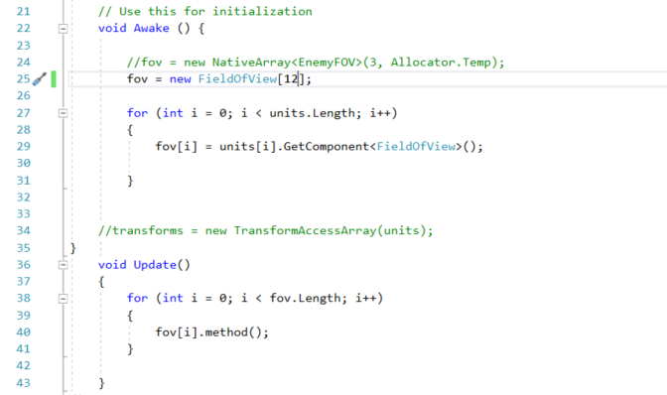

Figure 54 - AI FieldOfView initialisation in the Control script

The “FieldOfView.cs” script compares previews all the game objects in the scene and to establish the target, colleagues game objects and the target object. The boundaries for the AI’s field of view are set by the “FieldOfView.cs” script. All the game objects in the field of view of the AI are inserted into separated lists for colleagues, target and scene cover locations.

The field of view method enables a scene area view of 360 degrees, with the AI in the centre of the view. The field of view determines all possible the cover locations, hidden by from the view of the target, and will trigger the ray cast enemy detection method to find the target in the scene which will automatically trigger the A* pathfinding method to establish the shortest route to the target, avoiding any obstacle and making use of any possible cover location along the path.

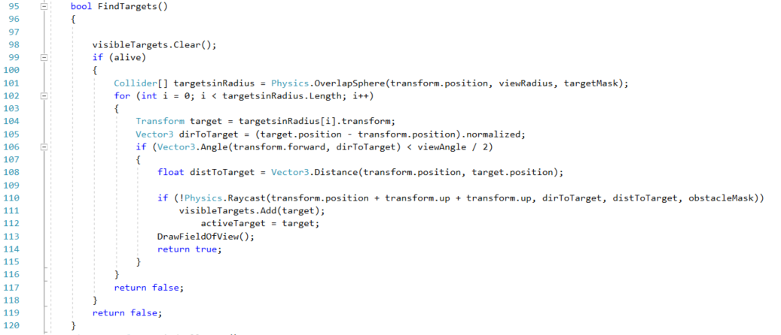

Figure 55 - Method to determine target in the FieldOfView script

The “FSoldier.cs” scripts determines the actions to be taken by the AI, the moment when the target has been spotted and the behaviour during a gunfire battle. A life spam algorithm, for the AI objects, is implemented in the script alongside methods determining the course of action and animation to be followed while the life spam, health, of the AI decreases following a battle. The script determines the removal of the AI objects from the game scene the moment his health has decreased to zero.

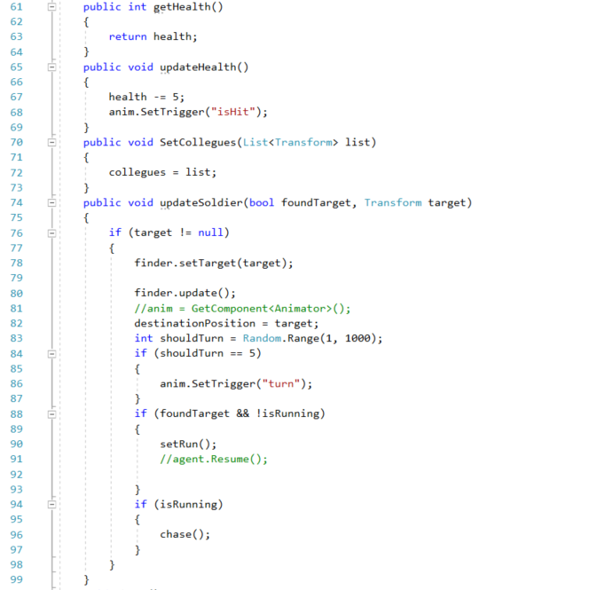

Figure 56 - Code snippet from the FSoldier.cs script

The script is not required through the development of the project, it will be implemented as an AI object script but will not be instantiated until the end of the project, with the completion of the aims and objectives, and it will be used to measure the progress obtained at the end of the development process. The animations in the game scene will be kept to a minimum and will be controlled by the “Soldier.cs” script through the development process. The script will provide basic animations for soldier attack, set the destination to the target and animation during a battle scene.

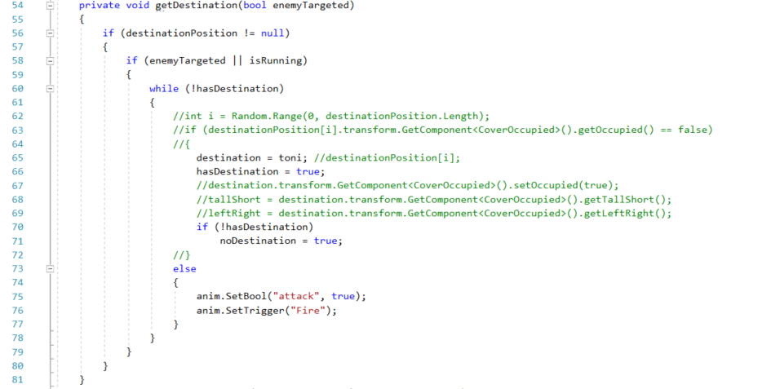

Figure 57 - Code snippet from the Soldier.cs script

## 1.2 Navigation

The pathfinding algorithm, implemented for the AI objects, is based on a grid, with a grid square, node having the value of 1 in the game world. The grid size is determined by the developer and it has a direct influence over the rendering process during runtime because all of the computations needed to determine the scene objects, cover locations, shortest path to the target and the target itself, through the ray-cast algorithm. The AI character is positioned in the centre of the grid and while it moves the grid moves along with it determining the rest of the scene and surrounding objects. There are two AI’s in the scene, and each one has its own grid.

A standard grid size for the development of the project would be 50 nodes long and 40 nodes wide with a size of the node of 0.5, to allow the best use of all the surfaces in a game scene, but it is highly taxing for the system resources. During the development of the project, a compromise will be made by reducing the size of the grid to improve the performance of the system and to reduce the number of grid nodes iterations of the A* algorithm. The compromise also comes with a shortfall that will be discussed later in the project.

The pathfinder algorithm is designed to iterate through the nodes, squares, of the grid several times until the shortest path, determined by the heuristics, is found. Vector3 Unity structures stand at the base of the A* Pathfinder algorithm.

A Vector3, in Unity, determines the 3D location and direction on a game scene and it is also used for common vector operations such as subtractions, multiplying, dividing and adding vectors by a number. The A* Pathfinder algorithm is based on a Vector3 method to determine the start position and the target position of the path.

The method takes the first node in the vicinity of the AI and facing towards the target determined by the Ray-Cast detection method, and iterates through the rest of the nodes, based on the Vector3 position and direction of the nodes. The initial node of the target will be called the start node and the last node of the path will be called the target node. Based on the position of the start node and the target node, the algorithm will loop several times, calculating the heuristics, and the shortest path found will be allocated to the AI with a Vector3 start point and a Vector3 target point. Any changes added to the scene after determining the path will lead to a new iteration for a new path towards the target location.

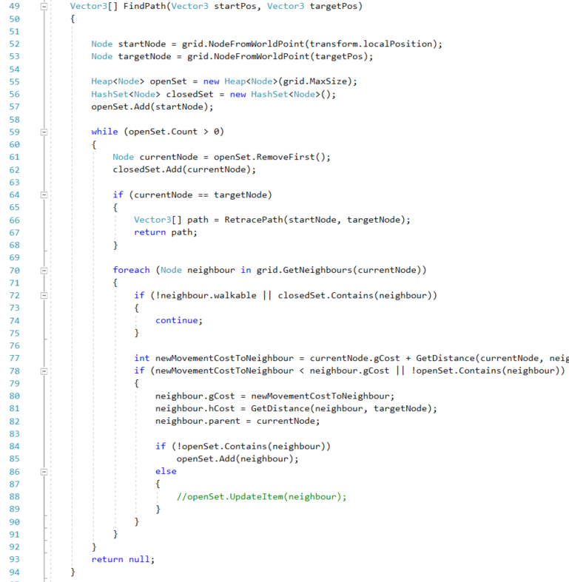

Figure 58 - A* Pathfinder method code snippet

## 1.3 Multithreading

C# scripts are written in Unity by using the MonoBehaviour API. The methodology provides a suit of classes, methods and datatypes used to build a bridge between the C# script files and the game engine itself. Without MonoBehaviour the scripts written in C# cannot interface with the Unity project.

In the MonoBehaviour approach, game objects are created, monobehaviours are attached to the game objects to accomplish a task. In the MonoBehaviour model, the processing and the data are coupled together being dependent on reference types. For example, in a game, a player can have a transform component, a Rigidbody component, collider and an animator component which are MonoBehaviour scripts attached to the game object with the purpose of accomplishing a task.

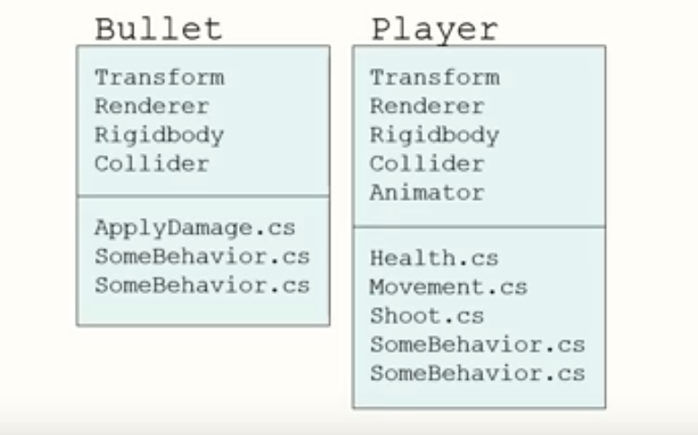

Figure 59 - MonoBehaviour approach for game objects

The are some problems with the classic MonoBehaviour implementation in the Unity game engine. The data is scattered everywhere, a game object is only a container that contains references to other memory locations that may have references at other memory locations at their end. When the CPU must work on a game object, the system must find the memory location of its components and put them in catches to be processed, action that can cause pointer misses and slow down the system. As an example, if a transform component needs to be moved from one memory location to another, along with the component, every data linked to the it has to be moved to another memory component reducing the overhaul speed of the system.

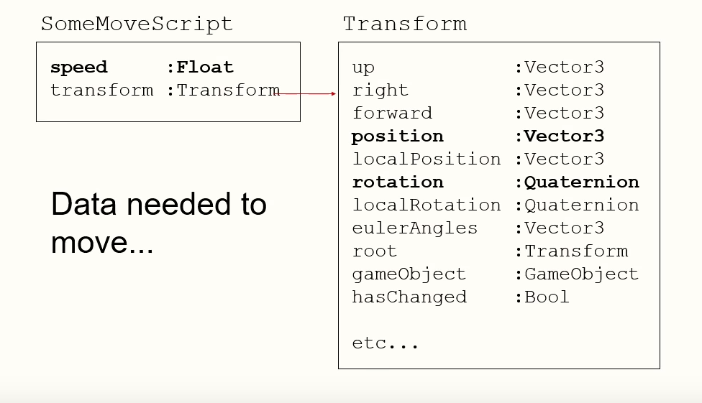

Figure 60 - Data linked to a Transform component

A second problem is that more data than needed is usually processed and attempting system optimisation, extra data becomes an impediment. The last issue of the MonoBehaviour approach is that it is not operating over more than one thread. The processes are completed sequentially, one at a time limiting the overhaul speed of the system to a minimum.(Geig, 2018)

Unity developed huge improvements in terms of performance and writing optimised, multithreaded code. At the centre of these changes stands the new Entity Component System (ECS). ECS allows the developer to write extremely performant code in a way that is easy to read and to reuse and with ECS we can take advantage of the new burst compiler for high performance C#. It provides an improvement in structuring data, a new methodology of writing code in C# moving from traditional object-oriented programming to a new implementation called data-oriented design.

### 1.3.1 Entity Component System

The Entity Components System is an improved approach towards game design, a code writing method focused on the behaviour and data problems in the game. It replaces game objects in the game, with all their components, with entities containing only the necessary data, improving the default performance of the game.

In ECS, an entity is used to control a collection of data that can be filtered for the collection by its components, without the interference of the developer. All the data is filtered in arrays and processed behind the scenes without the need for any reference types.

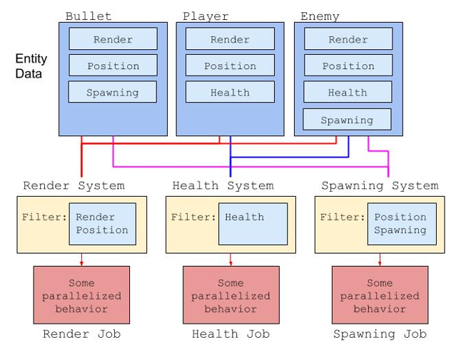

Figure 61 - ECS Jobs diagram

Unity has been based around game objects and monobehaviours. For example, to create a player, the developer would equip the player with MonoBehaviour components to develop functionality. The components would process rendering, physics and movements methods.

ECS takes a different approach splitting the game in three parts:

* Entities – group together components;
* Components – contain data, without any logic;
* Systems – define component-based behaviour A system is operating on every entity with a specific set of components. These are the only entities that contain any logic.

To develop a player, an entity would be created, and, on the entity, components would be placed with the sole attribute of storing data about the player without any functionality. For functionality, systems must be created. A render system can be created to render a component and a physic system to apply physics to all the entities with a physics component.

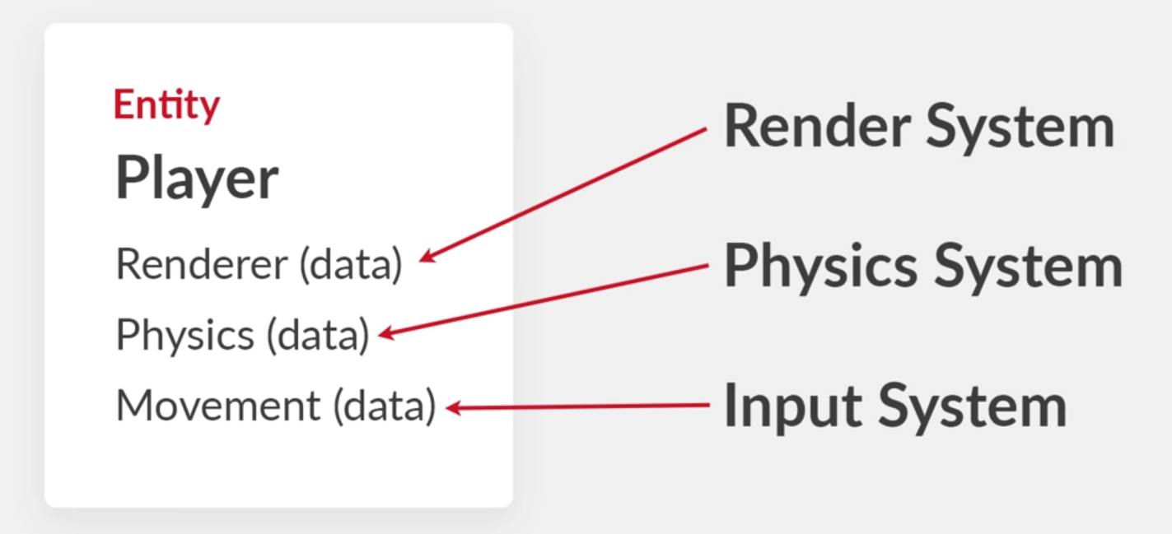

Figure 62 - Player development in ECS

#### 1.3.1.1 C# Job System

The C# Job System allows the development of multithread code, in a Unity software, that has a correct interaction with the rest of the components, components that determine how correct is the code written. The job system distributes the multithreading code by replacing the threads with jobs. High performances are the result of multithreaded coding, alongside significant increases in game frame rates, and code generation improvements can be added with the use of the Burst compiler that establishes and interface between the script and the components. It will also reduce the energy consumption while a device is running the software. The Job System is implemented for working threads development to a number that will not overflow the capacities of the CPU cores. The C# Job System is suitable for complex software where the result of one process is dependant of the completion of another, known as race condition. It detects all the possible race conditions and protects the functionality of any errors that may occur.

The overhaul functionality is based on sending copies for each thread that it operates rather than sending the reference of the memory location of the code into the main thread. The purpose of the data is to isolate the code to eliminate all the possible race conditions.(*Unity - Manual: C# Job System Overview*, 2018)

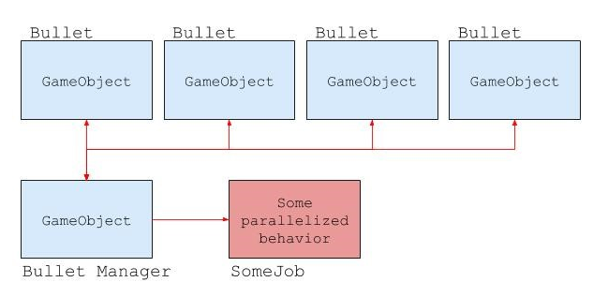

Figure 63 - C# Job System diagram

#### 1.3.1.2 Burst Compiler

The Burst compiler is directly influenced by the entity component system and represent a background performance achievement due to the data organisational efficiency of the ECS. The core functionality depends of the machine that runs the software, the burst compiler will organise code processing depending on the capabilities of the CPU.

A benefit of the Burst compiler is that it can provide an ahead-of-time (AOT) compilation of the functions based on the CPU running the software.

### 1.3.2 Hybrid ECS

The ECS approach is still in an experimental phase and a Hybrid ECS has been implemented as a transition from Standard Scripting to Pure ECS, which is a completely separate system from the standard coding method and where game objects and monobehaviours are no longer in use. The full performance benefits of Pure ECS will not be unlocked by using Hybrid ECS but it is a good way to start converting the scripts while still using MonoBehaviour components to store data.

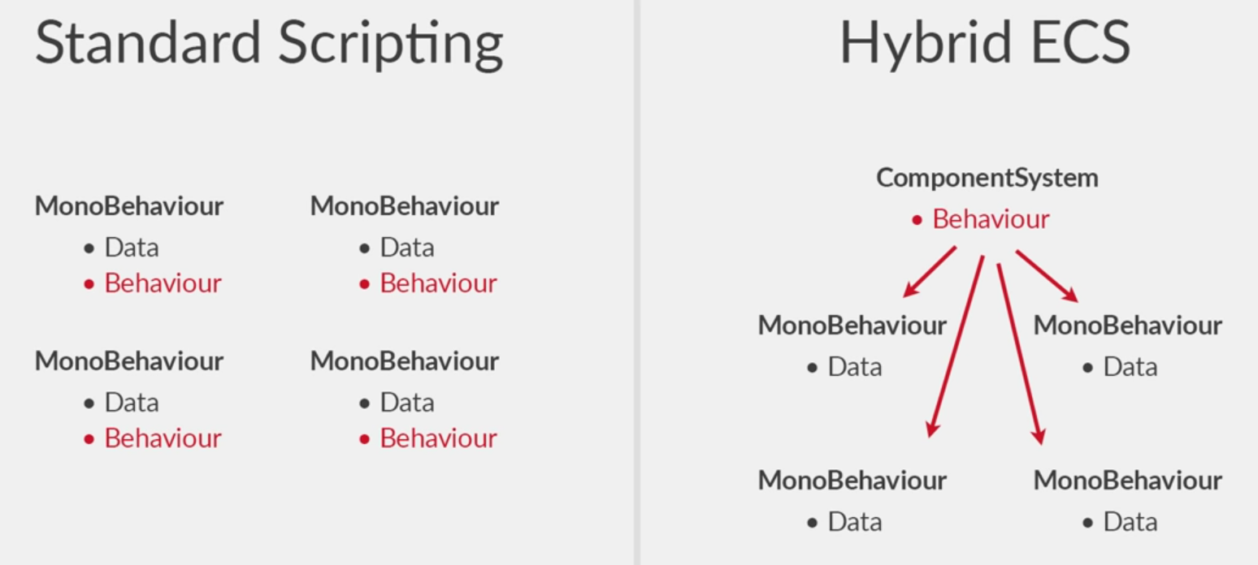

Figure 64 - Difference between standard scripting and Hybrid ECS

In standard scripting, every object has a scrip that contains data to handle the behaviour of the object, in Hybrid ECS there is a script which contains the data, but a component system is implemented to control the behaviour of the object.

The current multithreading approach, implemented for Patient Zero, is the Hybrid Entity Component System (ECS).

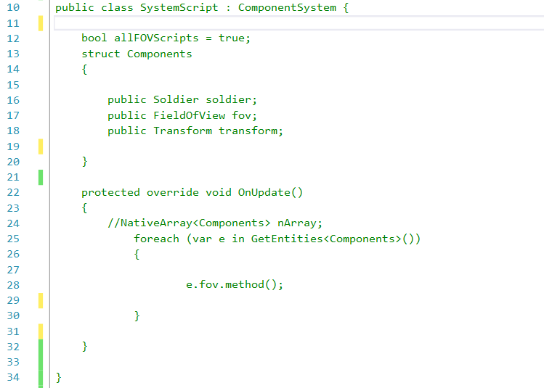

Figure 65 - Hybrid ECS implementation for Patient Zero

#### 1.3.2.1 Hybrid ECS Features

Features of the Hybrid ECS:

* Implements all the features of the Pure ECS;
* Includes special helper classes;
  + Converts Game Objects in Entities;
  + Converts MonoBehaviour in Components;
* More support for native Unity classes.

## 1.4 Current Scene

In the game scene, an Update () method is attached to every AI game object. Every frame update, for a specific game object, is driven by the function. It keeps track of every interaction between game objects, transform components position, animations and interactions in the game.

The Update () method is a common practice in Unity scripting, but increasing the complexity in a game software, the Update () method is completed, and determines the timing, of two supplementary update functions to keep track of the logic, animation and camera position in the game scene.

The FixedUpdate () function can be called several times per frame, determined by the frame rate produced by the software. The purpose of the method is to update all the physics calculations which occur instantly to function completion. A reliable method, separated from the frame rate of the software, by the implementation of an external timer independent from the system. The update of the method is driven by the Update () method, if the Update () method has an update sequence of 50 frames/second, the sequence of the FixedUpdate () method will be double, 100 frames/second.

The LateUpdate () function is generated a once per frame as soon as the Update () method has finished, when the LateUpdate () function begins, all the computations in the Update () method are completed. An example of LateUpdate () function is a third-person camera. If the movements of the character are calculated in the Update () method, all the physics calculations for the character can be performed in the LateUpdate () method to guarantee the movement of the character before the camera component will trail its position.(*Unity - Manual: Order of Execution for Event Functions*, 2017)

In the current system, to reduce computations, every Update () method, has been removed from the scripts of the AI game objects. To balance the modification, a game object has been added to the scene, and a script has been written with an update method and attached to the game object, where every AI object has been placed in an array in the script. At run-time, a loop iterates through the array, and for every AI object present in the script, an update method is called to perform calculations called for the game objects. The only issue is linked with the number of objects in the array. The array not being dynamic, if one AI agent would be removed at run-time, while the system iterates through the array, instead of returning the AI agents, the array would return a null pointer exception because the agent has been removed from its location without updating the array, and the location value of the array would be null.

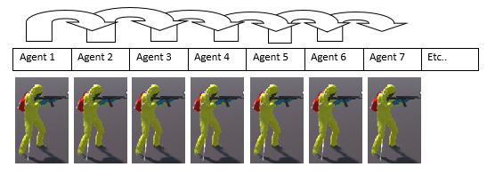

Figure 66 - Update () method in the initial system

The AI game object array is also used by the A* pathfinding algorithm. The A* algorithm produces thousands of ray-cast for, each AI object, to detect every obstacle in the scene, and more importantly, it will detect the edges of every static game object in the scene that can be used dynamically by the AI objects as cover locations on the path towards the target.

To allow detection for every static game object in the scene, the field of view, for every AI game object, is set for a range of 360 degrees, with the AI object centred in the middle of the field of view. By using the same script in the empty game object, the rest of the AI objects will be informed about the cover locations, determined by the field of view algorithm, and their availability, with the implementation of a Boolean value which will return true if the cover location is available or false if the cover location is occupied.

# 2. Initial Unity Profiler Measurements

Prior to the development of the project, the performances of the initial system have been measured with the Unity Profiler to serve as minimum performance marker while comparing different software configuration throughout the development of the project.

In the Unity Profiler, due to the continuous workload sustained by the CPU, measurements must be taken several times to assure the correctness and to determine an average of the measurements. Not every implementation, scripting, modification added, to a software developed in a game engine, has to be an improvement. Even after several positive measurements, drawbacks can be discovered, in the scripting, rendering or physics process, that can run in the background and have an impact over the overhaul functionality of the system.

To eliminate every possible drawback, several measurements will be issued while adding AI game objects, increasing the workload for the CPU, to view the impact over the functionality of the system.

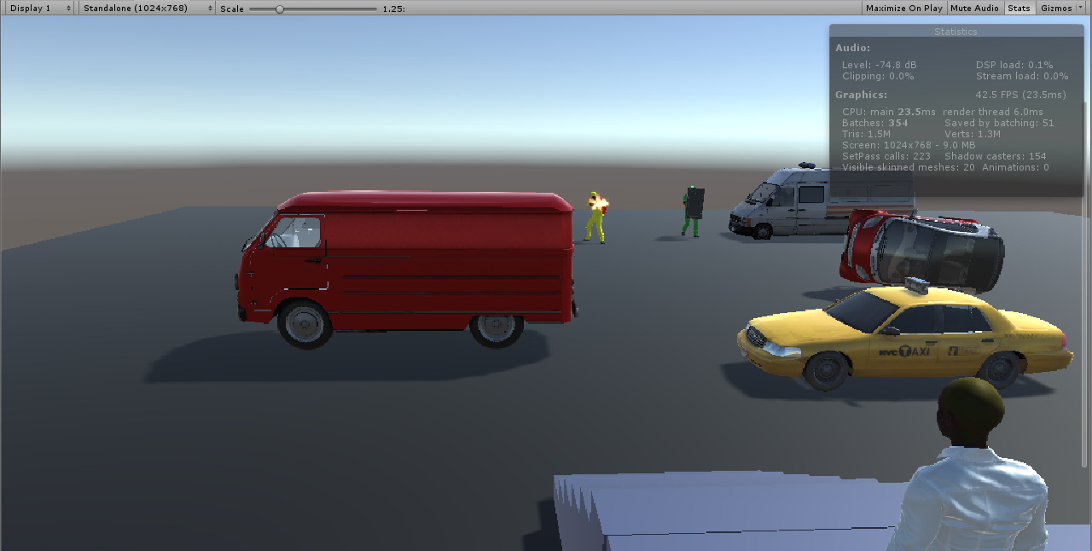

Figure 67 - Game View of the initial measurements

The baseline performance for project development, prior to hardware upgrade, for a game scene with three AI objects is approximately 42 FPS.

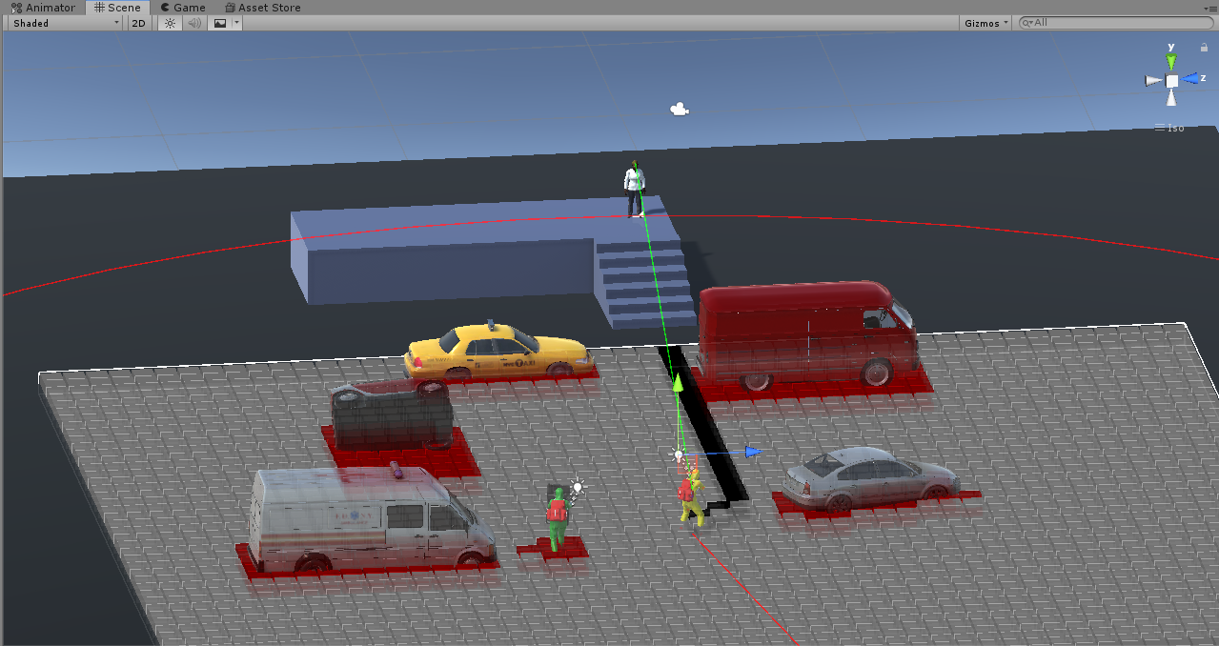

Figure 68 - Developer's view of the initial measurements

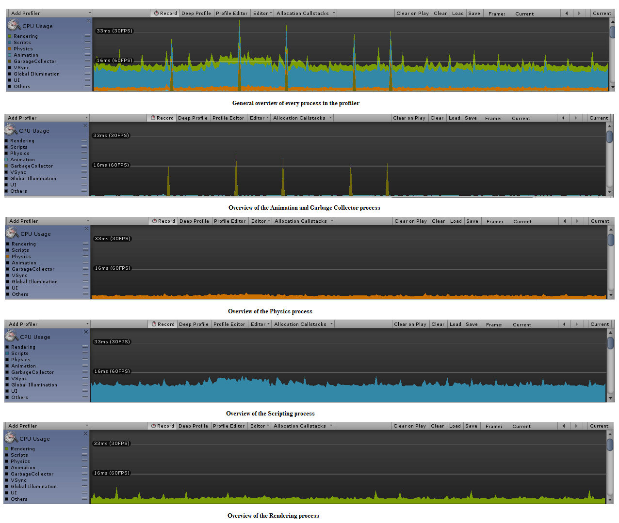

Figure 69 - Unity profiler overview for individual processes

The Unity profiler will provide insight about the resource allocation of the system towards the physics, animation and rendering process and the scripts workload. Considering the minimal scene, the animation process and the physics process are insignificant compared to the scripting process, but the data will change while increasing the complexity of the scene. The highest work overload is taken by the scripting process, while the pathfinder method iterates through a 50 x 40 grid, with a node radius of 0.5, to determine the shortest route to the target.

Three AI objects have been added in the scene, with their own grid to measure the overhaul changes in performance.

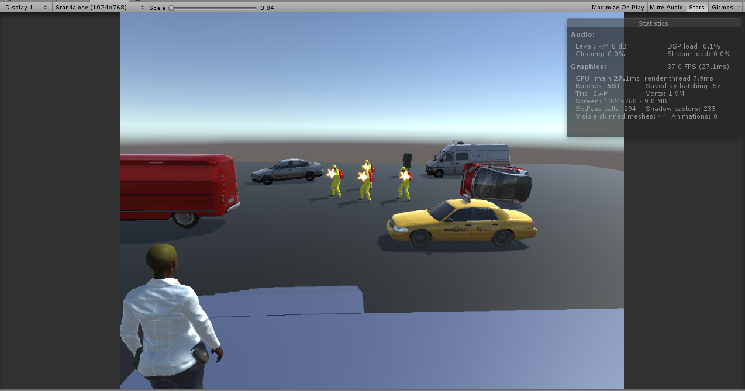

Figure 70 - Game view of a scene with four AI soldiers

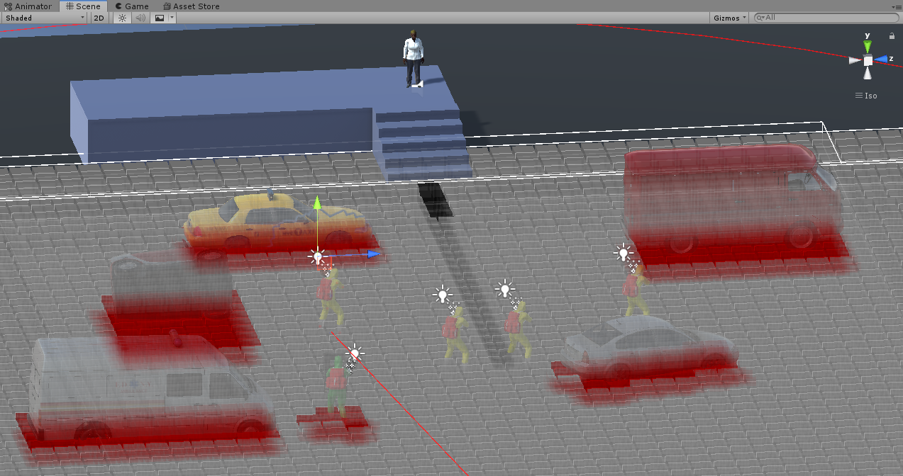

Figure 71 – Developer’s view of a scene with four AI soldiers

In a game scene with multiple AI soldier game objects, each AI soldier stands in the centre of its own grid and each AI agent casts approximately 800 ray-casts to determine the surrounding environment, including static game objects with cover locations and the target. The overhaul implementation has a performance drop of an average of 6 FPS. The performance drop is not significant, but in the implementation a drawback is present. The system will not allow all the AI soldiers to enable the A* pathfinder algorithm at the same time, instead it will allow the AI soldiers to complete the task consequently, as soon as one of the AI objects has reached his target, another agent will begin the process. The drawback must be resolved in the development of the project.

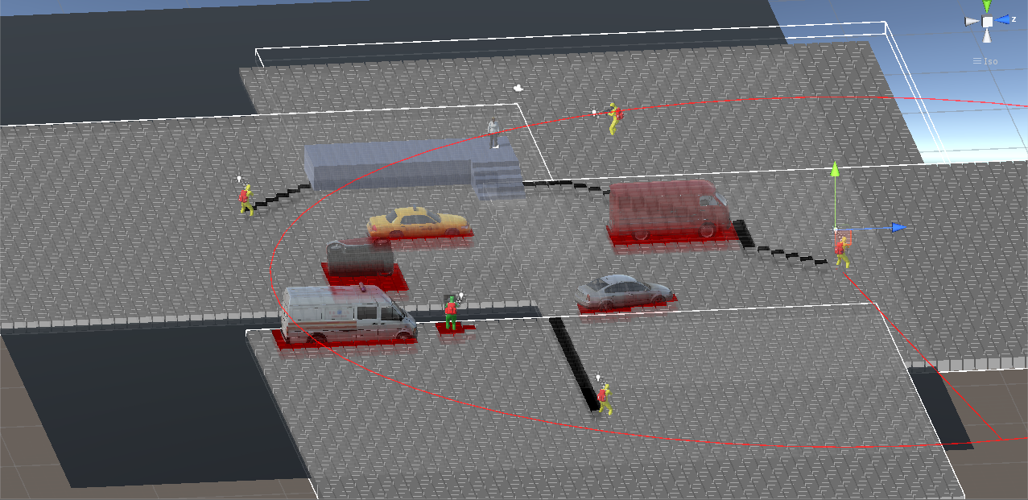

Figure 72 - Implementation drawback for four AI agents

In a scene with multiple AI agents, a visible increase in resource usage can be seen in the scripting process and the physics process.

The Unity Profiles gives an insight of all the individual threads from the main thread along with the completion time for each thread, a useful feature to determine resource consuming threads running in the background. Each background thread takes an overhaul of 1MB RAM for a cycle of 10 seconds and having multiple long-running background threads can have a negative impact on the system.(Nemirovsky and Tullsen, 2013)

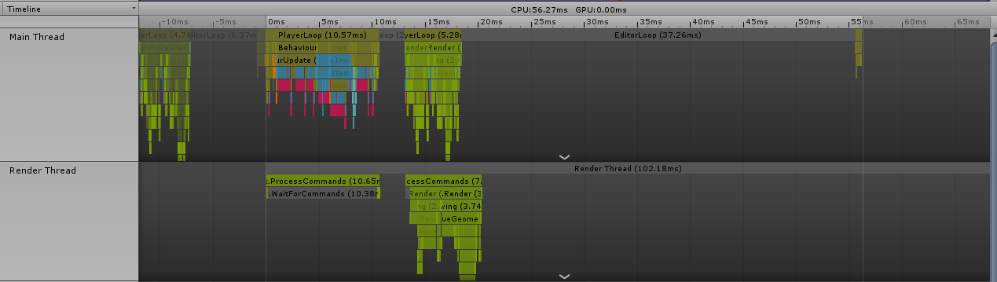

Figure 73 - Main thread view along with individual threads completion time

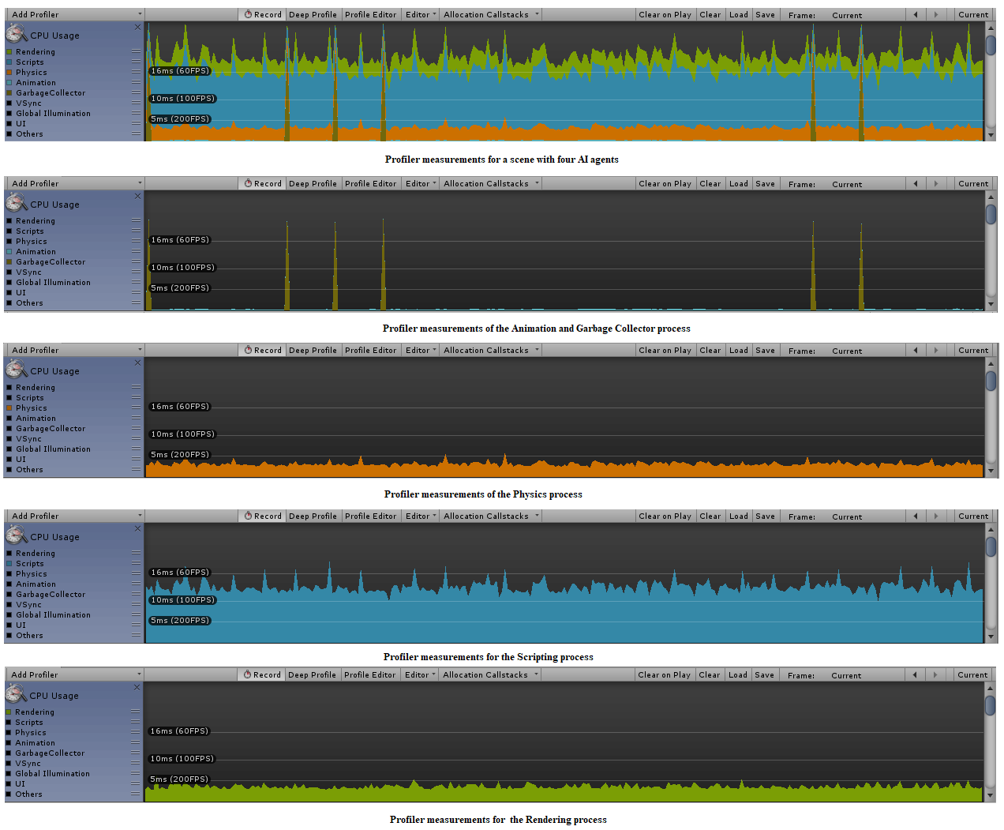

Figure 74 - Unity profiler measurement for a scene with five AI agents

The performance of a game is given by the precise measurement of the rendering process of the system, frames per second. At different scales, variations of FPS, result in different things. For example, a drop in FPS from 60 to 50 add 3.3 milliseconds to the additional time-completion of the process but a drop in FPS from 30 to 20 sum an extra of 16.6 milliseconds to the total completion time of the process, approximately 10 frames per second for each of the examples.

To achieve an understanding of how long it takes to render a single frame, a simple math equation can be used:

Time to render a frame = 1000 / (desired framerate)

According to the formula, if a game renders at 30FPS, a single frame will render in 33 milliseconds and if the game renders at 60FPS a single frame will render in half the time, 16 milliseconds. According to the results, if a game renders below 30FPS, at the end of the development process, it will be a major drawback for the release of the game.(*Diagnosing performance problems using the Profiler window - Unity*, 2019)

# Chapter 5 - Results

## 1. Development Shortcomings

### 1.1 Pathfinding

One of the aims of the project is to investigate the current A* pathfinding framework and propose an improvement of the current implementation. Unfortunately, there are several shortcomings of the A* algorithm implementations in the current project development.

The grid implemented, for the AI soldier agent in the scene, is a size of 50 nodes long by 40 nodes wide, with a node radius of 0.5, as stated above in the documentation. In a standard grid, the node size is 1, but to use the whole game scene effectively and to allow the AI to use the whole game scene, walkable paths, at the beginning of the project the node radius has been set to 0.5. While setting the radius of a node to 0.5, the size of the grid will remain the same but it will have a taxing effect on the resources of the CPU as it will double the calculation time to iterate through the grid in search for the optimal path, as the number of grid nodes with the standard size of 1 is 200 and the number of grid nodes for a size of 0,5 is 400.

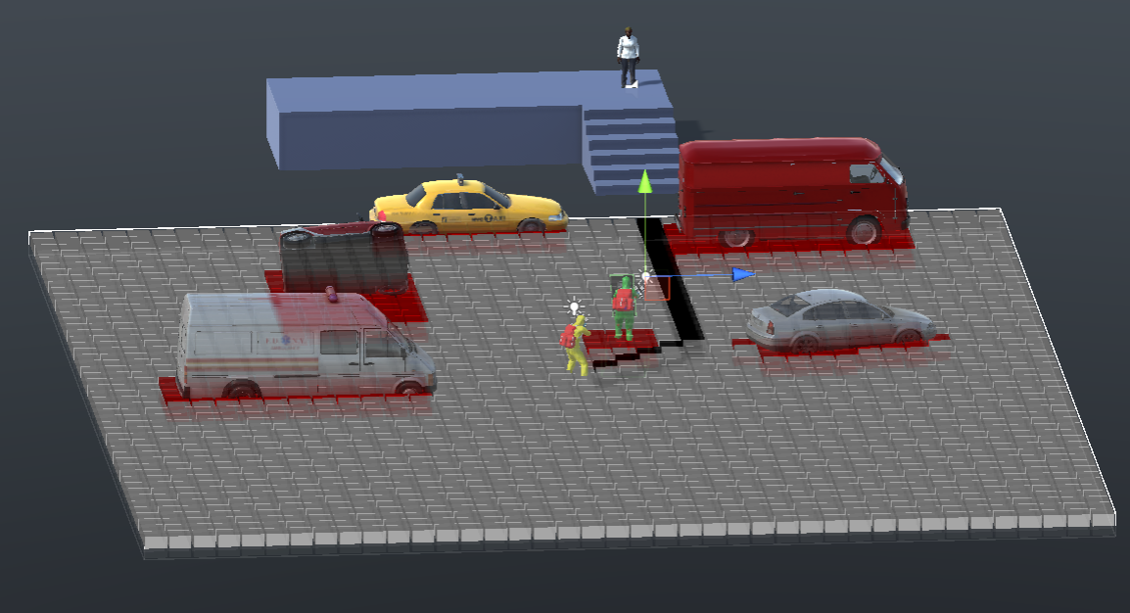

Figure 75 - 50x40 Nodes grid size with node radius of 0.5

The node radius of a grid determines the quality of the path towards the target. The whole scene becomes a smooth walkable area for the AI agent, the number of cover locations determined by the edge detection algorithm, with a node radius of 0.5, is far greater than the number of locations in a grid with a node radius of 1.

In an ideal game scene, the grid attached to the AI agent, would be the size of the whole scene, and the AI would determine at game start the configuration for the whole scene, but it would be highly taxing for the CPU, especially when adding extra AI agents in the scene, with a separate grid for every agent.

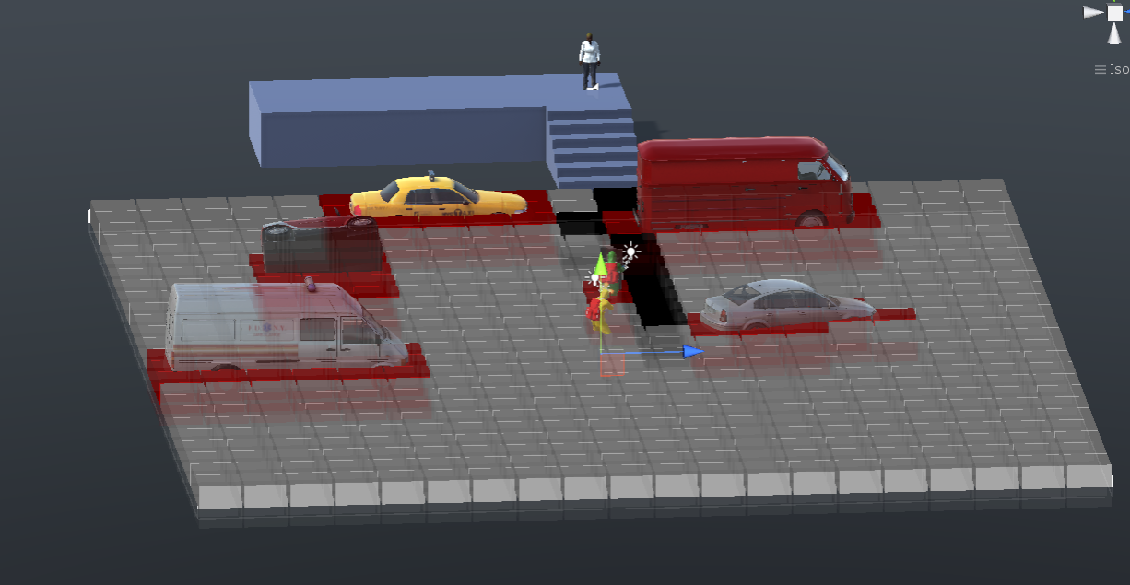

Figure 76 - 50x40 Node grid size with node radius of 1

The animation process of the AI agents, moving in the game scene, is highly improved on a grid with a node radius of 0.5, compared to the standard implementation. The grid determines narrow walkable areas giving the player the feel of a well build game scene, but unfortunately, while having the grid covering the entire surface of the game scene, is a highly taxing process reducing the rendering process of the system, for only one AI agent to 34.8 FPS.

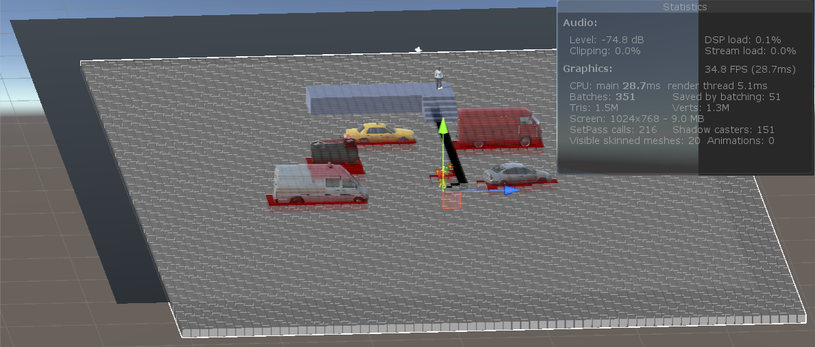Figure 77 - Rendering process measurement for a grid the size of the game scene

The size of the grid, not being implemented for the whole surface of the game scene, issues yet another shortfall. During regular testing done in the game scene an issue arises in connection to the size of the grid connected to the AI agent.

Once the target is in the ray-cast view of the AI soldier, automatically the A* Pathfinder will calculate the shortest path towards the target, around the existing game objects in the scene, until the last square of the grid. Once the last square of the node grid attached to the AI agent has been reached, the AI agent, will move on the path generated by the A* pathfinder algorithm, guided by the ray-cast enemy detection algorithm.

If, calculating the A* path towards the target, the last node of the grid is in the same area occupied by a static game object in the scene, the pathfinder algorithm will stop calculating the route, stating that there are no more nodes, in the grid, to calculate the rest of the path.

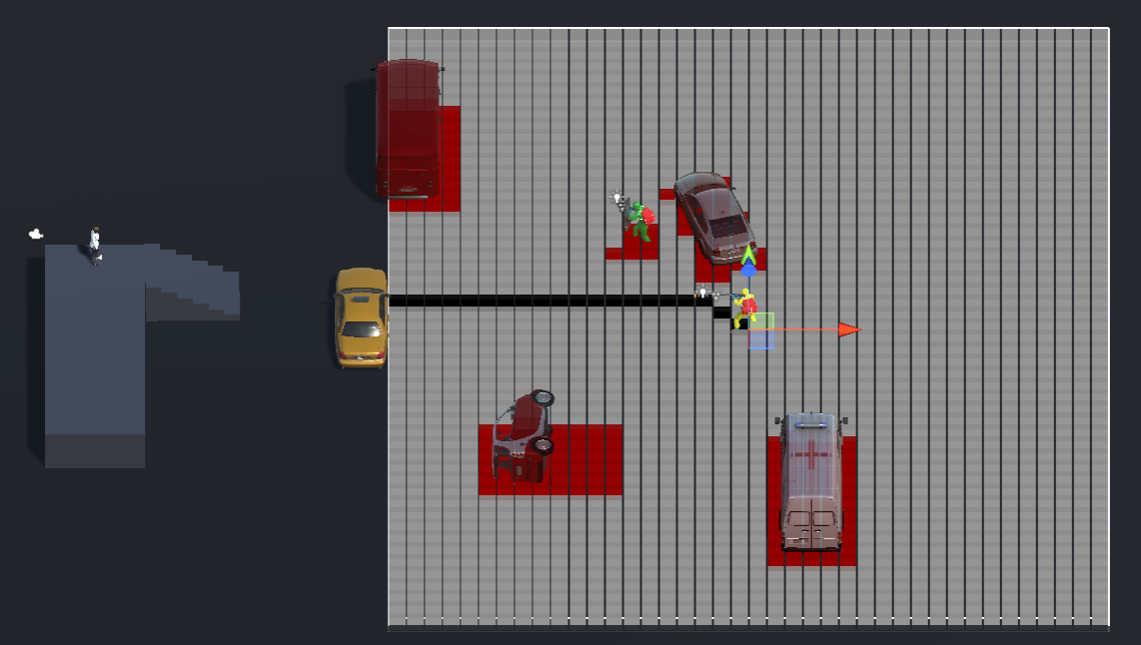

Figure 78 - A* Pathfinder route in a grid edged by a game object

Figure 78 displays the pathfinding route of the AI agent towards the target, with the grid in the exact vicinity of a static game object, which in our case is a vehicle taxi. The route is calculated instantly, as the shortest route to the target, and the AI agent will start moving in the direction of the target. The grid moves with the agent, in its path towards the target, but as soon as the last node of the grid, on which the path is generated, gets to a space occupied by a static game object, the pathfinder algorithm will stop calculating the route and the AI agent will stop, as presented in the following figure.

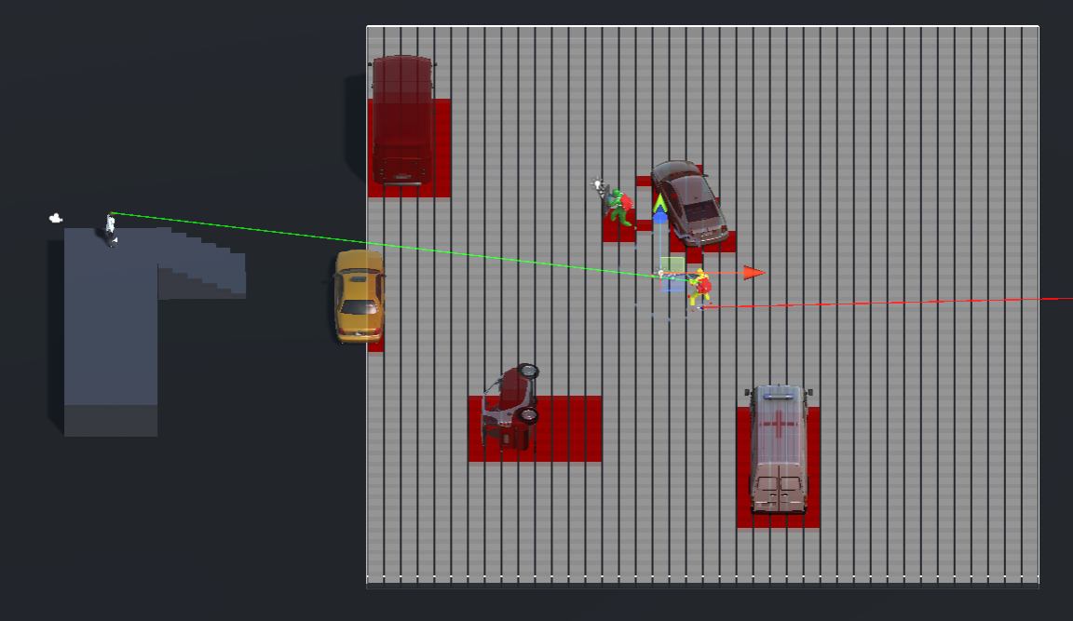Figure 79 - Error in the A* Pathfinding algorithm

The AI agent, through the ray-cast enemy detection method, is still aware of the existence of the target but due to the miscalculation in the A* pathfinding algorithm, in case of software developed in a game engine, it cannot follow a route towards the target because it is inexistent.

There is another issue linked to the size of the grid connected to the AI agent. Because the grid size does not cover the whole surface of the game engine, the ray-cast detection method must be triggered by the field of view method implemented in the scripts of the AI agent.

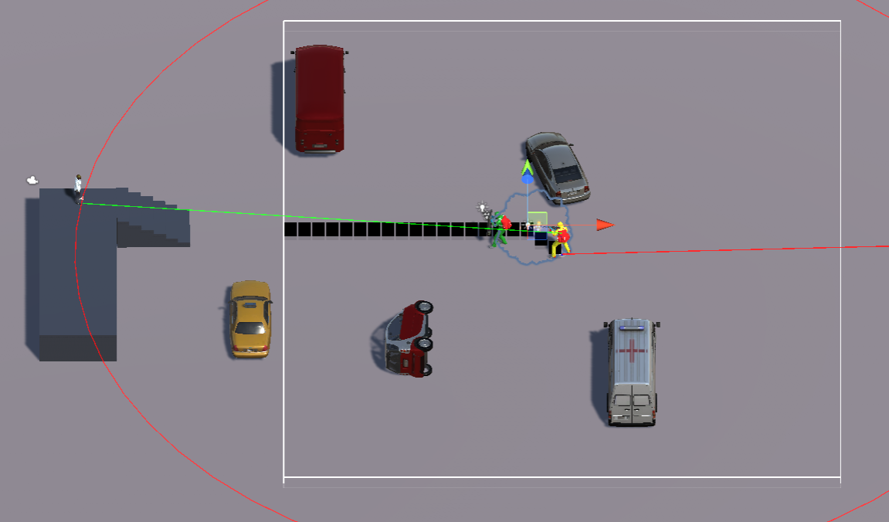

Figure 80 - A* path triggered by the target

The developers must assure that, on the start of the game, the field of view of the AI is wide enough to reach the target, to trigger the ray-cast enemy detection method. If the field of view of the AI agent does not reach the target to trigger the rest of the methods, the A* pathfinder algorithm will not determine a grid path towards the target and the AI agent will not move.

Figure 80 presents an example of the issue. The A* pathfinder is triggered by the contact of the enemy target with the edge of the AI agent field of view. The standard range, for the view of the AI agent, is 35 units. If, at the start of the game, the enemy target is situated at a higher distance than the view distance of the AI agent, than a path will not be calculated, and the game will be at a standstill. It will start but there will be no action present.

In the current game scene, the enemy target is positioned on a high-level game object, stairs. The stairs have been added in the scene to verify if the current game can support multistore levels. The implementations have been added before the beginning of the development project, to be treated as an objective if the development time will permit.

The problem faced, by adding high ground level in the scene, was to determine any possibility in which the A* pathfinder algorithm can generate a path to the target by climbing the stairs or prototype a solution that will allow the AI agent to reach the target.

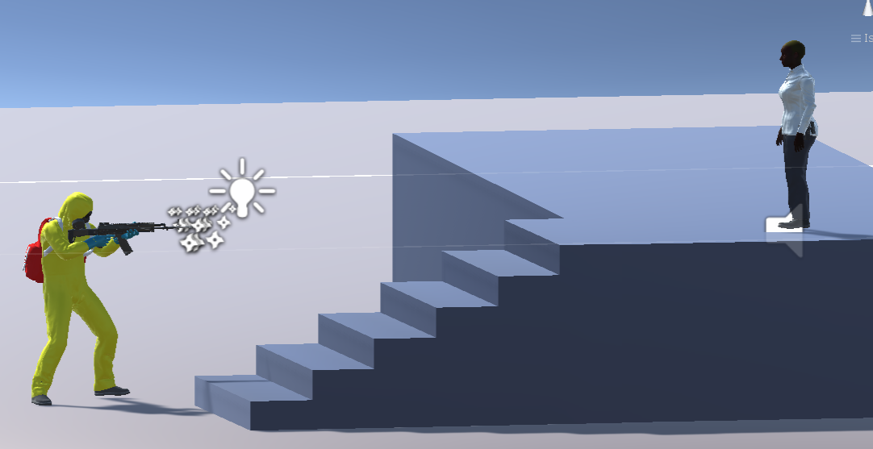

Figure 81 - High level ground problem

The basic formula in programming for climbing stairs, from bottom to top is:

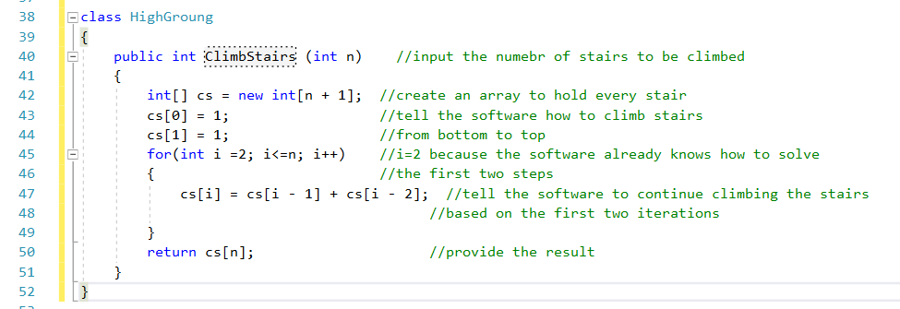

Figure 82 - General programming for climbing stairs

In general, the algorithm is simple, input the numbers of stairs to be climbed, tell the software the total number of stairs and state the method of work, in this case from bottom to top and one stair at a time. Based on the input provided, allow the software to continue the process similar to the input for the first two steps. The method is fully functional but to be suitable for a game scene further input must be provided.

The path of the AI agent leads to the position of the enemy target on the high ground, and not at the base of the stairs. In order to implement the ClimbStairs () method, the AI agent must be directed towards the base of the stairs. To resolve the situation, two empty game objects must be added to the stairs in the game scene. One at the bottom of the stairs, to tell the AI that it has reached the base of the stairs and must walk towards the game object assigned for the top of the stairs before the A* pathfinder algorithm can recreate a route to the target.

Not a complex implementation, but to be functional, a method must be determined to guide the AI agent to the bottom of the stairs and not to the position of the target on the high ground. An empty game object must be added to the AI agent, at the base, implemented with a ray-cast enemy detection method, once the target has been detected, the lower ray-cast method determines the existence of another game object that signals a high-level ground.

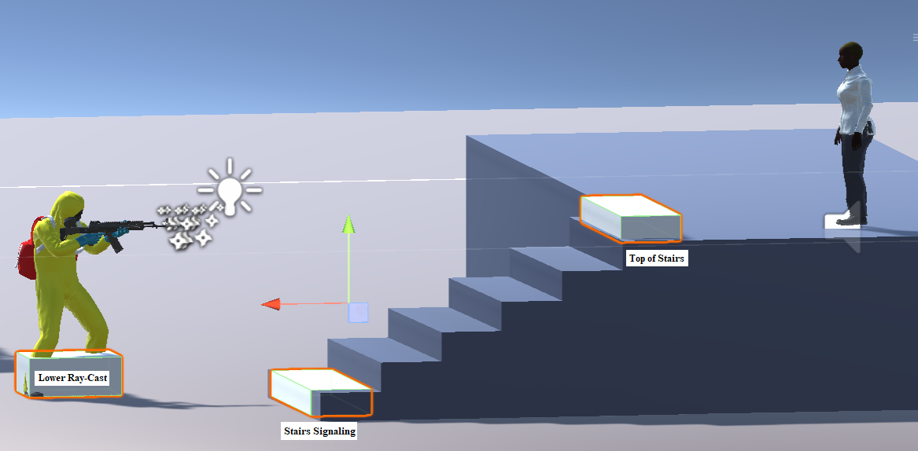

Figure 83 - Necessary game-object to determine an AI agent to climb stairs

If the object, signalling high-level ground, is spotted in the scene the AI agent will be guided to the bottom of the high-level ground where the ClimbStairs () method is called.

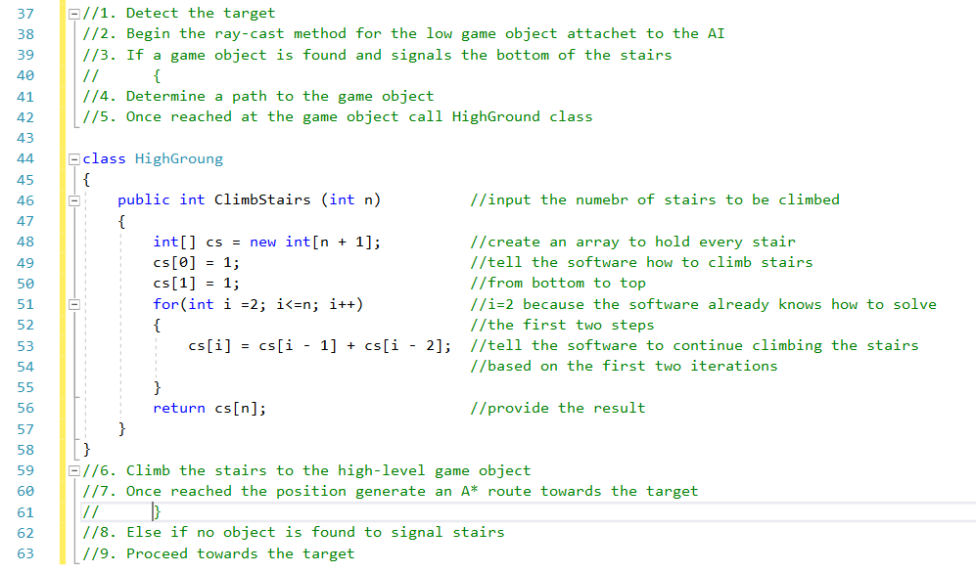

Figure 84 - General AI programming to reach a target situated on high-level ground

Functionality can be achieved, through the mild prototype presented, but several game objects and scripting files must be added to the game scene alongside a lower ray-cast enemy detection method which will be highly taxing for the resources of the system.

One of the objectives of the project is to make the game scene dynamic. At this point, the objects in the game scene are static except for the AI agents and the enemy target agent. If a game scene is dynamic, game objects can be thrown in the scene during run-time and the AI agents can be aware of the objects and put them to use on their behalf.

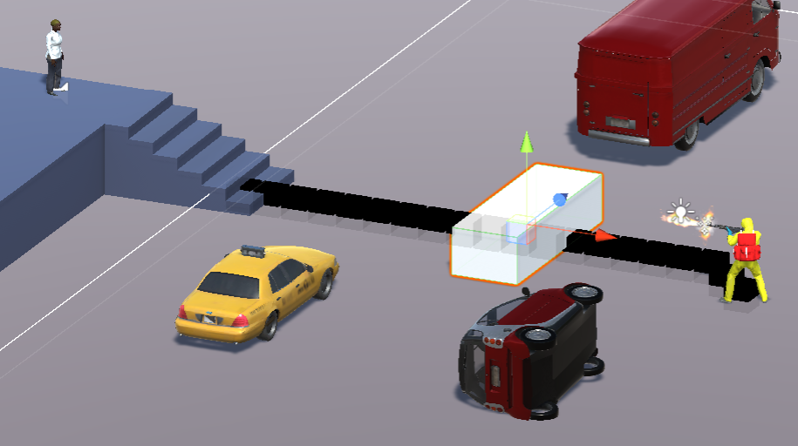

Figure 85 - Demonstrations of the game scene not being dynamic

In figure 85 a game object has been added to the scene, on the path of the AI agent. Because the scene is not dynamic, and the AI agents are not aware of the game objects added at run-time and will just pass through them during game play.

The A* Pathfinder is not native to Unity and has been created by external developers to serve as an option for the native Unity pathfinder, a basic algorithm called NavMesh.

Although, throughout the development process, the desire has been to work with the A* Pathfinder algorithm and improve its functionality, the number of problems encountered during game-play, along with the amount of work required to resolve them, have determined a final conclusion, which is to drop the A* Pathfinding algorithm, in the current development, and drive towards the NavMesh component, a native navigation feature of the Unity game engine which will be examined later in the project.

### 1.2 AI Agent Dynamic Cover Locations

The start of the development project has been set by the desire of developing a unique feature of the game, Patient Zero. The idea behind the development process would focus on developing a dynamic cover-based system that would upgrade the behaviour of the AI agents to simulate a real-life special-units application, where the AI agents have the possibility to find refuge, in the eventuality of a real-life gun-fire battle.

The objective is simple, every AI agent in the scene must discover and be aware of the game objects in the scene and make use of them by instantiating cover locations hidden from the view of the enemy target.

The implementation of the A* pathfinder method would reveal every game object in the game scene, with all the possible cover locations, as the AI agent advances towards the target. The first drawback is that the pathfinding algorithm, implemented for Patient Zero, can only detect game objects that have been pre-set before the game play.

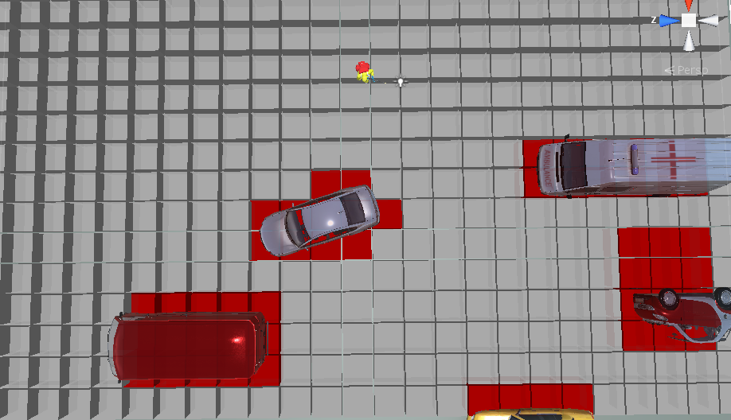

Figure 86 – Pre-set game objects detected by the A* pathfinding method

The AI object would not be aware of any game object added in the scene at run-time. The second drawback is that the pathfinding algorithm will detect every cover location around the entire game object, not only cover locations hidden from the view of the enemy target.

Considering the drawbacks of the A* algorithm in determining objects added at run-time and detection of possible cover locations, the only suitable implementation to be applied was a game object edge detection method that would be triggered by the field of view of the AI.

The field of view of the AI has a range from 0 to 360 degrees. The initial setup of the field of view has been for 360 degrees, to facilitate scene and enemy detection in the surroundings of the agent. Upon further analysis of the game action, the range has been set to 180 degrees, the game being designed to have the AI agent chase the enemy target, with a starting point behind the enemy and directed to the location of the enemy target.

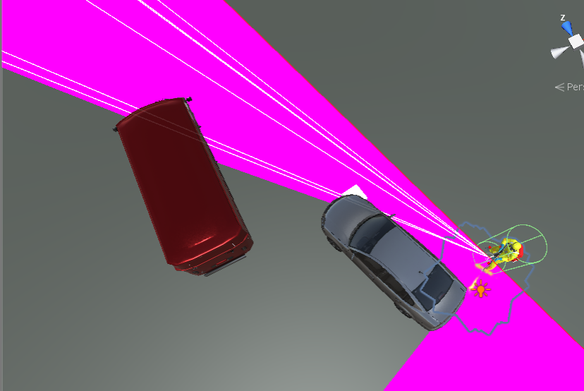

Figure 87 - Ray-cast thrown by the AI agent

In its path towards the enemy target, the AI agent throw ray-casts to determine objects in the scene and any possible cover locations.

#### 1.2.1 Ray-Cast

A ray-cast is defined by the process of throwing an invisible ray over a specified area and direction to determine the existence of any colliders in the path of the ray. The origin point of a ray-cast is a point in the world game, in our case the AI agent, defined by a Vector3. The direction of the ray is defined by a second Vector3, set by the limit of the field of view of the AI, and a variable will store the lengths of the ray, otherwise it will be infinite. Ray-casts are used for game objects and game characters detection and once a ray-cast has hit an object it will return the direction and the distance to target.

#### 1.2.2 Edge Detection

The edge detection algorithm, triggered by field of view of the AI is designed, at run-time, to cast approximately 800 rays in the game scene, cast that are limited only by the reach of the view. If the enemy is in the view of the AI agent, a ray-cast will pinpoint the location as the destination point and will trigger the pathfinding algorithm.

The edge detection method is based on two Vector3 variables, a minimum point and a maximum point, each attached to the first and the last ray-cast to be thrown by the AI agent. An angle variable is defined to determine the close vicinity of the two casts.

If the ray-casts do not return any information about objects in the designated angle, the process continues for the entire range of the field of view of the AI agent. When one of the ray-casts return a hit, a third ray will be casted in the between the minimum point and the maximum point, to determine the exact shape of the object hit, and the process will continue until the total range of the field of view will be covered.

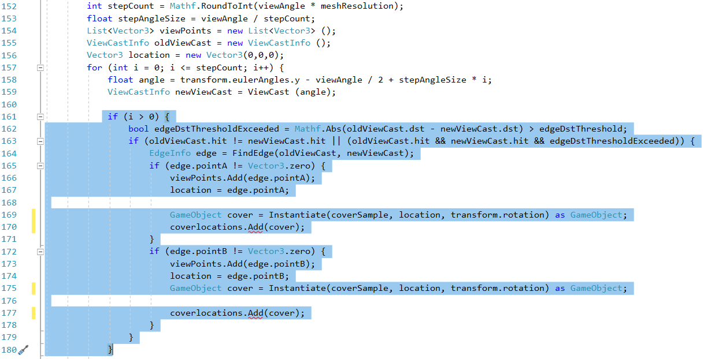Figure 88 - Code snipper to determine cover locations

The method updates every frame to insure real time detection of the game objects in the scene. The method is functional, cover locations are instantiated but at a far larger scale than needed.

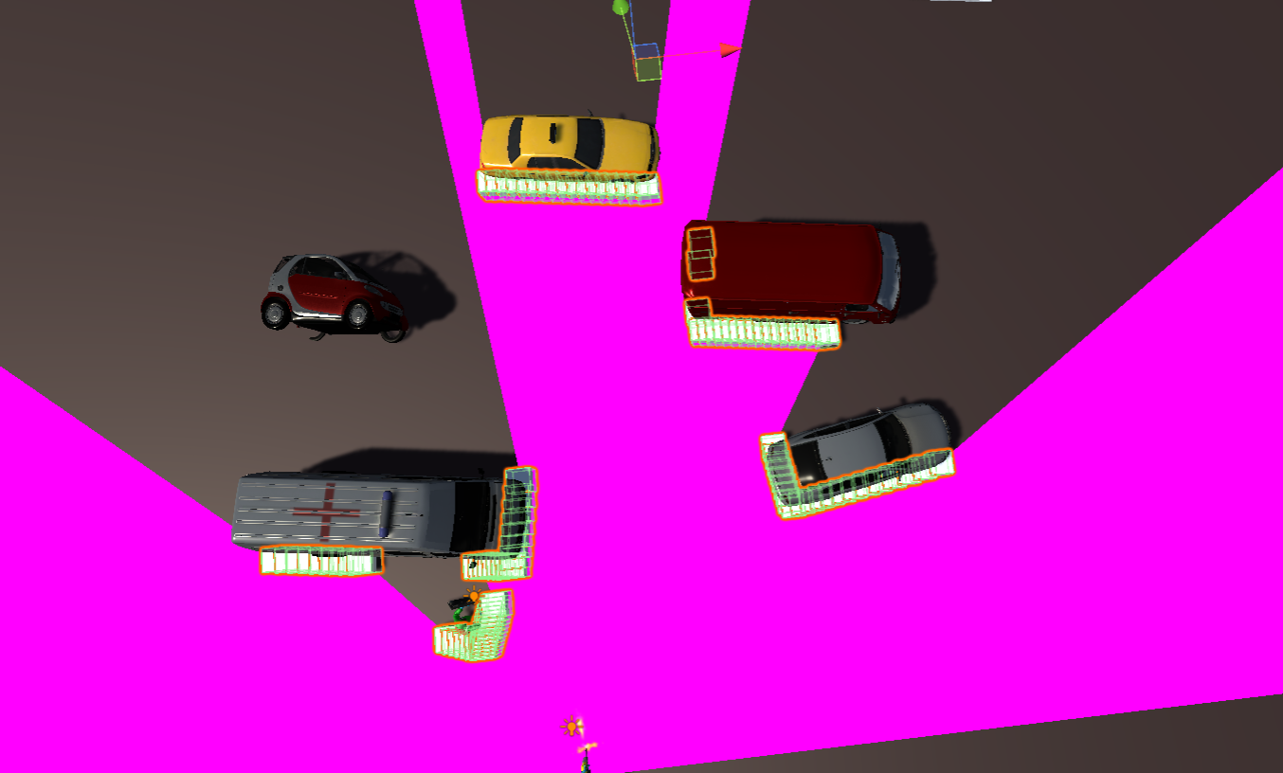Figure 89 - Top view of game scene cover locations

The method instantiates empty game objects in the scene around the static game objects. A high proportion of the cover locations are instantiated in suitable locations however a minority of cover locations cannot be used in game play by the AI agent.

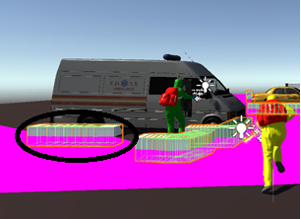

Figure 90 - Cover locations that cannot be used at run-time

The method also instantiates cover locations outside the area of the game scene, as the AI agent advances towards the target outside the reach and benefit of the AI agent.

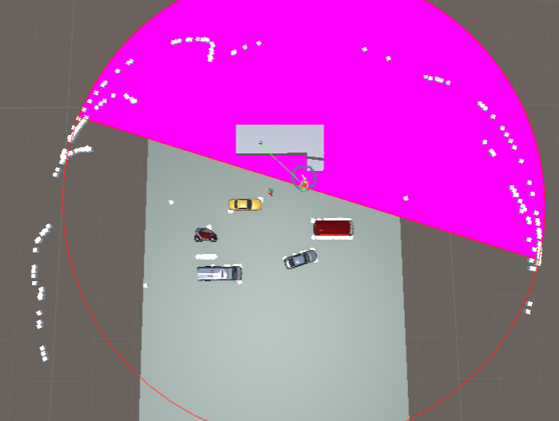

Figure 91 - Cover locations instantiated outside the game scene

Empty game objects instantiated as cover location outside the area of the game scene would not pose an issue for the rendering process of the system, but their number will do because the edge detection method will instantiate approximately 2000 cover location in the scene.



Figure 92 - Cover locations instantiated at run-time

The main issue with the number of the cover location is their Vector3 position, the algorithm instantiates cover locations on top of cover locations limiting their usage in the advantage of the AI agent.

The method must be revised to reduce significantly the number of cover locations and prototype a method to ease the interaction between the AI agent and the cover locations, instantiated by the edge detection algorithm, during run-time.

### 1.3 Threading

The third aim in the project refers to an attempt in tempering with the main thread. Specifically, to research and remove any possible functionalities attributed to the AI agent and develop a separated thread from the main thread, only to be called, for synchronisation, in the main thread.

The impediment of this aim stands in the design of the Unity engine, which is based on components, to be specific, transform components. Explained earlier in the project, a transform component is attribute by default to every game object in the scene to set its location in the game world.(*Unity - Manual: Transforms*, 2018) Because of the transform component, Unity will not allow access to any game object with a transform component, from any other location apart from the main thread.(*Thread Class (System.Threading) | Microsoft Docs*, 2018)

Any attempt to remove a game object from the main thread, in Unity, will return an error because Unity types are not thread safe and will through an exception at construction, and the compilation process will be stopped until the change has been reverted.

#### 1.3.1 Individual Threading Common Practices

When discussing removals of individual threads from the main threads, there are several aspects that must be considered:

* A common practice, in the Unity game engine, is to determine if a game object or a MonoBehaviour reference is null before trying to access its members. A function, myUnityObject == null retrieves an overloaded operator for anything that slopes from UnityEngine.Objects. A function implemented to combat this issues has been implemented, SystemObject.ReferenceEquals(), but it will only be functional, for this issue in a certain degree, for example when destroying an object in the scene, its reference will be equal to null by using the overload, but its reference in the SystemObject.ReferenceEquals() function cannot be set to null so the object can be called back when the game starts.
* Individual threading of rendering processes in Unity is regularly a safe procedure if the developer follows a disciplined procedure in what to modify, when and in what order to avoid inconsistency considering the main thread could modify the data while it is read for processing.
* Time static members and Random static members are not available, in Unity, for separated threads. For a separate thread, to create random instances and timing information, the developer must implement System.Radom and System.Diagnostic.Stopwatch for every thread.
* Mathematical functions, vectors, colour structures and matrix are available for separate computations across threads.
* Creating game objects, attaching monobehaviours, textures, meshes and materials are processes that must be done in the main thread.(*multithreading - How to not freeze the main thread in Unity? - Game Development Stack Exchange*, 2018)

In the .NET/ Mono framework separate threads can be created to run in the background for heavy computations or communicate with a native code plugin but not to interact with unity. Instantiations, at their end, are atomic operations that cannot be divided in small units and the must run until the process is finished and if the iteration is large there is no possibility to speed up the process.

A ground rule in multithreading is that any process based on a value type data is thread-safe because the process is based on a copy of the data. The majority of classes in Unity are divided in two parts, a native code part and a managed code part that increases the difficulty in developing thread safety. For example, all the mathematical computations, in Unity, are processed by the Mathf () function that is based on the System. Math Unity core module, a module that works with value types. Vector3, because it is a struct, it is a value type in Unity but the value of the Vector3 is determined by the instance of a transform, where a transform is based on a reference type. (*Threading in Unity - Unity Answers*, 2013)

In the .NET framework applications can be written to accomplish several tasks simultaneously. The process is suitable for separating operations that require a high amount of time to complete and the best option is to execute them in separate processes to eliminate the potential of delaying other processes. The response time for applications using multithreading is higher because the user interface can stay active while user input can be processed in different threads. Multithreading is considered driven towards scalable applications because separate threads can be instantiated while the complexity of the software increases.(*Using threads and threading | Microsoft Docs*, 2018)

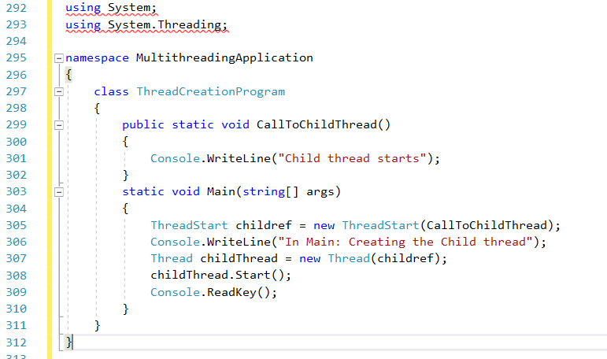

Figure 93 – Example of creating Threads

The multithreading implementation requires attention in programming when queuing execution requests, work coordination of multiple threads and handling block threads. However, multithreading issues new problems for developers such as race conditions and deadlocks. A deadlock is the result of a thread trying to lock resources already locked by another thread. A deadlock is a definition of the moment when both of the threads stop making any progress. The race condition issue, explained earlier in the project, is a programming bug that arises when the result of a program is dependant of two or more threads and which of the thread reaches a certain block of code first. Race conditions can be easily avoided by using Interlocked class methods, methods used to establish data synchronisation between multiple threads.

#### 1.3.2 Multithreading General Guidelines

General guidelines have been put in place for multithreading development:

* Thread. Abort is a function used to terminate the process of a thread. It is not suitable to use it while working with multi threads as the function will throw an exception without establishing the exact processing point reached by the thread.
* Synchronisation between activities in multiple threads cannot be done with the function implemented for single threading, Thread. Suspend and Thread.Resume, because the developer cannot keep track of the number of processes, and order, at run-time. Functions as Mutex, Monitor and AutoResetEvent are suitable to use in synchronising activities of multiple threads in C#.
* A good practice is not to control working threads from the main thread. The working threads must be designed to wait until a task is available, process the task and notify the main thread when the process has finished.
* Functions are implemented in C# to allow the possibility to lock a thread until another thread finishes the process. The developer must assure while using these functions, such as Mutex and Monitor to lock or monitor a thread, that the threads are unlocked upon finishing their tasks.
* If a process require the usage of different resources the best practice is to use multiple threads but for processes that use a single resource the best approach is single threading. (*Managed Threading Best Practices | Microsoft Docs*, 2014)

#### 1.3.4 Coroutines

Coroutines are functions, similar to threads, developed to write asynchronous code in C#. Coroutines are a general control structure where the operational flow control is passed among two different routines without returning anything until the end of the process. A coroutine has its own line of execution, variables and pointers but shares variables with other coroutines. The major difference between multithreading and coroutines is that multithreading is designed to run in parallel on several threads and coroutines are collaborative, meaning that at a certain point a program is running only one of its coroutines and it only suspends its execution when it requests to be suspended.(*terminology - What is a coroutine? - Stack Overflow*, 2016)

In a multicore system, at a certain time only one coroutine is running while multiple threads can run in parallel. The behaviour of a coroutine is simple, it develops operations based on the iterations of an iterator block.

#### 1.3.5 Thread Safe Architecture

Programming languages are designed to develop stable applications, intelligent features allow the compiler to determine any errors in advance and compiler performant code in a short period of time, but the concept of separate and individual threads has not been incorporated well in the design of programming languages. There are no high-level concepts regarding threads and the developer is responsible to start, stop and allow calls of threads from different methods, calls that can lead to unpredictable results. Threads can be easily introduced by beginner programmers, but thread errors can be very difficult to find.

##### 1.3.5.1 Architecture

There are several concepts to address thread safety:

* Critical Sections;
  + Critical sections stand for code that will allow an individual thread to process only once per object synchronisations, while other threads with the same target are stopped until the first thread has left the critical section. This process is usually done with lock statements;
    - Advantages:
      * Critical sections protect objects from multiple simultaneous modifications and stop several threads operating on the same data;
    - Disadvantages:
      * It is a difficult task to find all locations in the code that need a critical section;
      * Critical sections in large numbers can lead to deadlocks, a situation that cannot be predicted;
      * Calling critical sections multiple times leads to performance penalties;
    - Guidelines;
      * Attention in object referencing;
      * Use critical sections in conceptual clear situations;
* Thread Bound Objects;
  + Thread bound objects is the result of a single thread working on multiple objects, the objects and the thread are connected together similar to a single thread sub-application, where in case of multiple sub-applications, the message exchange is done through queues instead of method calling. A Microsoft application, .NET WinForms is implementing this concept to allow data access on its own threads to be accessed by foreign threads;
  + Communication between threads bound objects:
    - To send data from a thread connected to an object A, to be received by another thread connected to an object B, the first thread must write the data in a separate queue to be read by the second thread;
    - When a method is called, by a thread, from another thread attached to a separated object, the first method must input all the parameters into a queue that is only read by the second thread and implement a block until the second thread creates a return value;
      * Advantages:
        + The architecture determines parallel, clean operating modules;
        + By design, data corruption and deadlocks can be avoided;
      * Disadvantages;
        + The architecture must be clearly defined at the beginning of the project;
        + Queues and classes interface must be performed manually;
        + It is still possible to call methods directly when there are no references to other thread objects;
* Parallel Computing;
  + A new feature has been introduced for the development tool, Visual Studio 2010, for thread safety, a Task” library with debugging and parallel LINQ support. All the aspects of thread safety have been introduced in the library but the developer, Microsoft, explains that a better integration and messaging between threads is mandatory on top of the library, for an improved thread communication;
  + New programming languages, such as Maestro, are proposed by Microsoft to improve integration and inter-thread messaging.(Forster, 2009)

#### 1.3.6 Threading in Unity

In Unity, as in the dependant programming platform C#, multithreading is a type of programming that takes advantage of your CPU capacity to process many threads at the same time across multiple cores. A thread is a context that holds all the information needed by the CPU to execute a single set of instructions. Traditionally, applications run all of the code on one thread called the main thread but with multithreading you can write applications and execute multiple sets of instructions concurrently or at the same time.

Multithreading is a key ingredient in improving the performance of the game code by splitting a CPU’s intensive operation into multiple processes that can all run at the same time. The developer can dramatically reduce how long an operation takes to execute. This results in massive improvements to loading times, frame rates and battery life.(*Infallible Code • What no amount of unit tests can achieve*, 2018)

Multithreaded code is really complicated, it's easy to let the thread count get out of control which can cause frequent context switching. Context switching is a procedure that the CPU follows to change from one task to another. This happens automatically and plays an important role in computer’s ability to multitask. Context switching is highly taxing because they have to store the state or context of the running task, so it doesn't conflict with the one being changed, to give a possibility to the CPU to resume it on a later stage. The time it takes to do this can happen quickly especially when the number of available threads approaches or exceeds the number of available cores. Another thing to avoid when writing multithreaded code is race conditions explained earlier in the project. A race condition is a situation where your code is differently depending on the order in which it executes. A developer can start a thread at any point but there is no method to determine their process-completion time in relation to one another. This can result in unpredictable errors which are difficult to debug. The process is highly difficult when two or more threats share and modify the same data. An example is a room with multiple light switches that affect the same light bulb. If multiple people enter the room and randomly toggle light switches throughout the day, it is difficult to predict weather the light will be on or off at any given moment. On top of these examples there are plenty of other factors that make writing multithreaded code a complex and difficult task.(Albahari, 2011)

In Unity, multithreading cannot be counted as a solution for every performance issue. A method to execute large and difficult tasks in the background would have been the perfect answer to performance increase, but in real-life applications, complication arise with multithreading implementation. In the Unity software, multithreading is present to run the physics engine on a separate thread, reason why the FixedUpdate () method is part of the scripting methodology.(Kristin, 2014)

#### 1.3.7 Common Functions for Multithreading

Considering the complexity and difficulty of writing multithreading code, in Unity and C#, and considering the borders and drawbacks named above in this chapter, further research was mandatory to determine the most common methods used in multithreaded code to be tested later in the project.

A common function in attempting multithreaded processes, developed by Unity, was the use of coroutines hopping forth and back between a foreground thread , of the main loop, and a background thread.

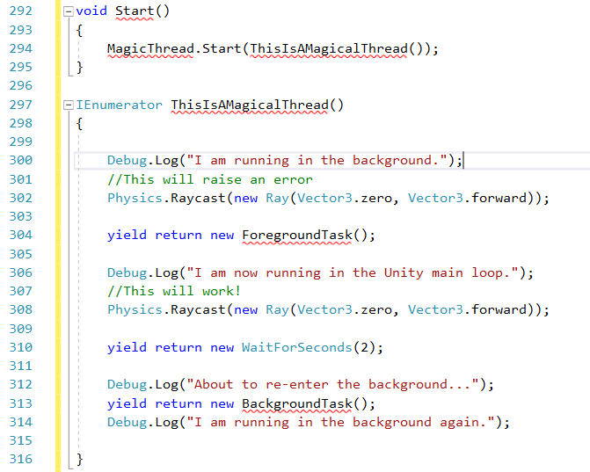

Figure 94 - MagicThread coroutine example

The method, MagicThread () was used initially to create a separate thread for the ray casting task, processed by the physics engine, before updated all calculations of the Physic engine on a separate thread.(Wittber, 2012)

Another shortcut for multithreaded processes is using a call back argument for a newly created thread. This applies only while the main thread is driven by a User Interface (UI). Non-UI threads can be created to handle heavy computations and completion, the thread triggers a call back method referencing the user interface instead of calling itself, process that would trigger an exception in the Unity compiler. Technically the non-UI thread would delegate the result straight to the UI instead of the main thread.(Yamanyar, 2015)

C# methods such as Matrix () and Monitor () are currently standard implementations in multithreading, highly used to date, where through a thread lock function, threads can be locked and monitored to the point that is safe to further continue their data processing. The drawback for the methods is that the developer must insure perfect timing in locking and unlocking the threads.(*lock statement - C# Reference | Microsoft Docs*, 2018)

The final method to be tested for individual multithreading is an Environment Process Count. Basically, the method iterates through the hardware of the current device to determine the number of logical processors and in theory it can schedule threads for different logical processors.(*GetLogicalProcessorInformation function (sysinfoapi.h) | Microsoft Docs*, 2018)

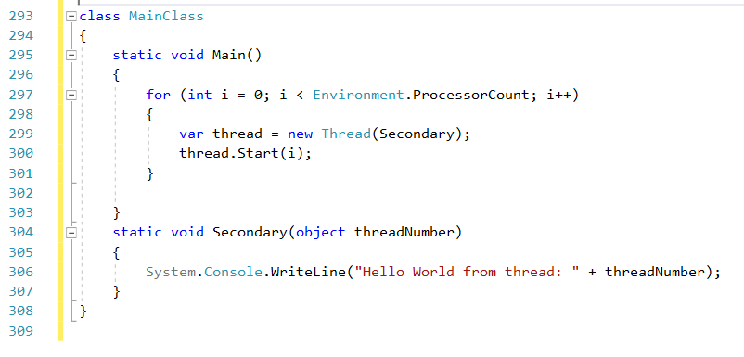

Figure 95 - Logical processor number count, and assigning a thread, example

The solutions will be tested towards the end of the development process.

## 2. Unity’s NavMesh

Due to the constrains of the initial navigation system, A* Pathfinder, and to be precise, the node grid on which the A* pathfinding algorithm is based, the current scene will be upgraded to Unity’s native navigation system, the NavMesh. Post implementation tests will be carried out to determine the rendering performance, capability and the results will be compared to the initial measurements of the A* Pathfinding algorithm.

The native navigation system in Unity allows developers to create AI agents than can move in the game scene using a navigation mesh determined by the geometry of the scene. Obstacle allow agent path alteration at run-time for example jumping from an edge or opening a gate.(*Unity - Manual: Navigation and Pathfinding*, 2018)

Unity’s navigation system, NavMesh, evolves the understanding of the AI agent towards the surrounding environment, for example it teaches the agents that in order to get to the first-floor stairs must be climbed.

The structure of the navigation system in Unity is as follows:

* NavMesh – the structure of the data describing the walkable surface of the game scene and determines the path between one walkable surface to another and it is baked at run-time based on the geometry of the level;
* NavMesh agent – Unity component that allow character development where each character will avoid each other while walking towards a target. Their design also implements obstacle avoidance;
* Off-Mesh Link – Unity components used in design to incorporate pathfinding shortcuts that cannot be represented in the game scene as a walkable surface. An example, for an off-mesh link, is the invisible connection between two different game surfaces implemented for the transit of the AI agent while animated as performing a jump;
* NavMesh Obstacle – Unity components that describe the non-static obstacles the AI agents have to avoid in their path towards the target.(*Unity - Manual: Navigation System in Unity*, 2018)

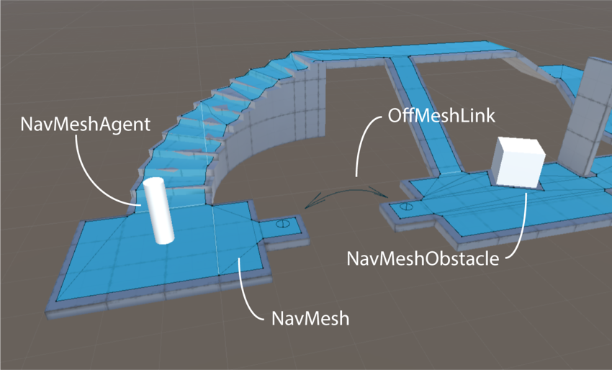

Figure 96 - Native navigation system in unity

### 2.1 NavMesh Functionality

To determine an intelligent path using Unity’s NavMesh, two problems must be resolved:

* Determine the level of the game scene to find the destination;
* Determine a path to move to the destination.

The problems are connected but very different, determining the game scene and the destination is a static problem and moving towards the destination is a local and dynamic problem only considering the direction and the path while avoiding obstacles.

The NavMesh is based on data to determine paths and walkable areas in the game scene. The walkable areas represent locations in the game scene where the agent can move and stand. Every walkable area is connected as a whole surface based on the geometry of the scene, which is called a mesh. The surface of the NavMesh is constructed in polygons, used for scene representation and to store information about the location of any polygon in vicinity to the rest, information that will stand as the base for pathfinding towards the target.

When determining a path towards the target the software will map the polygons which are closest towards the start position and the destination position. Based on the information, a polygon iteration will determine the shortest route beginning from the start position and moving through every polygon in the vicinity until it reaches the destination position. The A* Pathfinding algorithm is at the base of the Unity’s navigation system, but the iteration is based on polygons with a considerable size compared to the grid nodes initially used in the system.

The path determined by the NavMesh, based on the A* pathfinding algorithm is a corridor constructed on a sequence of polygons. The AI agent advances through the corridor moving towards the next visible corner of the nearby corridor. While dealing with one AI agent the path will be constructed based on the line segments connecting the corridors but in case of multiple AI agents the path must be deviated from the original to avoid the collision of the agents in their path.

While moving the agent, the NavMesh navigation system, considers a velocity variable to determine a smooth and natural movement of the AI agent towards its target. With the standard steering and obstacle avoidance method and having movement velocity implemented the movement animation of the AI agent is automatically constrained to the surface of the NavMesh.

The Unity’s NavMesh provides two method of pathfinding, global and local pathfinding. The difference between the two navigation methods is determined by the quantity of resources used while running the algorithm. Global navigation determines a path in the game world, covering the entire game scene, determining the start position, destination position and obstacles to be avoided. The process requires a large amount of memory resources and processing power. Local navigation can be easily adjusted with the movement of the AI agent due to the simple construction of polygons upon which the navigation determines an efficient movement to the corner of the neighbour polygon avoiding collision with any existing AI agent.

In NavMesh, obstacles are differentiated by their purpose. A game scene can contain static objects, objects added at run-time, character objects and AI agent objects. Object handling can be done using local obstacle avoidance and global pathfinding. While a game object is moving, for example an AI agent, the best way to handle the obstacle is using local avoidance, where the size and exact location of the game objects is calculated according to the surface of the container polygons. The method is suitable to prevent and avoid collisions. When a game object is static it is considered an obstacle for the AI agents by the navigation system, and it will affect global navigation or the navigation mesh. Carving is the procedure of modifying the navigation mesh. Carving detects what part of the static game object interacts with the navigation mesh and carves an area in the navigation mesh around the game object, a taxing operation determining another reason to focus more on handling game objects by using local avoidance.

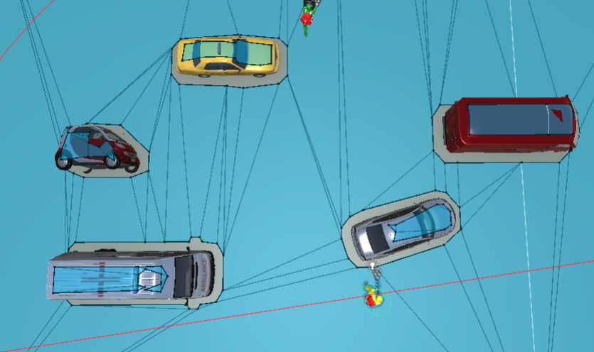

Figure 97 - Carving around static game objects on the navigation mesh

In any game navigation system, with walkable areas, it is important to develop solutions that can allow an AI agent the possibility of navigating between two walkable areas by crossing over a non-walkable area. The solutions enhance the AI agent’s awareness of links established to reach a certain destination. For example, crossing from one room to another by opening a door. In the NavMesh navigation system these solutions are called Off-Mesh Links. Technically, the solutions, allow the AI agent to cross from a game scene to another.(*Unity - Manual: Inner Workings of the Navigation System*, 2018)

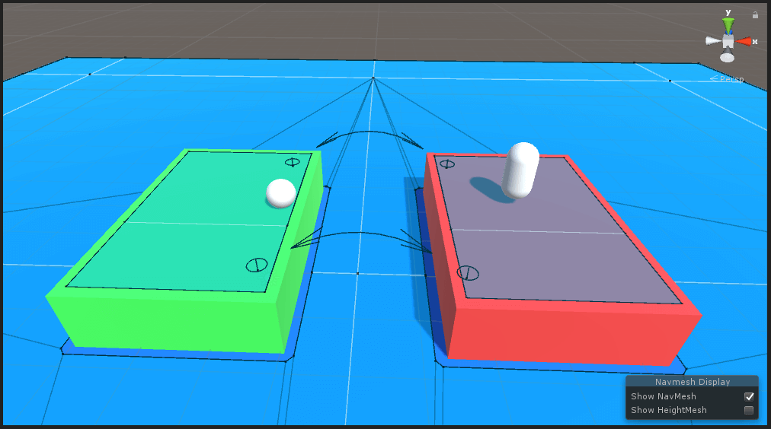

Figure 98 - Off-Mesh Links example

Off-Mesh links by design can be increased and decreased in size to suit the needs of the developer.

### 2.2 Building a NavMesh

The process of creating a navigation mesh, from the geometry of the game scene, is called NavMesh baking. The process collects render meshes from every game object in the scene, determining the static game objects, and processes a navigation surface which approximates every walkable surface of the game scene. The surface generated by the NavMesh is contracted, compared to the total size of the walkable areas in the scene. The process is done for a better interpretation of the efficiency of the game at run-time and allows the developer to compare the size of the navigation area with the size of the AI agent to remove any issue that can rise from the radius of the agent and the size of the walkable areas. (*Unity - Manual: Building a NavMesh*, 2018)

Any scene in Unity game engine can be implemented with a navigation mesh in four steps:

* Select the geometry of the scene where navigation will be implemented, together with obstacles and walkable surfaces;
* Select Static Navigation in the menu to include every static game object in the scene;
* Adjust bake navigation settings to match the radius and size of the AI agent;
  + Radius – determines the maximum distance from the centre of the AI agent to a static game object;
  + Height – determines the height of the objects that an AI agent can reach;
  + Slope – determines the steepness of the ramp an AI agent can climb;
  + Step Height – defines the step height that an agent can perform;
* Bake the NavMesh.

NavMesh provides components with additional control for building high-level navigation surfaces.

Four high-level components can be implemented in developing a NavMesh:

* NavMesh Surface – determines a navigation mesh for any type of game character;
* NavMesh Modifier – tempers with generating a navigation mesh specific to a game area based on a hierarchy. Baking a navigation mesh for a lake area in the game scene centred in the middle of a terrain is an example, as the NavMesh Modifier can establish the boundaries and velocity of the two surfaces;
* NavMesh Volume Modifier – determines modifications on a navigation mesh baked to cover an area based on volume;
* NavMesh Link – used to connect different type of surfaces for AI agents;

The drawback of the NavMesh, seen to this point in the project is that, the complete and updated navigation component is available starting with Unity5 version, but with the limitations. In Unity5 the navigation system will lay the components in the scene, such as an Off-Mesh Link, without the guidance of the developer, while higher versions of Unity allow the use of the navigation system according to the needs of the developer. External web sources facilitate individual download of the NavMesh component but only fully functional with higher versions than Unity5.

For the current project, the basic navigation mesh provided by Unity will be implemented, the initial A* Pathfinding algorithm will be used for the NavMesh, disregarding the initial grid. Post implementation measurement will be taken with Unity’s Profiler and presented in the following chapter. If time will permit, at the end of the project, the current Unity version will be upgraded, to a higher version of Unity, to take advantage of the full potential of the navigation mesh system. Measurements will be taken and presented in the project.

## 3. Cover-Based System

While working with cover locations, the code generates game objects at every position the ray cast has hit, generating game objects at the corners of the game objects. Unfortunately, the instantiation also generates game objects at locations that are not the edges of game objects, are rather the middle of the game object. This should not pose a problem if the game object is low in height determining a legitimate cover position.

The first problem was the game object would instantiate game objects on top of game objects, not realising that the location is already occupied by another game object, generating thousands of cubes. As a solution to the problems the use of dictionaries was mandatory.

### 3.1. Dictionary

In C#, a Dictionary class is a generic collection of keys and values pair of data. In C#, a generic class, System.Collections.Generic, defines a Dictionary class capable of storing any data type in the form of values and value keys. Each key must be unique in a collection.

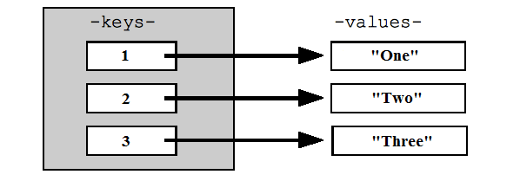

Figure 99 - Overview of a Dictionary class

In a dictionary, a value can be null, but the key should never be null because it uses a key value relation without using an index and the values are not continuously stored in memory. The purpose of the key in a dictionary is to reference the location of every value stored without setting a first or a last position. To get the index of a value in a dictionary a loop must iterate through all the elements in a dictionary. The number of items in a dictionary is given by the total number of keys/value pairs in a dictionary.(*C# Dictionary Example*, 2019)

Game objects instantiated in the scene as cover locations are added to the dictionary with their x, z coordinates of the game objects as the key. A loop will iterate through the dictionary to check if the key already exists in the dictionary. If the loop returns true, the systems assumes that a game object has already been set in the dictionary as a cover location, if it returns false the system assumes that the object does not exist in the dictionary and will instantiate a new game object and a new key, with the x and z coordinates, in the dictionary.

The only drawback is the float value type used for the size measurements of the game objects and location. Because it is a float value and not a whole number such as an integer, instead of returning a single game object for a single location, the algorithm will return over ten times the number of the desired cover locations. For example, number 1 is an integer but the float value for number 1 can begin at 1.0 or 1.1 and while integer 1 is a single value, float 1 can be at least ten times bigger than the integer starting at 1.0 and ending at 1.9. While the number of game objects is still high, the AI agent cannot use the cover locations in its advantage.

Further development must be directed towards reducing the number of cover locations in the scene and to attempt an algorithm to develop a dynamic cover-based system for the AI agent.

Research has been conducted to find a similar algorithm implementation, in Unity and other game engines such as Unreal Engine, Game Maker and Cry Engine. The purpose of the research was to view the functionality, if any, and attempt developing an algorithm different than the existing ones. The research is designed to be used in the project as a guide, the aim of the project is to attempt to develop a unique feature to be used in the expansion of the game Patient Zero. In the result of the research, assets of the Unity engine can be named such as “Cover + Shooting System – 3rd Person Shooter” and “Third Person Cover Shooter Template v1.6.2”, found on the Unity asset store.

The result of the research has determined the existence of dynamic cover-based systems, implemented in games, available for purchase on game engine asset stores, but designed to serve a 1st person shooters. Technically, the player benefits from the implementation of the algorithm and not the AI agent. The algorithm is simple, the player character can be animated to perform an action, for example hide, crouch, jump, actions determined by the surrounding environment, based on the directional input of the player. The proposed algorithm for Patient Zero is designed to serve the AI without any user input, as a stand-alone feature.

Further development will be discussed in the following chapter.

# Chapter 6 – Discussions

## 1. Results from NavMesh Implementation

The implementation view for Unity’s NavMesh is viewed from a developer’s point of view in the following figure.

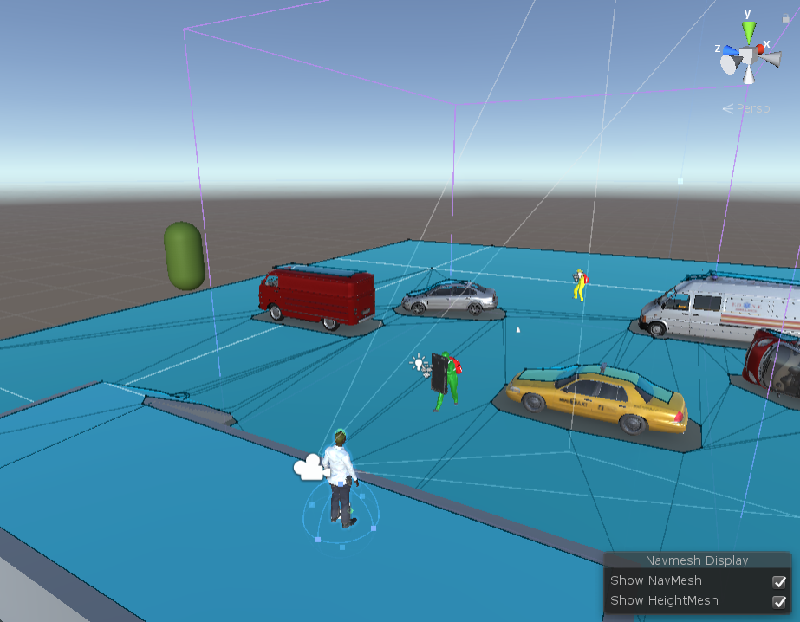

Figure 100 - NavMesh view

With the NavMesh implementation, every game object has been detected before the game has entered run-time mode by baking the current scene. Every walkable surface is highlighted with the presence of blue coloured polygons while the non-walkable surfaces have been carved from the surface of the NavMesh. The game characters on the scene are positioned on the surface of the NavMesh, their position is not carved as the characters are instantiated, in the software, as game objects designed to get to a destination on the game scene.

When instantiating game objects as cover locations, the carving process will serve as a proximity limit between the cover locations and the static game objects allowing the AI agents to stand at a suitable distance from an object on the scene while in a cover position. It will also deny the edge detection algorithm to determine and position cover locations in the middle of the static objects or any other location in the carved area of the NavMesh, where the locations cannot be of any use to the AI agent.

The first thing to be considered, in the NavMesh implementation, is that the surface generated by the navigation system covers the entire game area. The original A* pathfinder will determine the path in the current navigation system due to the advanced development of game and the amount of work required to modify the navigation scripts for game characters.

The drawback encountered in the original A* pathfinder grid was the connection between the game scene and the high-level ground game object and the amount of programming to be conducted to drive the AI agent to follow the path towards the target. The NavMesh has eliminated this drawback by connecting the surface of the high-level ground game object with the rest of the navigation surface eliminating the need for further programming to guide the agents towards upper levels.

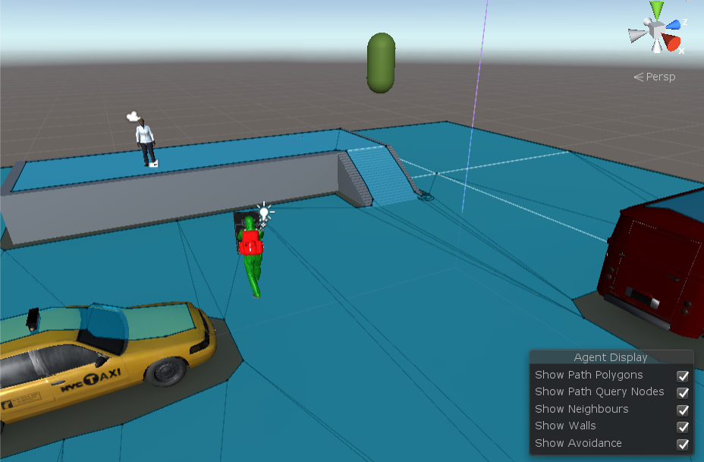

Figure 101 - Navigation surface baked on high -level ground

With the NavMesh, the AI agent also has access to walkable surfaces with simple implementations of Off-Mesh Links, for example the top side of the static game objects, denied by the initial implementation of the navigation system. The procedure is to add Off-Mesh Links to the game scene, to behave as a bridge connecting two walkable surfaces.

The NavMesh navigation system is not bound by the ray-cast enemy detection algorithm. Because the AI agent and the enemy target are on the same navigation surface, with a primitive algorithm, the AI agent can determine a path to the target without the field of view of the agent triggering the ray-cast enemy detection method, which at its end will trigger the A* pathfinder algorithm.

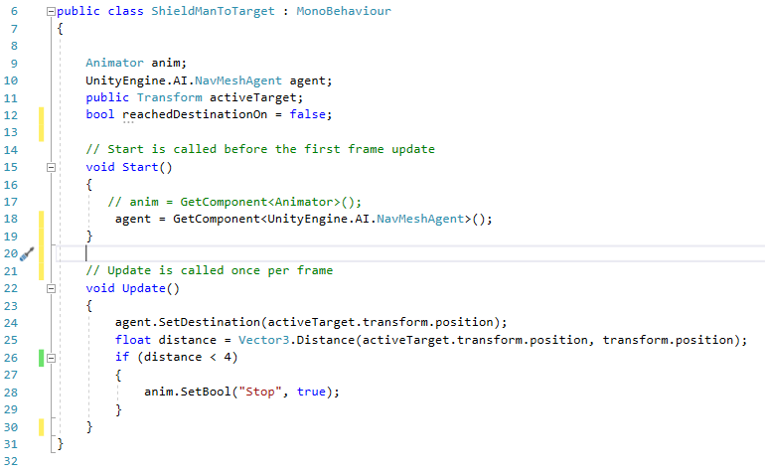

Figure 102 - Code snippet to determine the path of the Shield agent on a NavMesh

The focus of the project is to develop a human-like behaviour for the AI agent. To achieve the behaviour, previously implemented methods such as field of view and ray cast enemy detection will be implemented further in the development process. The previous system functionality will be maintained, the only difference is the functionality of the A* pathfinding algorithm based on a NavMesh system.

After the NavMesh implementation, a capsule 3D game object has been added to the scene high above the surface level. The 3D object is driven by the physics properties implemented in the game scene, and at run-time gravity will act upon the capsule dragging it down on the level surface. The purpose of the capsule is to verify if the navigation system implemented is dynamic. The capsule will fall in the game scene, on the path of an AI agent towards its target.

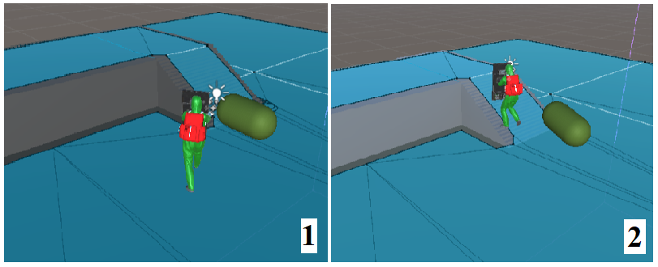

Figure 103 - Shield soldier walking towards the target

With the NavMesh implementation the shortfalls of the initial pathfinding algorithm have been removed, the current game scene is dynamic, and the AI agents can detect objects added in the game scene at run time.

The next step is to measure the performance of the system with the new navigation system.

### 1.1 NavMesh Performance

The performance is measured from two perspectives:

* Standard MonoBehaviour – scripting system based on object behaviour controlled by data;
* Hybrid Entity Component System – scripting system based on object behaviour controlled by a component.

#### 1.1.1 MonoBehaviour Performance

Unity’s game software functionality, in the project, has been set to standard scripting MonoBehaviour for performance measurements following NavMesh implementation. The Control.cs script, enabling MonoBehaviour functionality, has been re-set in the interface of the Unity software.

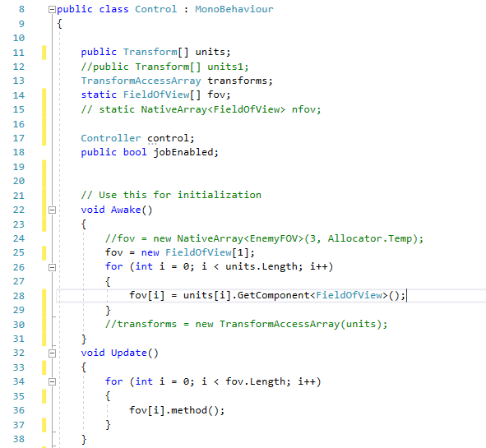

Figure 104 - MonoBehaviour Control Script

Performance measurements are taken individually for a scene containing a single AI agent and a scene containing four AI agents to have an insight of the impact in the rendering process.

##### 1.1.1.1 MonoBehaviour NavMesh Performance for a Single AI Agent

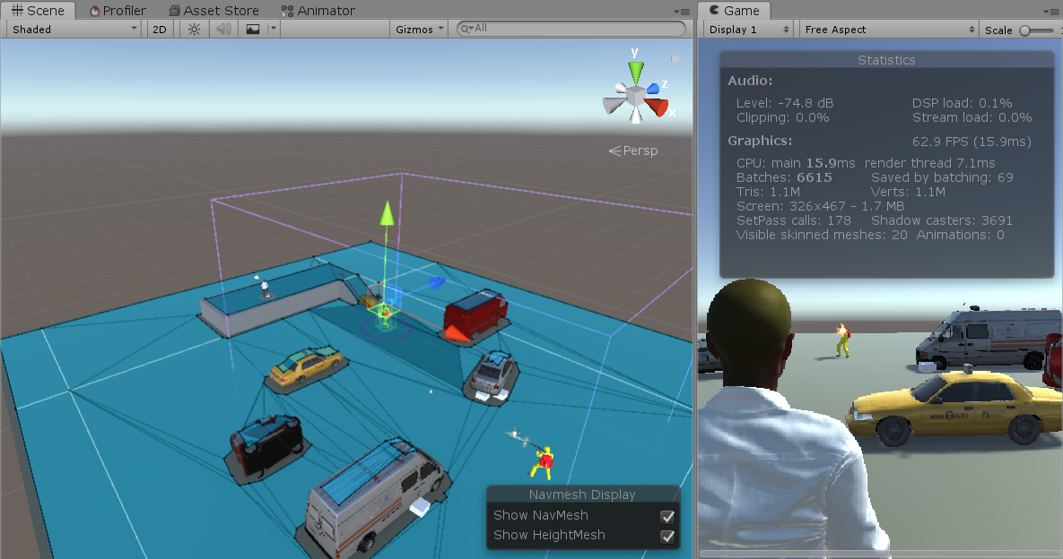

Figure 105 - NavMesh Performance with a single AI agent in the scene

Significant improvements can be seen in the performance of the rendering system. The performance recorded with NavMesh implementation is an average of 62FPS, for a single AI agent in the scene while the initial implementation of the A* Pathfinding grid determined a performance of 42FPS. Further details are presented in an overview of the Unity Profiler.

During the measurement process, the Shieldman game character has been updated with a script determining a dynamic path the target.

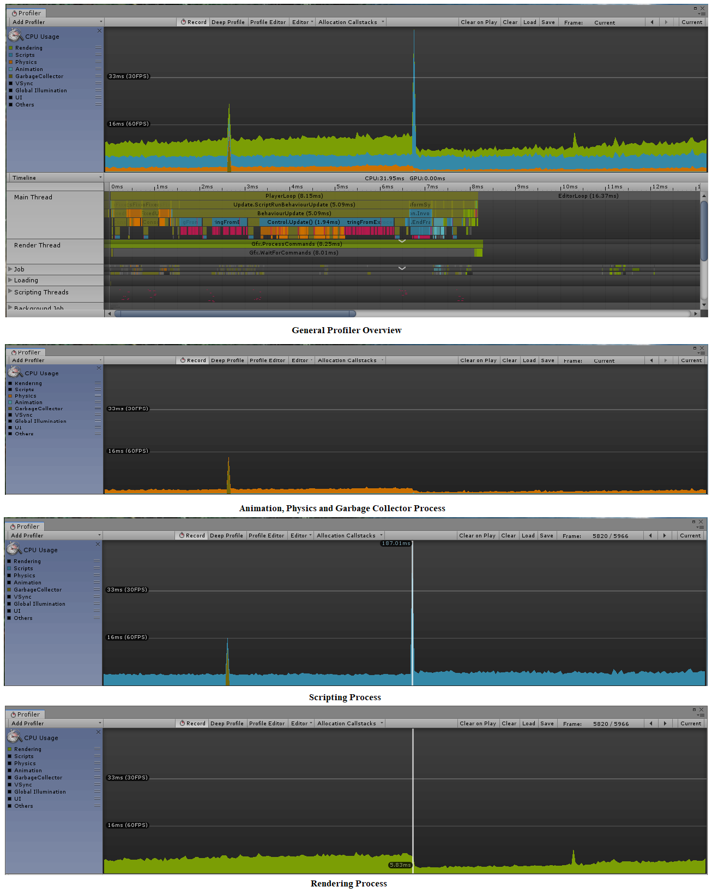

Figure 106 - Profiler Overview for system performance

##### 1.1.1.2 MonoBehaviour NavMesh Performance for Four AI Agents in the Scene

The current game scene has been updated with further four AI game agents, each agent having the same target to view the impact on the navigation system.

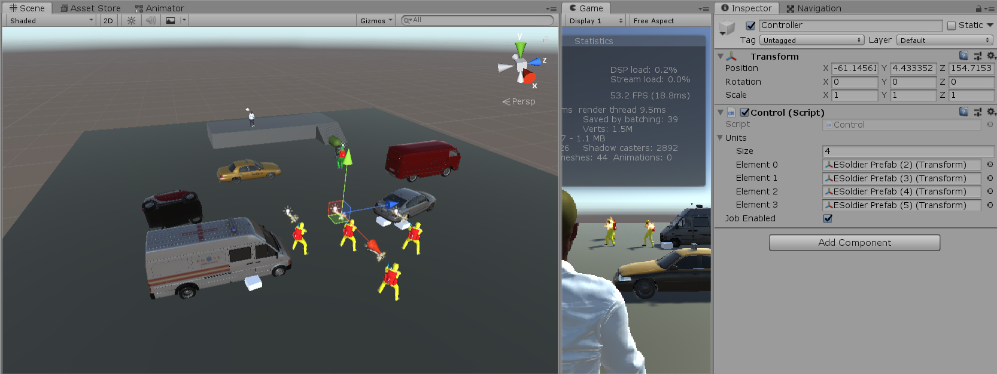

Figure 107 - MonoBehaviour NavMesh performance with four AI agents in the scene

With four AI agents in the scene a performance of 53FPS has been recorded, a framerate dropdown, compared to the previous measurement, of 9FPS and, an increase in performance compared to the initial A* pathfinder implementation of 16FPS.

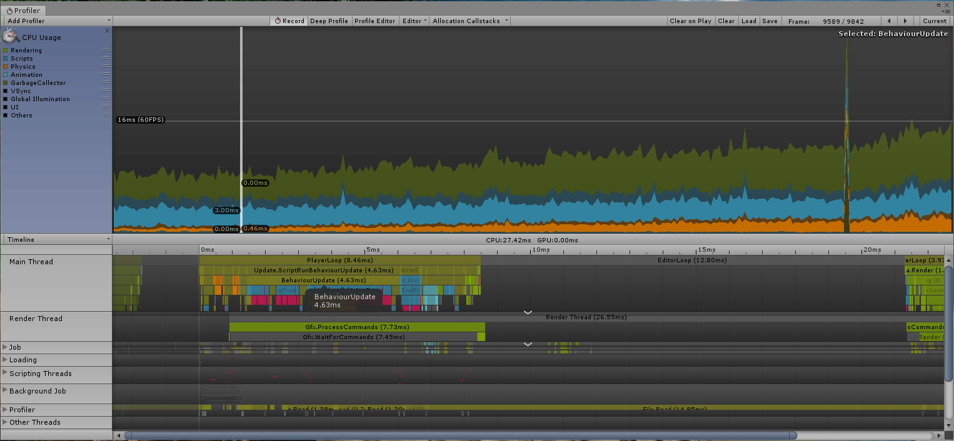

Figure 108 - Profiler overview for system performance with five AI agents in the scene

#### 1.1.2 Hybrid ECS Performance

The current, MonoBehaviour, system implementation will be removed in favour of Unity’s optimised data-oriented framework, Hybrid ECS, to measure the performances of the system. The control script will be disabled from Unity’s interface and the Hybrid Entity Component script will automatically take responsibility for the behaviour of the system. The script has been presented earlier in the project at page 66.

##### 1.1.2.1 Hybrid ECS NavMesh Performance for One Agents in the Scene

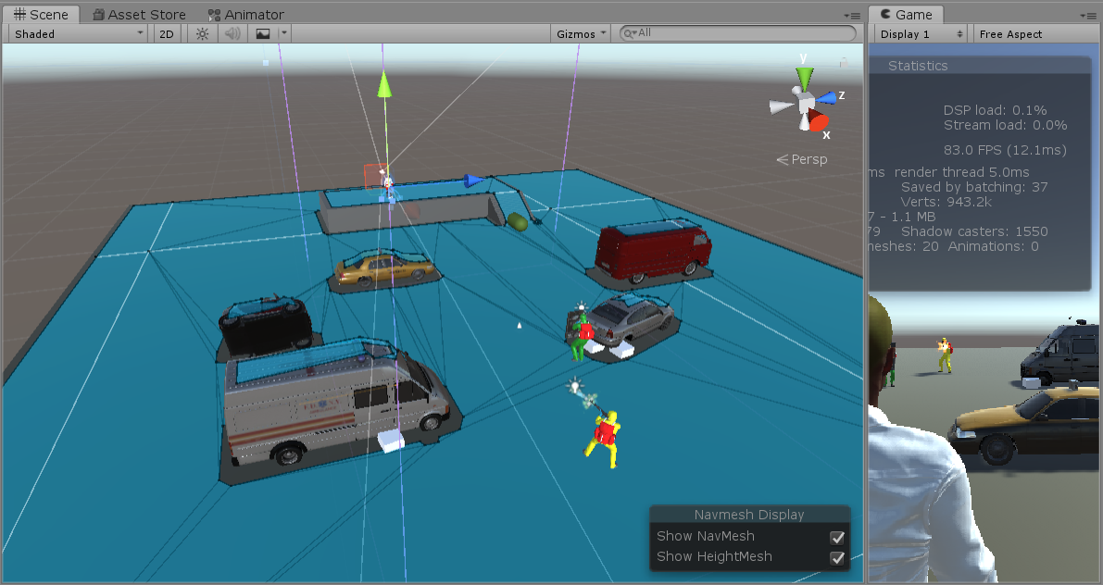Figure 109 - NavMesh performance on a Hybrid ECS framework

The Hybrid ECS framework increases the performance of the system with 20FPS compared to the MonoBehaviour framework, raising the rendering performance level, on a scene with one AI agent, to 83FPS.

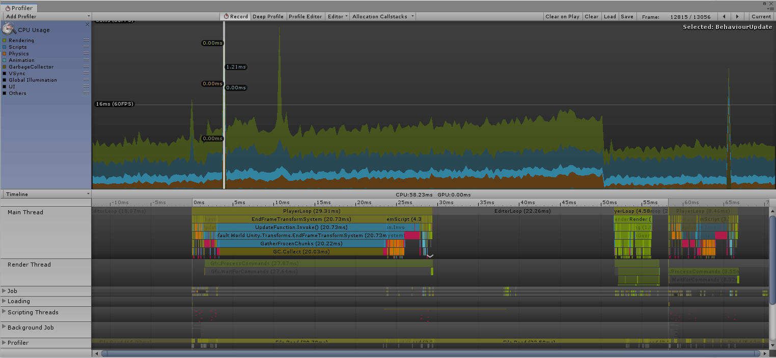

Figure 110 - NavMesh Performance on Hybrid ECS framework

With Hybrid ECS framework, the overhaul performance of the game has been raised above the average performance of current games on the market, one example named is Need For Speed Rivals developed by Electronic Arts running at 60FPS.(*Need for Speed: Rivals review • Eurogamer.net*, 2013)

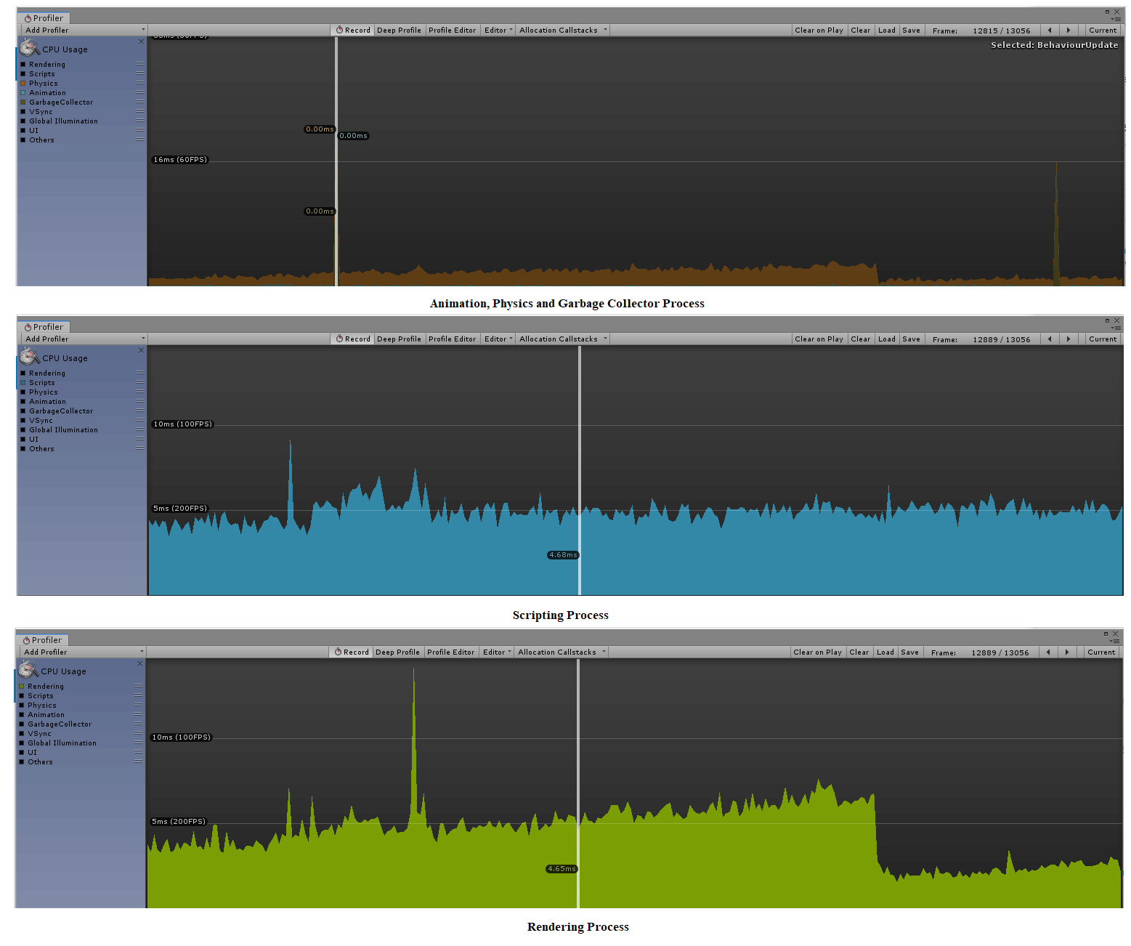

Figure 111 - NavMesh performance Profiler on Hybrid ECS framework

The lowest amount of resources used, as visible in the Profiler, on a Hybrid ECS framework, is in the Animation process driven by the physics engine.

##### 1.1.2.2 Hybrid ECS NavMesh Performance for One Agents in the Scene

As the previous MonoBehaviour framework measurement, three more AI agents will be added to the scene to gain insight over the performance impact of the system.

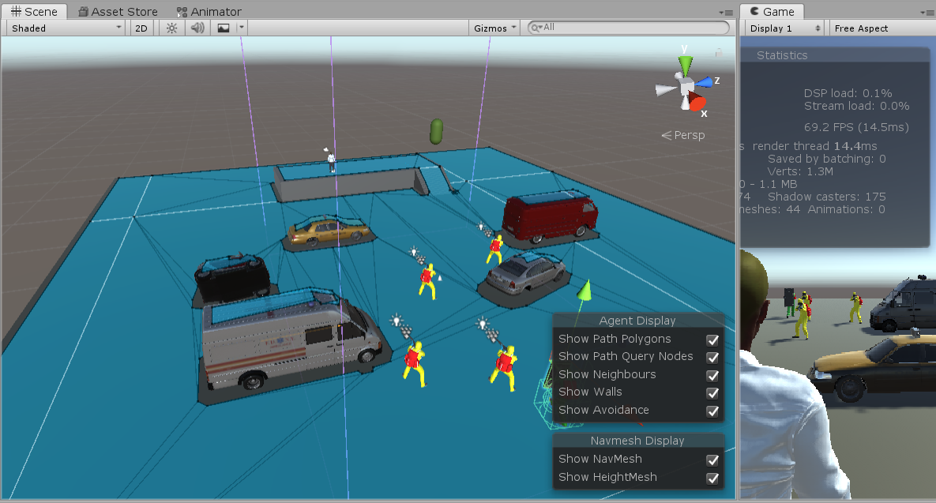

Figure 112 - Hybrid ECS NavMesh performance with four AI agents in the scene

The performance increase is constant with the Hybrid ECS implementation, a game scene with four AI agents on a NavMesh system, the rendering process is at 69FPS, 14FPS higher than the measurement taken on the MonoBehaviour framework.

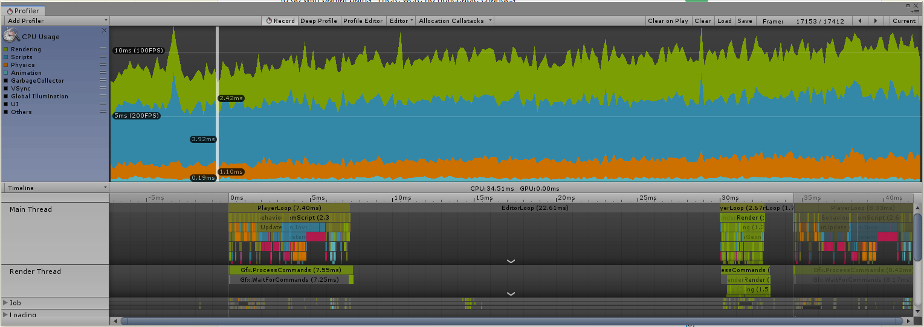

Figure 113 - NavMesh Performance on Hybrid ECS framework in a scene with four AI agents

Please note, the measurements have been taken with visible cover locations in the scene, the mesh renderer has been set active, for development purposes. A mesh determines the texture of a game object. If the mesh is active, the game object is visible in the game scene, otherwise is hidden from the eyes of the user. Towards the end of the development process, the mesh of the cover locations will be turned off generating higher Profiler performance readings, by eliminating the rendering process of thousands of objects in the game scene.



Figure 114 - Visible cover locations - rendering mesh active

## 2. Dynamic Cover-Based System

To resolve the issue of the large number of cover locations instantiated, decrease their number, and to get precision in measuring the size of the cover locations, the float values have been converted to integers. The result was improving but game objects would still be instantiated one on top of another. The solution was to design and “if” statement, teaching the system to build cover location one after another according to the x and z coordinates of the previous built game objects.

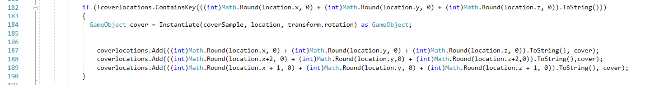

Figure 115 - Reduce the number of cover locations with an "If" statement

Following the implementation, the number of implemented in the scene by the edge detection method has been reduced from approximately 2000 cover locations to approximately 30 cover locations throughout the game scene.

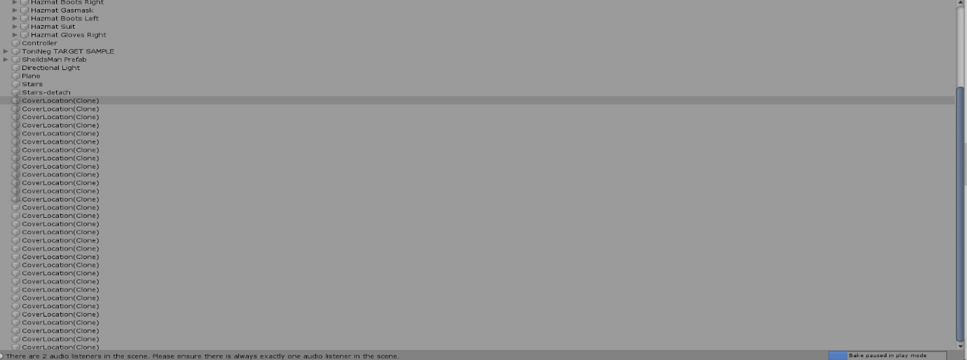

Figure 116 - Total number of cover locations after script update

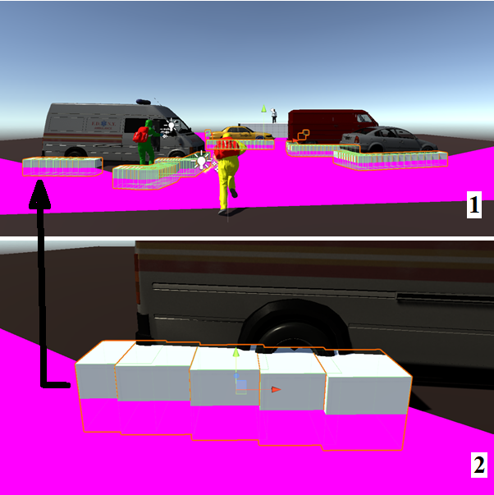

Figure 117 - Cover location number before and after

The edge detection method still generates cover locations in the middle of the static game objects but due to the small number cover locations in the scene the rendering process is not going to be affected at run-time.

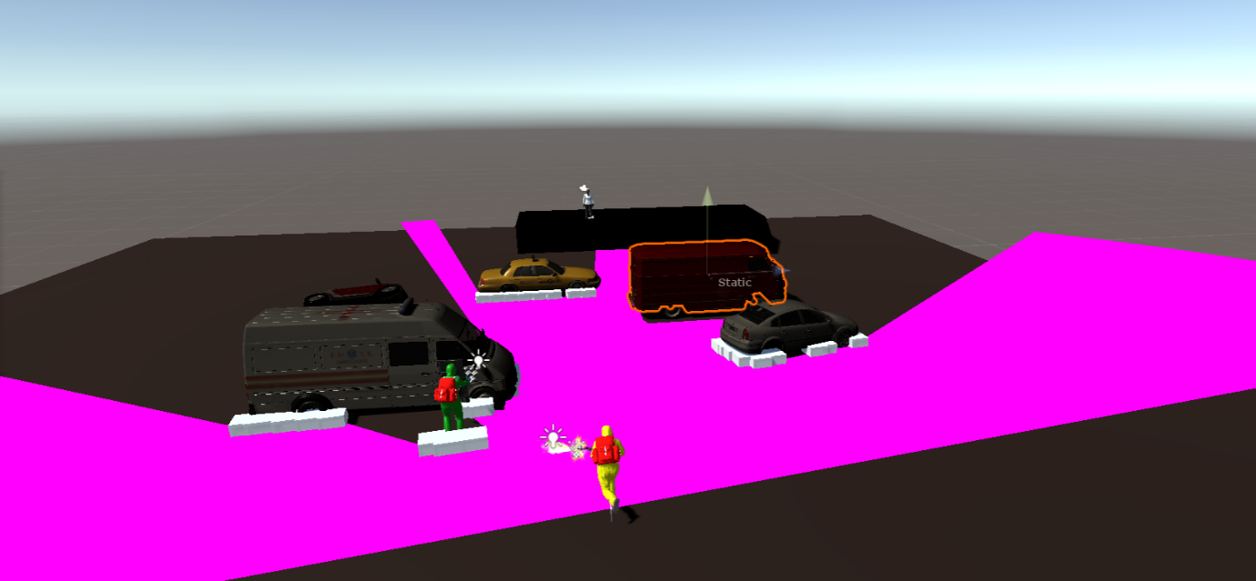Figure 118 - Total number of cover locations in the scene

Instantiation of cover locations is seen outside the game scene, determined by the field of view of the AI agent, but again their number is low and the design of the game, Patient Zero, encloses completely the game scenes and cover locations will not be implemented outside the scene.

However, a new problem arises from the distance of one cover location to another. The instantiation of cover locations is limited by the field of view of the AI agent. In a dynamic cover-based system, technically, the AI agent has the ability to choose a location at random, but if the locations are positioned at different ends of the field of view, the algorithm can have poor results and not simulate a human like behaviour.

To counter the problem, a second field of view has been created and attached to the AI agent strictly to determine the distance between the agent and the instantiation position of the cover locations. The area of the second field, restraining cover locations instantiation, will be limited inside the area of the initial field of view that is redesigned to only trigger the ray-cast enemy detection method and pathfinding algorithm.

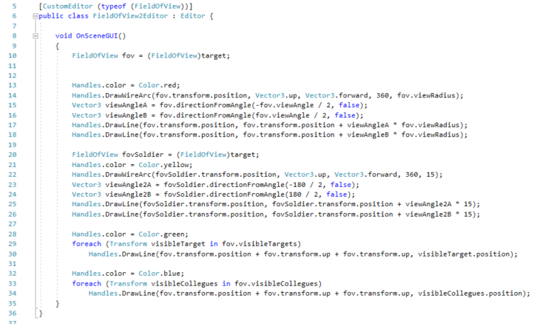Figure 119 - Code snippet - AI agent initial field of view (fov) + AI agent cover location instantiation field of view (fovSoldier)

Succeeding the implementation of the second field of view, the AI agent has been updated with a second ray cast that will allow him to detect any moving characters in the scene that can serve as a cover location, specifically the Shieldman game character.

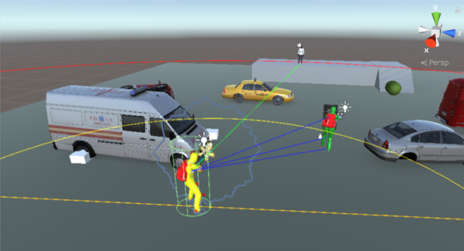

Figure 120 - Ray-cast detecting the Shieldman character + view of cover locations instantiation area

Code has been designed to set every cover location, determined by the field of view, in a dictionary. For every cover location a Boolean variable has been assigned to determine the availability of the location, if the location is available the AI agent will go to the location, otherwise the AI agent will be guided towards another available location. The Boolean value implementation was mandatory to determine location availability to suit a game scene with multiple AI agents in the scene. If every location is occupied during run-time, the AI agent will proceed directly towards the target.

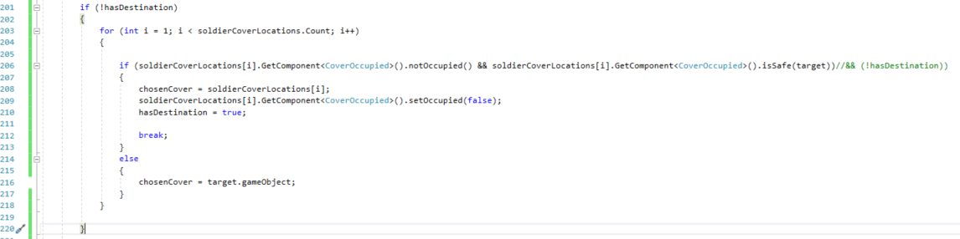Figure 121 - Primitive code snippet to determine and walk towards a cover location

The primitive code developed to assign cover locations to an AI agent raised an error. The algorithm implementation did not generate any cover locations and no errors in the software have been detected. Two development days have been dedicated to find the fault in the algorithm. The algorithm is functional, and the issue was related to the location of the first cover location. The transform location of the first game object cover location has been set automatically by the software, at the centre of the game world at Vector3 coordinates x=0, y=0 and z=0 while the game scene, due to the design, was set at a nearby location. A dummy cover position has been added to resolve the issue.

Figure 122 - Instantiation of a dummy cover position

The solution of the problem determined instantiation of cover location in the designated field of view, limiting even further the number of cover locations added to the game scene. Cover location will be generated and their position in the game scene will be limited by the secondary field of view of the soldier. The primitive code to determine a path towards the target is functional to a point, the AI agent stops in the first cover location awaiting further instructions. The code will be progressed further, if the development time will permit, to enhance the unique feature chosen to be implemented in the game play of Patient Zero.

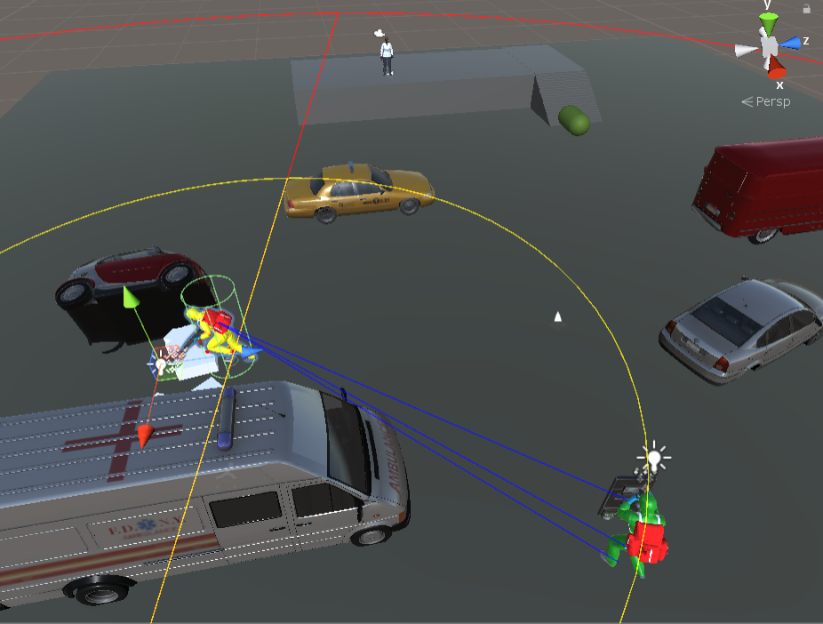

Figure 123 - AI agent running to cover

The overhaul results will be presented of the method will be presented in the final chapter.

## 3. Multithreading Objective and Unity Job System

The multithreading process allows developers to execute multiple pieces of code that can share resources without data corruption. In multithreading, there is no guarantee when a thread is going to execute, and resources must be locked until a thread is done to prevent data corruption.

### 3.1 C# Multithreading

In C#, every process is associated with a thread. A process facilitates the execution of a program for the operating system by providing the required resources. A unique ID is associated with each process to identify the process where a program is executed. Every process is assigned to a virtual space address to ensure the data lock for the current process against usage by another process.

A process is executed by the memory managed by the CPU. If the data in a process is corrupted the functionality of the performance of the CPU is downgraded. Threads have been introduced to overcome the problem and to behave as a CPU virtualisation. Each process in a system is associated with its own thread to remove the delay of completing operations sequentially.

Multiple threads can run at the same time, using context switching, by allowing one single thread to be executed at one time, each individual thread depending on the main thread.

In Windows OS programming a single application can have multiple threads to achieve the following results:

* The functionality of every UI application is based on a single thread. While executing long processes, the process completion time will increase. To resolve the issue separate, background threads can be created to process long-running tasks and to keep the UI application active;
* Two types of operations are performed by every application:
  + Operations connected to the I/O where the application must wait for the completion of an external process before execution;
  + Operations connected to the CPU that can be processed while waiting for process connected to the I/O to complete.

Two types of threads are encountered in C#:

* Foreground Threads - are independent from the main thread, the process continues until the assigned work has been processed regardless of the state of the main thread;
* Background Threads – are completely dependent on the state of the main thread, alive or dead, a background thread must end its process if the main thread has finished processing.(*Multithreading in C# - Basics • Dot Net For All*, 2015)

Multithreading is a scalable process, in a complex software threads can be added based on the needs of the developer, but the drawback stands in the design of the software, thread processes must not interfere. Software designed for user interaction must achieve performance in response time to the user input and processing user data.

#### 3.1.1 Advantages and Disadvantages of Multithreading

Advantages;

On a system designed for multiple CPU cores the advantages of multithreading are:

* Fast communication time between the system and networks, servers and databases;
* Capability of processing heavy and time-consuming computations;
* Task prioritising capability;
* Constant responsive user interface.

Shortfalls:

* Increasing number of threads in a system impacts the performance and resource consumption during process completion – the memory of the system is consumed to provide context information required by the threads;
* Significant processing time is consumed by keeping track of a large number of threads in a system;
* Code execution complexity;
* Thread destroy process usually result with an error;
* Complex synchronisation is required to eliminate deadlocks and race conditions;
* Conflicts result from shared access to system resources.(Thakur, 2016)

#### 3.1.2 C# Multithreading Drawbacks

* Slow Process Execution – on a device with a single CPU core the completion time for a task processed by a single thread is less than a task processed by multiple threads in context switching;
* Maintainability -high impediments are encountered maintaining a code designed to perform multiple tasks;
* Ability to debug – context switching increases the difficulty in debugging software developed for multithreading.(*Multithreading in C# - Basics • Dot Net For All*, 2015)

#### 3.1.3 Thread Pooling

Thread pooling, in a multithreading approach, increases efficiency by providing a pool of threads managed by the system. In many applications, individual threads are set in a sleeping stage waiting for events to occur. A thread is constantly monitoring every operation queued at the thread pool. Once an operation is completed a worker thread executes call back functions.

Operations that are not related to thread pools can also queue a work request at the thread pool, request that cannot be stopped once queued.

Two types of worker threads can be identified working with thread pools:

* I/O worker threads – threads waiting in an alterable waiting state to be called for asynchronous procedure calls
* Non-I/O worker threads - threads waiting at I/O completion ports, more efficient than I/O worker threads.

In thread pooling, work items and functions must be thread pool safe and not a dedicated or persistent thread.(*Thread Pooling - Windows applications | Microsoft Docs*, 2018)

### 3.2 Job System

On a gamming device, a simulation built in Unity, profits from every available core through the Job System. In the present date, a large number of applications and games are designed around a single core CPU, but the possibility of dividing the procedure into smaller units to be processed by multiple cores simultaneously, uses fully the performance of multiple cores to massively improve the performance. The ability to use multiple cores reduces significantly the process wall time and does not need thread time optimisation.

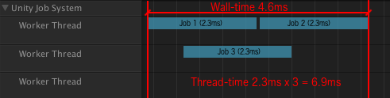

Figure 124 - Wall-time frame rate

#### 3.2.1 Minimising Wall-Time

Wall-time represents the completion time of a task from the start moment until the whole process has been completed. A method to reduce the wall-time with the Job System is the use of ParallelFor jobs. ParallelFor jobs is designed for processing large set of values using the same methodology. For example, in an array, each item of the array is processed individually but using a job or a thread, meaning that in a multithreaded system all the items in the array can be processed in parallel making use of every available CPU core.

In reality, the number of jobs available in a system is less than, for example, a given set of characters in an array. Every CPU core handles a job and the amount of jobs is evenly distributed between the cores. If any of the worker threads finishes processing, a work-stealing event occurs to level processing time spent in each core, worker treads iterate through the ongoing progressions in the CPU and processes tasks assigned to another thread.

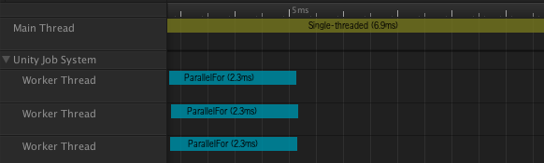

Figure 125 - Insight of ParallelFor jobs

#### 3.2.2 Above ParallelFor

ParallelFor is suitable for complex systems focused on similar items computations, but the Job System is suitable to process information of different variable types at the same time. By design, the Job System defines the system in small work units named jobs, threads, assigned to each CPU core. The cores process the information in parallel with the other threads meaning that if threads do not depend on each other the design of the Job System allows the developer to schedule a job that will run in parallel with the rest of the processes.

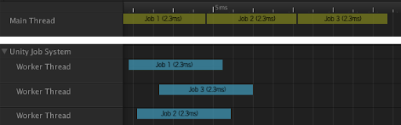

Figure 126 - Worker threads scheduling

#### 3.2.3 Late Completion, Early Scheduling

The design concept of the Job System is early scheduling and late completion. The purpose of the design is to assure the main thread must not await worker thread completion. In the moment the main thread requires the result from a worker thread, the job of the worker thread must be completed. The design pattern of the Job System is focused to allow a job as much time as possible to run.

The designed pattern does not bound the schedule of a job and the result wait time to a specific frame, but the aim is to distance the two actions as much as possible. If a frame latency is acceptable the request for the result can be set for the next frame. The Unity Profiler is designed to investigate wait times to allow the developer possibility to schedule a job earlier in an attempt to reduce the impact on the performance.

The Job System is not designed as a solution for heavy, long time computations with low priority in the system and for processes set on hold instead of using the resources of the CPU. It is possible to implement a job for these types of operations, but limitations are set.

#### 3.2.4 Cooperative Multi-Tasking

Every worker thread is connected to a virtual CPU core. If the threads begin processing the task will be completed without interruptions. If the developers desire to share the CPU’s core with another thread, he manually has to yield and splitting the job in two different jobs dependant of each other. While the system is not designed to provide context-switching automatically, in this case, a job will occupy the entire core of the CPU regardless of the priority of the job.

#### 3.2.5 ECS and Burst

The C# Job System has many applications that lead to a better overhaul performance. The performance is yet improved by implementing the new Unity Entity Component System and Burst Compiler technology. The ECS is designed to reduce the operation time completion of a thread by a cache-friendly data classifying. The Burst Compiler is focused towards thread performance by optimising the code in the Job System.

The goals of every system are to improve performance for the Unity game engine while supporting existing workflows. The C# Job System is designed to allow the developers to write threaded and safe code, providing protection from multiple multithreading pitfalls such as race conditions.(Johanasson, 2018)

### 3.3 Job System vs Multithreading Performance

Performance is a decisive factor in the game industry. The Job System implemented by Unity is designed to replace the standard C# multithreading implementation to increase performance and data optimisation. Advantages and disadvantages can be noted for every threading methodology, either simple C# multithreading or the Unity Job System. Optimisations determines the quality of a software but the decisive factor in the contrast between two implementations is going to be performance.

To determine accurate results comparing the multithreading framework and the Job System, the development background of the project, Patient Zero, cannot be used for this purpose. The large number of scripts, assets and functionalities, implemented to this point in the development of the game, may cause inaccurate readings leading to unexpected results.

To test the performance of both, simple multithreading and the Unity Job System, a game scene is designed with hundreds of game objects, every game object performing a task at the same time as the others. The scene is designed to be highly taxing for the performances of the device considering the high amount of game objects in the scene targeted to achieve a scenario highly taxing on device performances.

The project is designed to be simple, a single empty game object is created in the scene, and a script is attached to the game object. The script is designed to create jobs and create functionality powered by UnityEngine.Jobs and Unity. Jobs libraries.

Variables in the script are declared to dictate:

* the number of game objects to be instantiated,
* the range where cubes can be instantiated,
* the speed at which the cubes can move,
* private arrays to hold information about the instantiated game objects,
* a variable will be added to determine the use of the Job System.

Arrays declared in the script hold details about the transform component and the Vector3 component of the instantiated game objects. Because the of the limitation imposed by the Unity debugger regarding value types, and because Vector3 is a reference type, a third array is created to store information about the transforms and the targets before assigning the components to a job.

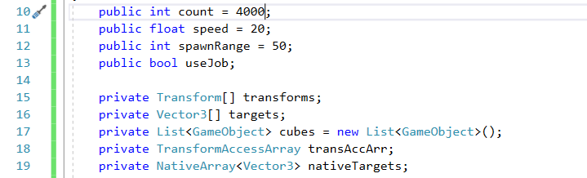Figure 127 - Variables to dictate objects

The following step is to create the C# job. Every job created must be a struct. A class is a reference type. Creating an object in a class, the variables of the object hold just a reference to a memory location while a struct is a value type, the variables hold the actual value and not a reference to a memory.

Jobs variable and methods are declared:

* a time variable;
* a native array to store a Vector3 array;
* a float variable for speed,
* an Execute method to define the purpose of the job, in this case, to determine the movement of game objects from a destination point to a target point at a defined speed.

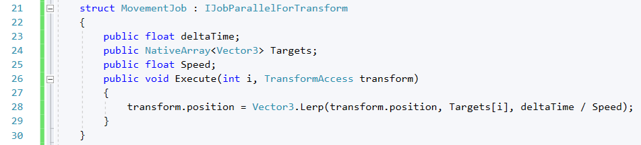Figure 128 - C# Job

The Start () function creates a new array of Transforms defining the number of game objects in the scene and a for loop generates game cubes in different location, cubes which are added to a list. The procedure continues until every game object has been instantiated.

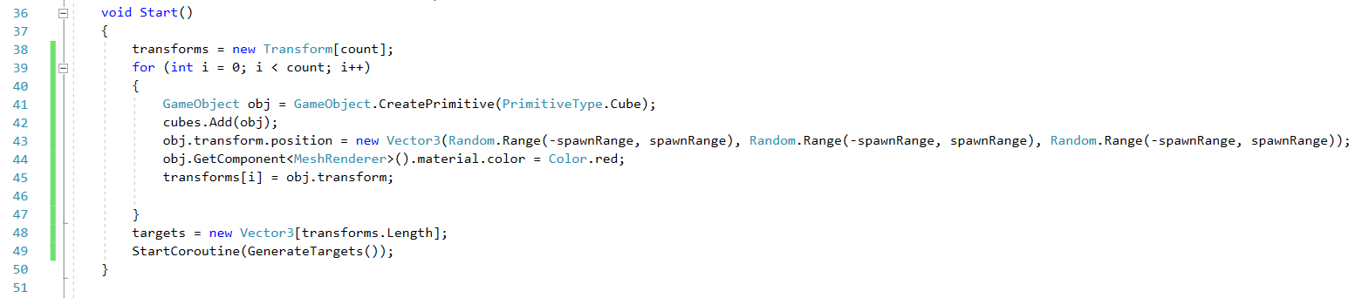

Figure 129 - Game cube instantiation

Coroutines are created to set game objects at a range specified by the developer, while the update method will process the information according to the Boolean value, use Job, set by the developer. If the value is set to true, the project will move the game objects in the scene based on the job created, otherwise, if the value is set to false the project will perform the same task but without using the Job System.

It is important to include a LateUpdate method in the code, containing functions to properly end the jobs preventing any memory leaks. In the method the job will be market as complete and the game objects instantiated will be destroyed. It is also useful for the execution of the script and to ensure the completion of a job before moving on to the next one.

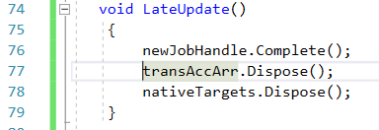

Figure 130 - Game objects disposal functions in the LateUpdate() method

The last code implementation generates a complete script for a functional game scene populated with 3000 game objects, instantiated in a predefined range and moving in the scene at a predetermined speed of 20 units.

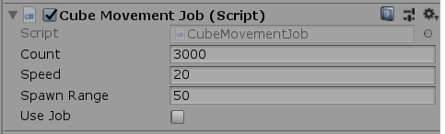

Figure 131 - Cube Movement Job component

Depending on the capabilities of the device further game objects can be instantiated. A Boolean variable, “Use Job”, determines the use of the Job system, while set to true the software will implement the use of Unity jobs, otherwise the software will maintain its current functionality. The measurements will be taken by running the scene individually with the default system scripting implementation and the Unity Job System.

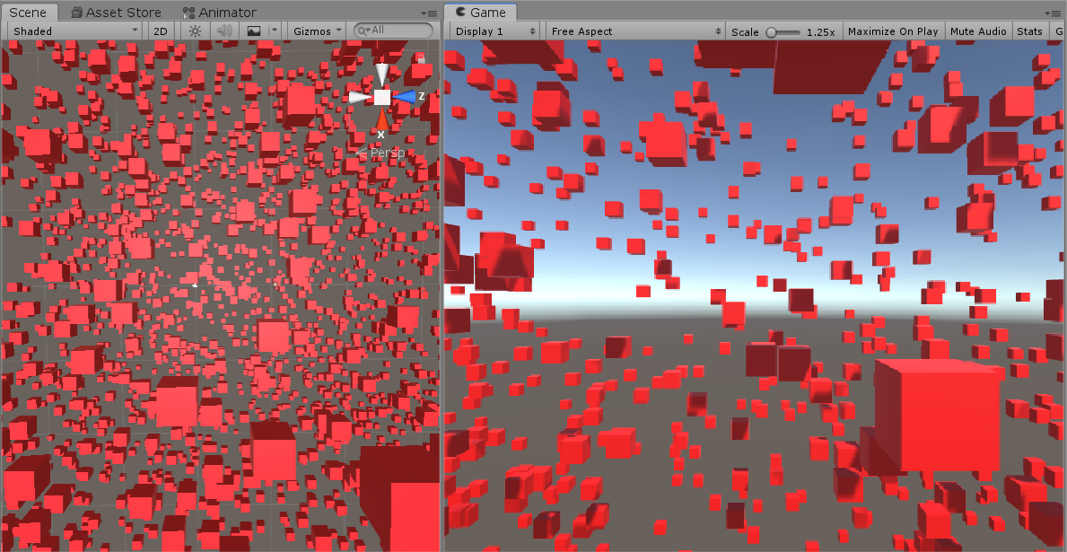

Figure 132 - Cube Movement game scene

With the aid of the Unity Profiler, the performance of the system will be measure, in terms of scripting, while the software is running on default scripting implementation. The measurements recorded, for both frameworks, will be compared to gain insight of system performance, if any.

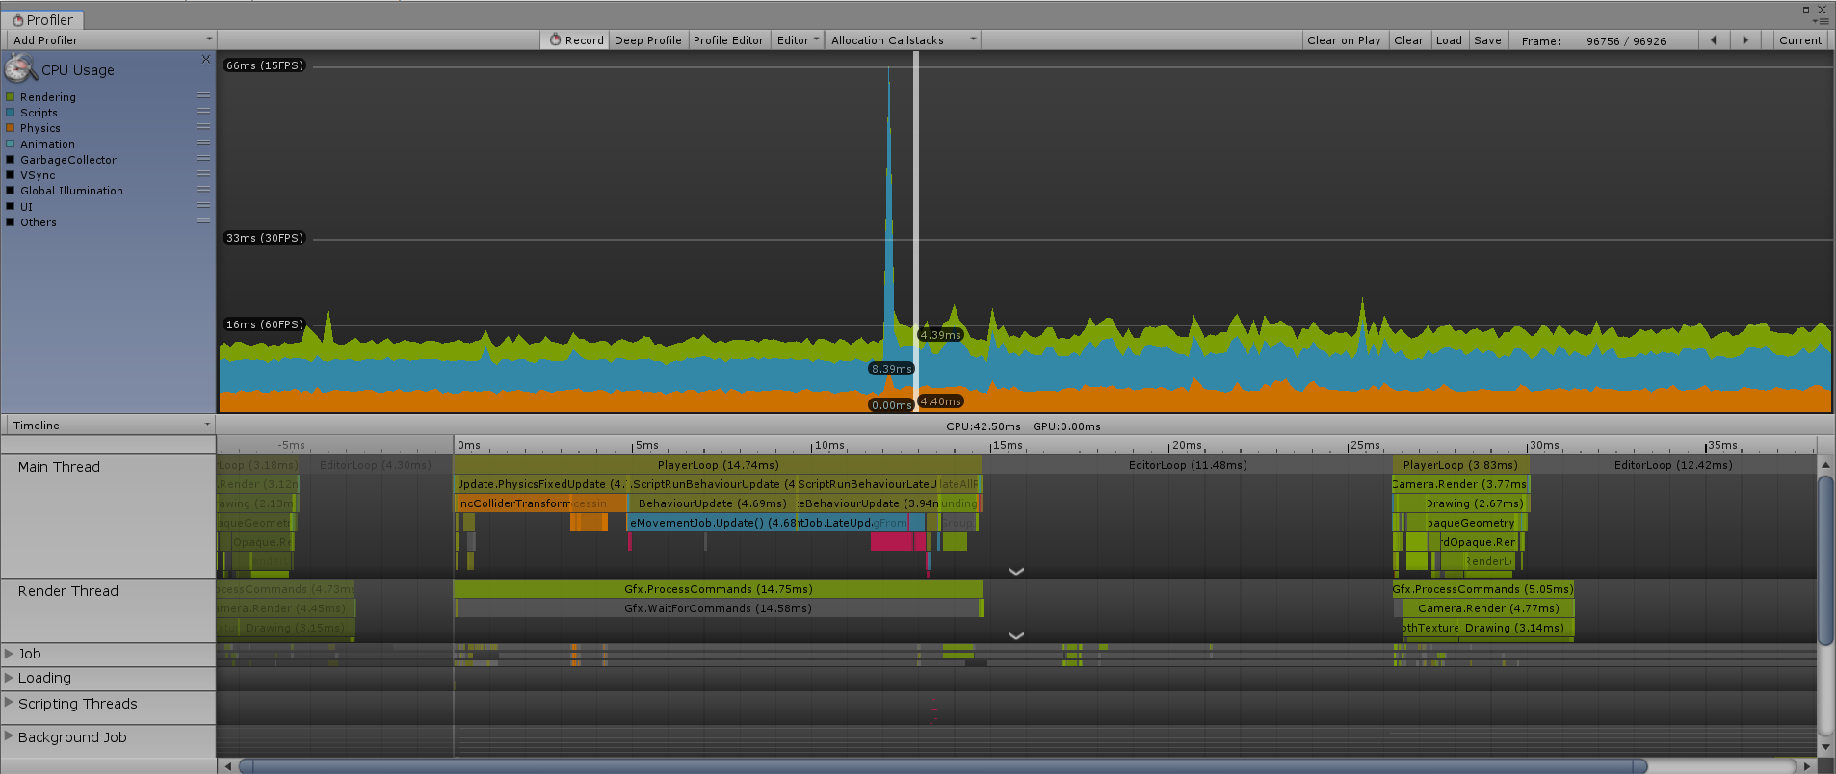

Figure 133 - Unity Profiler while not using Job System

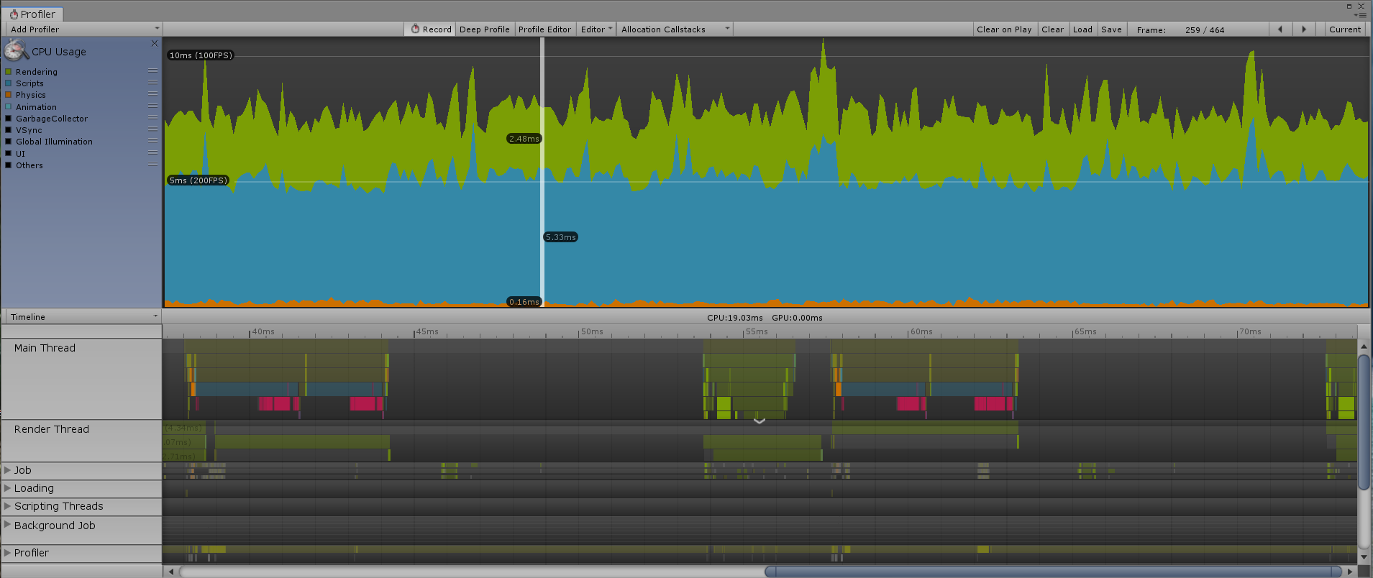

Figure 134 - Unity Profiler while using Job System

The results are surprising, while not using the Job System, the amount of time required by the CPU to complete a task is 8.39ms, and using the Job System the time to complete a task is reduce to almost half of the time recorded for the first measurement, 5.33ms. The difference is constant growing while increasing the number of game objects added to the scene. In a scene with 7000 game objects, the total time to complete a task while not using the Unity Job system is 12.71ms and the total time recorded in completing a task using the Unity Job system 9.24ms.

Based on comparing the measurements given by the Profiler the overhaul conclusion is that performance improvements can be seen while using the Unity Job System. Multithreaded code is a difficult task for the developer but offers immense performance increases. The Unity Job System is designed to increase performance by creating structs and inheriting from job interfaces and it has been developed by Unity as a standard feature to support their goal in achieving performance by default.

### 3.4 Create Individual Sequences of Instructions - Threads

The last aim debated in the project is focused on multithreading and specifically, create and remove individual threads from the main thread of the system. Along the project, several multithreading methodologies have been revised, specific to C# platform and to Unity game engine, in an attempt to determine a method to remove functionalities of the AI agents from the main thread and create single sequences of instruction for performance increase.

To recap, in Unity, every value type is thread-safe because a single value cannot be used by two or more threads at the same time knowing that value types are always copied and not referenced. While referring to objects, every class derived from UnityEngine.Objects are not thread-safe including most of the reference types values defined in Unity such as transformers and colliders which cannot be used in a single thread.

A possibility to overcome the drawback, raised by the development of the project, would be to copy, for example, the functionality of the AI agents, some date in an array or a list created in the main thread, pass the array to an individual thread which will process the data and at the end of the process the data can be read from the main thread.

Multithreading is complex and a difficult process to understand and introduces a variety of problems that random code errors, bugs and usually no performance gain is recorded because the number of threads used is usually larger than the number of processor cores. Furthermore, running threads outside the main thread require pausing, that is usually not implemented in the thread, which leads to unpredictable results. Without pausing, no thread synchronisation can occur that leads to crashing, data loss and access violation.

Unity job processes, threads, worker threads an anything set as a safe threading procedure by Unity, can be seen by the Unity profiler, but there is no software, designed and available, to view individual threads in a Windows operating system that are removed from the main thread of an game engine software.

Process Explorer, a software designed by Microsoft allows developers to have an insight of all the internal system process running in a Windows operating system. Following an online survey, the C# development platform tool, Visual Studio, does not implement a feature allowing an insight of multithreading processing running in a compilation. Any past features enabling the possibility in the past have been deprecated following updates of Visual Studio software development tool.

A second reliable tool to view the total thread number running in a process in the Windows Resource Monitor, a tool capable of counting the number of threads existent in an operating software and allocated to their specific process. Unfortunately, while attempting to remove an individual thread from the main thread, this software, like the previously mentioned, will only allow an insight of the number of threads in Unity software once the process is running.

A second reliable tool to view the total thread number running in a process in the Windows Resource Monitor, a tool capable of counting the number of threads existent in an operating software and allocated to their specific process.

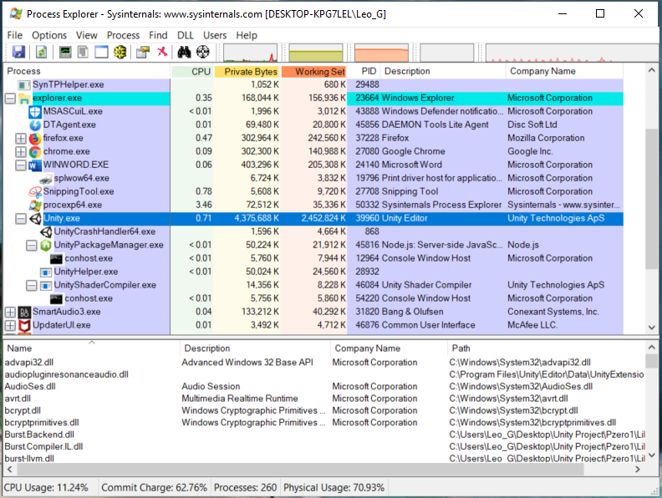

Figure 135 - Process Explorer from Microsoft

To recap, while attempting to multithread in the Unity game engine, separated from their design development, there is no tool to allow an exact confirmation of the success of the process. The result is based on the decision of the developer and the insights he can procure from the Unity Profiler, resource monitoring applications, compilation errors and increases or drops in performances.

#### 3.4.1 Multithreading Procedures

Several multithreading procedures have been mentioned in the previous chapter, apart from the Job System, suitable for new thread development in Unity and C# development platform:

* Simple Threading – create a new thread based on the C# platform threading library and assign a method to the newly instantiated thread. The drawback stands in the processing speed of the thread. Depending on the performance and design of the device, if the main thread and the newly created thread have the same task to process everything depends on which task can lock the CPU resources first ;
* Coroutines – allow a process execution to be suspended and resumed;
* Context Switching – store the current state of a process to be resumed from the same place at a later point;
* Unity’s Magic Threads – a combination of coroutines and context switching;
* Matrix () and Monitor () - programming methods designed to lock the current functionality of a thread and allow a second thread to complete a process before resuming activity;
* Environmental Processor Count – designed for devices that allow CPU virtualisation, constructed to count the available logical process cores and assign processor cores to individual threads. The only drawback appears when the number of individual threads is bigger than the number of logical cores designed for the CPU.
* Thread Pooling;
* Creating a C# thread with a call back argument.

Another interesting method discovered, while researching Unity blogs, is multithreading process queueing. Technically, a list of threads can be built and assigned to a queue awaiting the resources of the CPU according to the priority of the tasks performed by threads. Once the threads have been assigned to the list, the CPU will check the priority of the threads and will process the tasks, rearranged according to priority.

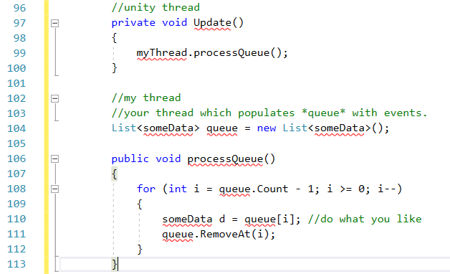

Figure 136 - Process Queue Threading

Several multithreading methods have not been mentioned in the project due to the time restraints of the submission date, methods that have been designed by individual developers, currently posted on Unity Asset Store, but unfortunately time restrains and cost of products, have led to abandoning the research in favour of the current multithreading methods mentioned above.

#### 3.4.2 Individual Threading Attempt

Due to time restrains, in the attempt to create an individual thread apart from the main thread in Unity game engine, only three multithreading methods will be used:

* Environmental Processor Count;
* Simple Multithreading;
* Process Queue Threading.

The rest of the above-mentioned multithreading methods will not be used in the development of the project due to the high complexity and common implementation of the methods throughout software designed in C# and Unity game engine.

Before attempting any implementation, it is mandatory to remind the reader that anything in Unity game engine bound to a transform component cannot be removed from the main thread due to the design of the game engine, thing mentioned several times throughout the project. The only method not bound to a transform position component in Unity and available for processing on an individual thread is the AI agent field of view method, responsible for generating an environmental game scene awareness for the AI game object.

##### 3.4.2.1 Simple Multithreading

The threading C# library is the base for the simple multithreading. The process consists in creating a simple thread, add a process and start the thread. The process to be added to the thread is the DrawFieldOfView() method implemented in the AI soldier script.

Every attempt in individual multithreading is compared with the current functionality and the total number of threads presented by the Windows Resource Monitor. At run-time, a total number of 95 Unity threads are counted by the application . While attempting to multithreads, an increase or a decrease of the number of threads is expected.

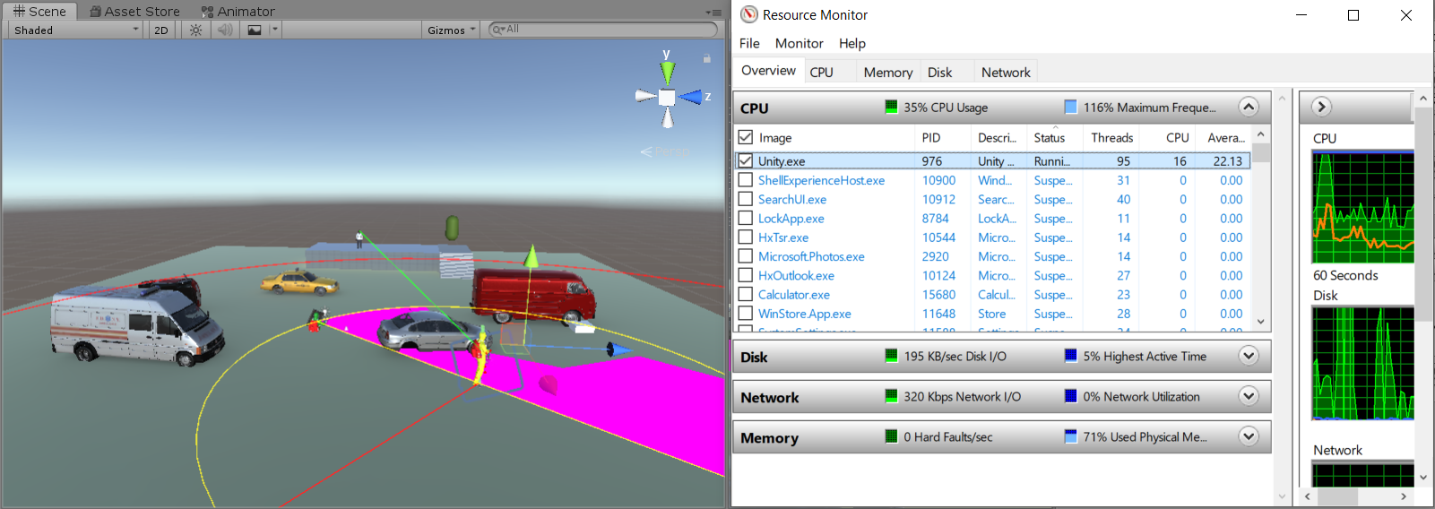

Figure 137 - Comparison measurement in multithreading attempt

The method available in the update methods of the AI soldier will be commented, and a new thread will be created to process the DrawFieldOfView() method of the AI.

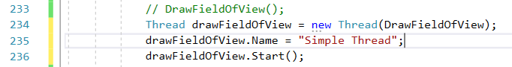Figure 138 - Simple Multithreading to draw the field of view of the AI

A name is assigned to each thread to have a base marker for the Unity Profiler, Windows Resource Monitor and the Process Explorer applications that will be used to verify, if possible, the instantiation of a new thread.

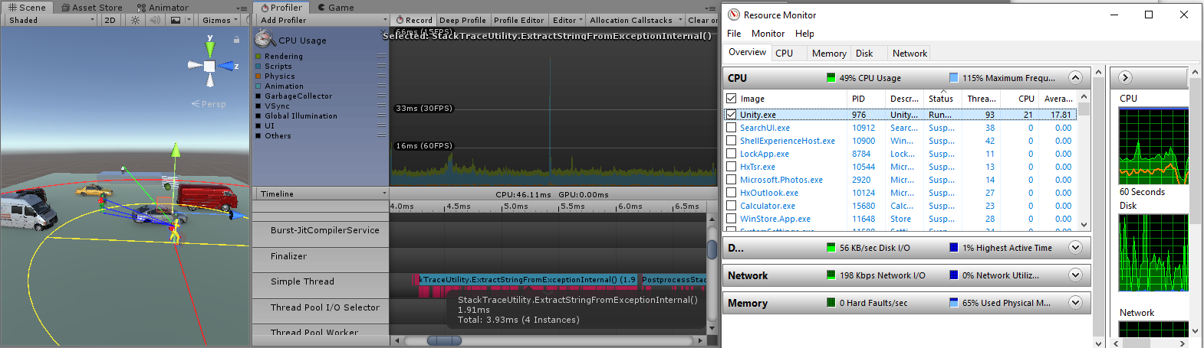

Figure 139 - Simple Multithreading Results

The total number of threads has decreased by two units but unfortunately there is no activity in the game scene, the field of view of the AI is not drawn and the AI agent refuses to move towards a cover location, but the compiler does not issue, and in the Unity Profiler, the “Simple Thread” created to draw the field of view of the AI stands as an individual thread.

In the Unity Profiler a drop of 10 FPS has been recorded while working with an individual thread. The thread is created, it is seen by the Unity Profiler and the Windows Resource Monitor, but it does not process the given task.

Several proprieties have been attributed to the individual thread, such as:

* Priority – value indicating the priority of the thread;
* Is Alive – value indication the execution status of a thread;
* Execution Context – a getter containing various information about the current thread;
* Current Thread – information about the current running thread;
* Current Context – Get the current execution context of the thread.

The simple properties were implemented to determine any fault that can cause lack of functionality of the current individual thread but unfortunately the issue has not been resolved. The most plausible explanation is the complexity of the field of view method. A simple game scene would have been ideal to test simple threading implementation on a simple script but due to the narrow submission deadline more development will be conducted in the nearby future.

#### 3.4.2.2 Environmental Processor Count

The environmental processor count method retrieves the total number of logical processors in the current device. There is no default implementation for the current method, if the current device contains multiple processor groups, the method will return the available processor cores to be used at run-time.(*Environment.ProcessorCount Property (System) | Microsoft Docs*, 2018)

The current method will be used, in the project, to iterate every available core, and via a for loop, a thread assigned with processing the AI agent field of view data will be assigned to a core. The process involves simple threading.

The previous implementation will be used, a thread is created to process the field of view and through a for loop it will be assigned to an available processor core, the only difference is that the loop will be constructed in the main class of the DrawFieldOfView() method.

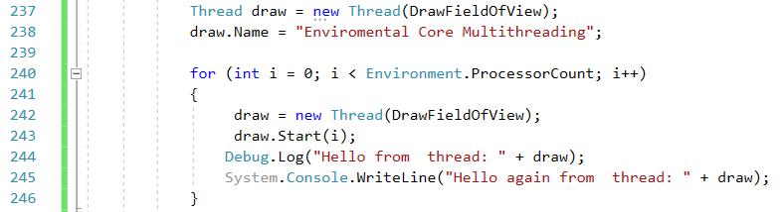

Figure 140 - Environmental Core thread implementation

The method has been presented previous in the project, at page 92, Common Functions for Multithreading.

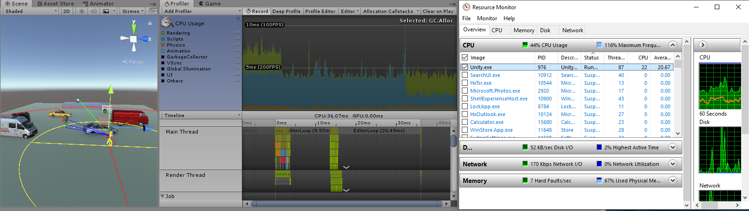

Figure 141 - Environmental Core Multithreading result

The number of threads counted by the Resource Monitor has dropped by three units compared to the previous attempt but yet again no thread functionality is present, and the rendering process, in FPS, is similar to the previous attempt. The Unity profiler cannot see the thread and further investigation has been required.

Upon further analysis an error has been detected in the console of the Unity interface. The threading methodologies, current and previous are functional but due to a number of coding design the thread is unable create a delegate to collect the data and return it for processing.

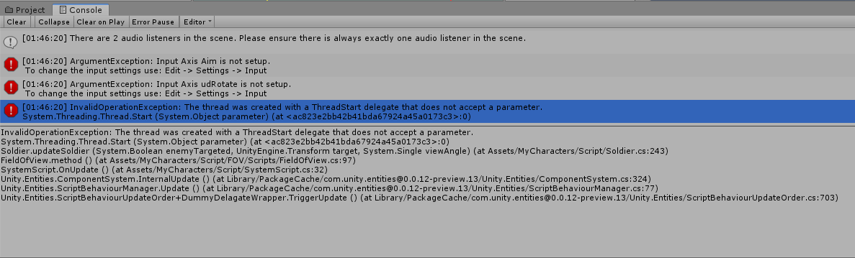

Figure 142 - Error detected in Unity Interface Console while attempting multithreading

Further research will be done in the nearby future to determine a design of the field of view method to allow individual thread processing.

#### 3.4.2.3 Process Queue Threading

Process queue threading is a general solution in multithreading using queue operations form .NET framework thread pooling mechanism. The process is suitable for scaling and for long running thread pool operation. Allows the users to specify the operations based on items and schedule operations using adjustable thread pools.

A large part of the script contained by the Process Queue is focused on thread management and the relations between threads. A general overview of the method has been presented at page 126, Multithreading Procedures.

A list with data is created, data related to the desired multithreading process, stored and iterated through a loop where priority of the process is established, once completed the process is called in the Update () method.

The implementation result is similar to the previous two attempts, the rendering performance drop is constant, equal with the previous attempts and the error message received in the second attempt is present.

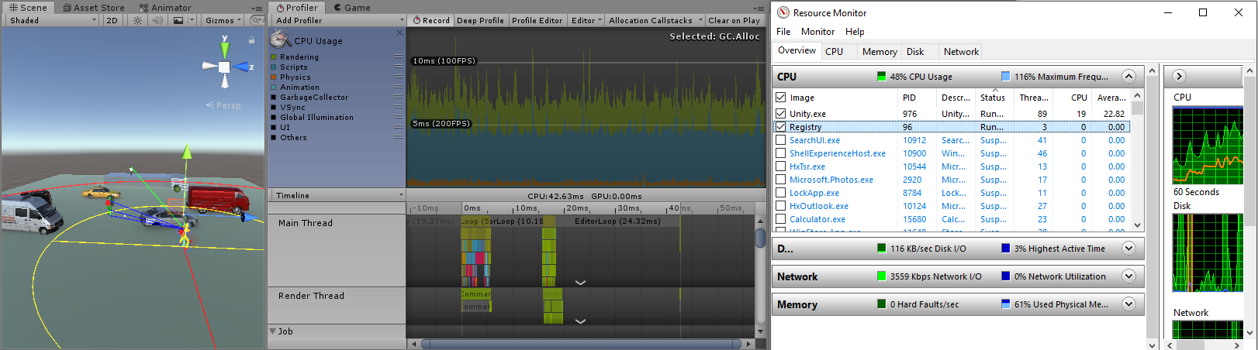

Figure 143 - Process Queue multithreading result

From the point of view of the developer all three multithreading attempts are functional. Due to the restrictions imposed by the design of the Unity game engine in regards with transform components, the AI agent field of view represented the only possibility of having a process in the development of the game manually attached to an individual thread.

Unfortunately, due to script complexity, in developing the field of view of the AI agent, functionality has not been obtained while attempting to develop individual threads, but there are high possibilities of developing complex multithreaded code, manually, by considering the feature from the design part of the development process and enhancing functionality with every development stage.

Multithreading is a complex task, not impossible, but best used with the limitations imposed by the development tools in use.

### 3.5 Overhaul Project Results

The results of the project in terms of performance are presented by the Unity Profiler. The base performance recorded at the beginning of the development projects, recorded by the Unity Profiler for a single AI agent in the scene, has been an average of 42FPS.

The initial A* pathfinding algorithm, for the AI agent was based on a node grid limiting the performances of the software in terms of system rendering at game run-time. A second factor imposing drawbacks in performance was the number of cover locations generated by the edge detection method of the AI agent. The high number of cover locations instantiated would stall the system in a constant iteration of the game objects triggered by the AI agent edge detection algorithm in its path towards the target.

The basic MonoBehaviour scripting framework, based on a single thread, has been replaced with the Entity Component System bridge framework, the Hybrid ECS allowing multithreading functionality of game objects behaviour controlled by components. With Hybrid ECS the Unity Burst Compiler has been introduced in the scene increasing the performance by ordering the code to allow a balanced system resource management.

Every alteration implemented in the system, during the development project has brought significant performance improvements in terms of system performance, pushing the overhaul rendering process of the system from 42FPS, in developer view mode, to 121FPS average rendering speed.

The results are impressive, based on the current rendering performance, the functionality of the system has overpassed the basic performances of modest games, good quality games and the game scene is suitable to be transformed to be rendered by VR devices.

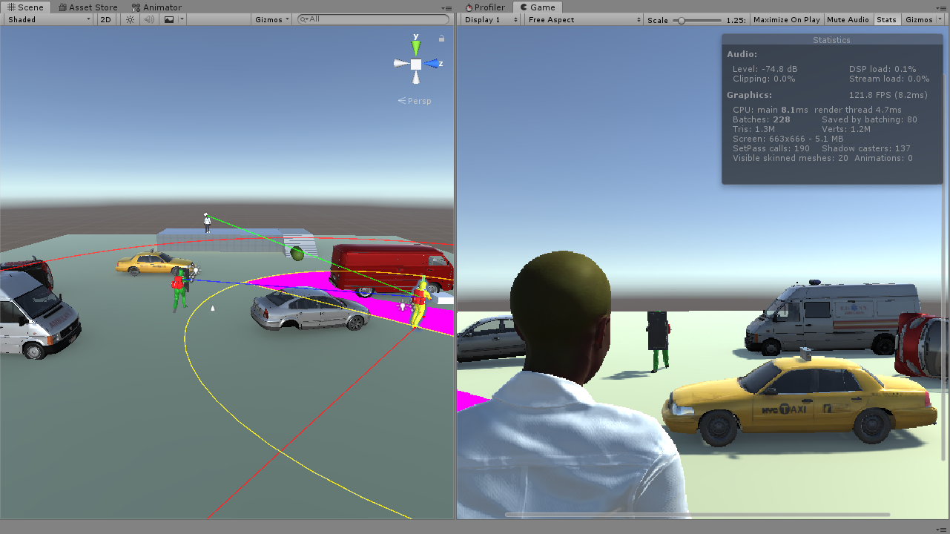

Figure 144 - Final rendering performance measurements

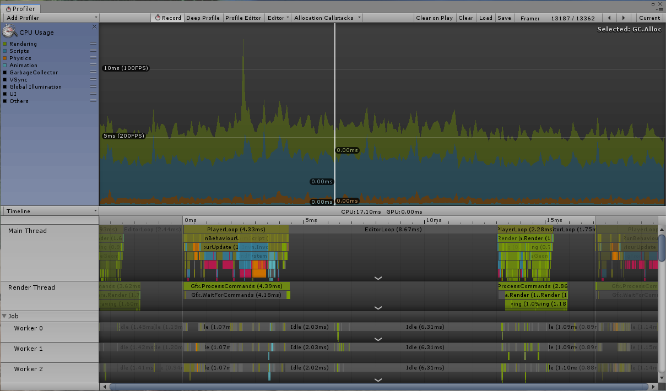

Figure 145 - Unity Profiler final rendering performance measurements

The Unity Profiler measurements provide an insight over the performance increase of the system by setting the rendering graph of the processes well below the 100FPS line, towards the 200FPS line in run-time pause mode.

During the development of the project all the measurements have been taken from the point of view of the developer, every game object instantiated in the scene having active meshed making them visible in the scene. Turing off the mesh rendering process for the game objects instantiated at run-time will bring another improvement on the overhaul performance of the system, having the game objects in the scene but not visible. The results of the rendering process, from the users point of view cannot be presented at this stage due to the development process carried out for the dynamic cover based feature designed for the AI agent, but the results will certainly overpass the current measurements taken from a developer’s point of view.

# Chapter 7 – Conclusions

### 1. Introduction

Developing software using a game engine is a highly complex process. With the existing technology on the market, the most important aspect of a software is the idea.

However, the fast advancements in improving game engine technologies imposes certain limitations in developing a functional software:

* The development time frame of any project must be restricted as much as possible due to constant upgrades developed to increase the performances of any game engine;
* Developers must know exactly the structures and features the game must include;
* In terms of implementing functionality, the methods used must be constant through the whole project development;
* Methods must be developed individually, in separate scripts and must be called only when required;
* A design plan which reflect the final game functionality must be available.

The project is focused on developing functionality in the current software, designed for powerful multicore devices, to be processed on modest hardware devices, while still offering game quality, without any needs for upgrades, using the abilities offered by the game engine.

To achieve the target, aims have been put in place to research an improve features that are highly taxing for the rendering process of the system, such as the A* pathfinding algorithm, the Entity Component System and Multithreading.

A basic presentation of game engine features has been reviewed and research has been conducted to determine the drawbacks and any possible improvement of the current features to increase run-time game performance. Based on the results of the research and the drawbacks of the initial system implementations, modifications have been made which added a spike performance increase of the overhaul system functionality.

The A* Pathfinder algorithm, due to its limitations, has been replaced with the Unity NavMesh, a constant developed feature, native to Unity game engine designed specifically to provide a pathfinding algorithm for Unity game scenes. The initial NavMesh implementation has been dropped by developers due to poor performances in the early stages of Unity game engine development but constant upgrades added to Unity’s NavMesh, over time, have created a powerful navigation tool.

The default MonoBehaviour framework, implemented in Unity, designed to process tasks over a single main thread has been transitioned towards the Beta version of the Entity Component System, a framework where the game objects behaviour, in a game scene, is controlled by components. Because the framework is released in Beta version, the first official issue being set for June 2019, the Hybrid ECS, a transition framework between the standard MonoBehaviour and Pure ECS has been implemented in the project.

Testing has been conducted in Pure ECS, the framework is not yet fully functional, but it would be a bit unfair to propose testing and issue results in the project for a framework not yet officially released. However, significant improvements can be seen by implementing Hybrid ECS in the development of the project compared with standard MonoBehaviour implementation, based on the Unity Profiler measurements.

An attempt has been made, during project development to remove some of the functionality of the AI game object from the main thread. The methods used in the attempt, can be seen by the Unity profiler, are functional for simple processes in a software, but due to the complexity of the AI agent feature the thread cannot process any functionality. However, functional individual threading algorithms have been established, functional for a well design feature, and proposed for future development processes.

### 2. Reflection

A final aim of the project is to develop a unique feature for Patient Zero, a dynamic cover-based system that would allow the AI agent to function as a stand-alone game object during game run-time. The feature is unique but due to complexity and project time constrains it is only partial functional.

The attempt in developing the feature comes as a result of a challenge released officially by the Unity game engine in regard to AI capabilities in a run-time game scene as a stand-alone character capable of making decisions based on the progress made during run-time. Unity developers have created a game scene with multiple levels, completed by dynamic actions and objects with the purpose of limiting the AI characters to reach their target. The challenges have brought in a huge number of developers, racing for completing the task and claim the prise set for challenge completion, set at 100.000 $.

The project has been a great learning curve in game development and objects-oriented programming. Although the lack of experience, in game development and .NET frameworks, has been massive at the beginning of the project, I have managed to complete the aims and the objective, enhancing my programming, project management and game development skills in the process, in a small time frame allocated for a very complex development process.

I have managed to build several, functional game scenes ,outside the project and designed for the current project, and have set new projects for future development based on game engines and experience gained throughout the development process.

### 3. Future Development

A hardware downgrade was set for the end of the development project, but due to time constrains, it was no longer achievable. The device used in the development of the project will be taken apart and downgraded to the initial specification, prior to upgrade to measure the rendering performance of the current game scene with initial specification where the current measurement recorded has been approximately 35FPS.

From the developer’s point of view the measurements will be highly satisfactory as the expectations for the rendering process performance are around 65FPS, automatically setting Patient Zero in the region of high-quality games.

Before downgrading the device, a processor throttling issue must be investigated , issue that complicated the development process in the final stage. The amount of computations done by the processor, in the final stage of the project, have led to a constant device processing at 99.1% determining a stall in the system, not very convenient while developing game engine software.

As a result of the performance gained at the end of the development process, a VR scene is proposed to be built for the current game scene, textures, graphics and terrains will complete to enhance the VR experience. The VR scene has been set to mark the successful completion of the project if the current development process would not have been restricted by the time-constrains.

Further development will be conducted to complete the unique dynamic cover-based system feature designed for Patient Zero and, with the official ECS release, a transition from Hybrid ECS framework to Pure ECS.

# Bibliography

Anon., 2008. *PMI | Project Management Institute.* ed. (): Project Management Institute.

Anon., 2015. *Before starting a new software project - a few things to consider.* [Online]   
Available at: https://www.software.ac.uk/resources/guides/starting-new-software-project-few-things-consider  
[Accessed 7 November 2018].

Anon., 2015. *Learning about C# for beginners.* [Online]   
Available at: https://www.thoughtco.com/learn-about-c-958280  
[Accessed 10 November 2018].

Anon., 2016. *C Pointers.* [Online]   
Available at: https://www.tutorialspoint.com/cprogramming/c_pointers.htm  
[Accessed 7 11 2018].

Anon., 2016. *C# - Multithreading.* [Online]   
Available at: https://www.tutorialspoint.com/csharp/csharp_multithreading.htm  
[Accessed 05 11 2018].

Anon., 2016. *Tutorials Point.* [Online]   
Available at: https://www.tutorialspoint.com/sdlc/sdlc_iterative_model.htm  
[Accessed 1 November 2018].

Anon., 2016. *Unity.* [Online]   
Available at: https://unity3d.com/  
[Accessed 28 10 2018].

Anon., 2017. *Multithreading.* [Online]   
Available at: https://www.techopedia.com/definition/24297/multithreading-computer-architecture  
[Accessed 11 November 2018].

Anon., 2018. *C# Job System Exposed.* [Online]   
Available at: https://docs.unity3d.com/Manual/JobSystemMultithreading.html  
[Accessed 29 10 2018].

Anon., . *C# Language Specification.* ed. (): Ecma International.

Anon., . *What is Project Management?.* [Online]   
Available at: http://www.pmi.org/About-Us/About-Us-What-is-Project-Management.aspx  
[Accessed 31 10 2018].

Anon., . *What's new in C# 7.2.* [Online]   
Available at: https://docs.microsoft.com/en-us/dotnet/csharp/whats-new/csharp-7-2  
[Accessed 1 11 2018].

Bennett, C. & Sagmiller, D. V., 2014. *Unity AI Programming Essentials.* [Online]   
Available at: https://amazon.com/unity-programming-essentials-curtis-bennett/dp/1783553553  
[Accessed 29 10 2018].

Birrell, A., 2005. *An Introduction to Programming with C# Threads.* [Online]   
Available at: http://birrell.org/andrew/papers/035-threads.pdf  
[Accessed 29 10 2018].

Gajjar, A., 2013. *Learning C# by Developing Games with Unity 3D Beginner's Guide.* s.l.: Packt Publishing Ltd.

Goyal, N. & Ram, M., 2014. Software development life cycle testing analysis: A reliability approach. *Journal | MESA,* , 5(3), pp. 313-329.

Kind, A. & Padget, J., 1998. *Multi-lingual threading.* [Online]   
Available at: http://ieeexplore.ieee.org/document/647230  
[Accessed 7 11 2018].

Kwak, Y. H. & Stoddard, J., 2004. Project risk management: lessons learned from software development environment. *Technovation,* , 24(11), pp. 915-920.

Kwak, Y. H. & Stoddard, J., 2004. Project risk management: lessons learned from software development environment. *Technovation,* , 24(11), pp. 915-920.

Marchand, A., Hennig-Thurau, T. & Hennig-Thurau, T., 2013. Value Creation in the Video Game Industry: Industry Economics, Consumer Benefits, and Research Opportunities. *Journal of Interactive Marketing,* , 27(3), pp. 141-157.

Neto, B. H., Fernandes, L. A., Werner, C. M. L. & Souza, J. M. d., 2010. Developing Digital Games through Software Reuse. *Journal of Information Processing Systems,* , 6(2), pp. 219-234.

Nieborg, D. B. a. d. G. S. v., 2008. The mod industries? The industrial logic of non-market game production. *European Journal of Cultural Studies,* Volume II, p. 177–195.

Phillips, K., 2016. *Developing a 3D game engine using multi-threading.* [Online]   
Available at: http://ssudl.solent.ac.uk/3400  
[Accessed 29 10 2018].

Rhalibi, A. E., Merabti, M. & Shen, Y., 2006. *Improving game processing in multithreading and multiprocessor architecture.* [Online]   
Available at: http://dblp.uni-trier.de/db/conf/edutainment/edutainment2006.html  
[Accessed 29 10 2018].

Snell, M. & Powers, L., 2010. *Microsoft Visual Studio 2010 Unleashed.* [Online]   
Available at: https://amazon.com/microsoft-visual-studio-2010-unleashed/dp/0672330814  
[Accessed 1 11 2018].

Subashni, S. & Kumar, N. S., 2010. *Software Testing Using Visual Studio 2010.* [Online]   
Available at: https://amazon.com/software-testing-using-visual-studio/dp/1849681406  
[Accessed 30 10 2018].

UKEssays, 2013. *Risk management in project development.* [Online]   
Available at: https://www.ukessays.com/essays/it-research/risk-management-in-project-development.php  
[Accessed 09 November 2018].

Xie, J., 2012. *Research on key technologies base Unity3D game engine.* [Online]   
Available at: https://ieeexplore.ieee.org/document/6295169  
[Accessed 7 3 2019].

Yoo, J.-K. & Kim, Y., 2015. *Packet Discard Policy of Network Thread in an Unity Engine for Multi-player Online Games.* [Online]   
Available at: http://ocean.kisti.re.kr/downfile/volume/kgames/kgohcl/2015/v15n6/kgohcl_2015_v15n6_97.pdf  
[Accessed 29 10 2018].

Zander, J., . *Couple of Historical Facts.* [Online]   
Available at: http://blogs.msdn.com/jasonz/archive/2007/11/23/couple-of-historical-facts.aspx  
[Accessed 30 10 2018].

Anon., 2008. *PMI | Project Management Institute.* ed. (): Project Management Institute.

Anon., 2015. *Before starting a new software project - a few things to consider.* [Online]   
Available at: https://www.software.ac.uk/resources/guides/starting-new-software-project-few-things-consider  
[Accessed 7 November 2018].

Anon., 2015. *Learning about C# for beginners.* [Online]   
Available at: https://www.thoughtco.com/learn-about-c-958280  
[Accessed 10 November 2018].

Anon., 2016. *C Pointers.* [Online]   
Available at: https://www.tutorialspoint.com/cprogramming/c_pointers.htm  
[Accessed 7 11 2018].

Anon., 2016. *C# - Multithreading.* [Online]   
Available at: https://www.tutorialspoint.com/csharp/csharp_multithreading.htm  
[Accessed 05 11 2018].

Anon., 2016. *Tutorials Point.* [Online]   
Available at: https://www.tutorialspoint.com/sdlc/sdlc_iterative_model.htm  
[Accessed 1 November 2018].

Anon., 2016. *Unity.* [Online]   
Available at: https://unity3d.com/  
[Accessed 28 10 2018].

Anon., 2017. *Multithreading.* [Online]   
Available at: https://www.techopedia.com/definition/24297/multithreading-computer-architecture  
[Accessed 11 November 2018].

Anon., 2018. *C# Job System Exposed.* [Online]   
Available at: https://docs.unity3d.com/Manual/JobSystemMultithreading.html  
[Accessed 29 10 2018].

Anon., . *C# Language Specification.* ed. (): Ecma International.

Anon., . *What is Project Management?.* [Online]   
Available at: http://www.pmi.org/About-Us/About-Us-What-is-Project-Management.aspx  
[Accessed 31 10 2018].

Anon., . *What's new in C# 7.2.* [Online]   
Available at: https://docs.microsoft.com/en-us/dotnet/csharp/whats-new/csharp-7-2  
[Accessed 1 11 2018].

Bennett, C. & Sagmiller, D. V., 2014. *Unity AI Programming Essentials.* [Online]   
Available at: https://amazon.com/unity-programming-essentials-curtis-bennett/dp/1783553553  
[Accessed 29 10 2018].

Birrell, A., 2005. *An Introduction to Programming with C# Threads.* [Online]   
Available at: http://birrell.org/andrew/papers/035-threads.pdf  
[Accessed 29 10 2018].

Gajjar, A., 2013. *Learning C# by Developing Games with Unity 3D Beginner's Guide.* s.l.: Packt Publishing Ltd.

Goyal, N. & Ram, M., 2014. Software development life cycle testing analysis: A reliability approach. *Journal | MESA,* , 5(3), pp. 313-329.

Kind, A. & Padget, J., 1998. *Multi-lingual threading.* [Online]   
Available at: http://ieeexplore.ieee.org/document/647230  
[Accessed 7 11 2018].

Kwak, Y. H. & Stoddard, J., 2004. Project risk management: lessons learned from software development environment. *Technovation,* , 24(11), pp. 915-920.

Kwak, Y. H. & Stoddard, J., 2004. Project risk management: lessons learned from software development environment. *Technovation,* , 24(11), pp. 915-920.

Marchand, A., Hennig-Thurau, T. & Hennig-Thurau, T., 2013. Value Creation in the Video Game Industry: Industry Economics, Consumer Benefits, and Research Opportunities. *Journal of Interactive Marketing,* , 27(3), pp. 141-157.

Neto, B. H., Fernandes, L. A., Werner, C. M. L. & Souza, J. M. d., 2010. Developing Digital Games through Software Reuse. *Journal of Information Processing Systems,* , 6(2), pp. 219-234.

Nieborg, D. B. a. d. G. S. v., 2008. The mod industries? The industrial logic of non-market game production. *European Journal of Cultural Studies,* Volume II, p. 177–195.

Phillips, K., 2016. *Developing a 3D game engine using multi-threading.* [Online]   
Available at: http://ssudl.solent.ac.uk/3400  
[Accessed 29 10 2018].

Rhalibi, A. E., Merabti, M. & Shen, Y., 2006. *Improving game processing in multithreading and multiprocessor architecture.* [Online]   
Available at: http://dblp.uni-trier.de/db/conf/edutainment/edutainment2006.html  
[Accessed 29 10 2018].

Snell, M. & Powers, L., 2010. *Microsoft Visual Studio 2010 Unleashed.* [Online]   
Available at: https://amazon.com/microsoft-visual-studio-2010-unleashed/dp/0672330814  
[Accessed 1 11 2018].

Subashni, S. & Kumar, N. S., 2010. *Software Testing Using Visual Studio 2010.* [Online]   
Available at: https://amazon.com/software-testing-using-visual-studio/dp/1849681406  
[Accessed 30 10 2018].

UKEssays, 2013. *Risk management in project development.* [Online]   
Available at: https://www.ukessays.com/essays/it-research/risk-management-in-project-development.php  
[Accessed 09 November 2018].

Xie, J., 2012. *Research on key technologies base Unity3D game engine.* [Online]   
Available at: https://ieeexplore.ieee.org/document/6295169  
[Accessed 7 3 2019].

Yoo, J.-K. & Kim, Y., 2015. *Packet Discard Policy of Network Thread in an Unity Engine for Multi-player Online Games.* [Online]   
Available at: http://ocean.kisti.re.kr/downfile/volume/kgames/kgohcl/2015/v15n6/kgohcl_2015_v15n6_97.pdf  
[Accessed 29 10 2018].

Zander, J., . *Couple of Historical Facts.* [Online]   
Available at: http://blogs.msdn.com/jasonz/archive/2007/11/23/couple-of-historical-facts.aspx  
[Accessed 30 10 2018].

Albahari, J. (2011) *Threading in C# - Part 2 - Basic Synchronization*. Available at: http://www.albahari.com/threading/part2.aspx (Accessed: 4 May 2019).

Bethke, E. (2002) *Game development and production*. Wordware Pub. Available at: https://books.google.co.uk/books?id=m5exIODbtqkC&hl=ro&source=gbs_navlinks_s (Accessed: 13 April 2019).

Blodyk, G. (2017) *SDLC Waterfall Model*, *CreateSpace Independent Publishing Platform*. Available at: https://www.tutorialspoint.com/sdlc/sdlc_waterfall_model.htm (Accessed: 11 April 2019).

Burnett, K. (2012) *sdlc_iterative_model.jpg (JPEG Image, 600 × 243 pixels)*, *Springer Science & Business Media*. Available at: https://www.tutorialspoint.com/sdlc/images/sdlc_iterative_model.jpg (Accessed: 11 April 2019).

*C# Dictionary Example* (2019) *Net-Information.com*. Available at: http://csharp.net-informations.com/collection/dictionary.htm (Accessed: 6 May 2019).

*C# Multithreading* (2017) *Tutorials Pont*. Available at: https://www.tutorialspoint.com/csharp/csharp_multithreading.htm (Accessed: 26 March 2019).

Craighead, J., Burke, J. and Murphy, R. (2007) *Using the Unity Game Engine to Develop SARGE: A Case Study*, *Computer*.

D. Banker, R., B. Davis, G. and Slaughter, S. (2000) *Software Development Practices, Software Complexity, and Software Maintenance Performance: A Field Study*, *Management Science*. doi: 10.1287/mnsc.44.4.433.

Damon William (2012) *Achieving Performance: An Approach to Optimizing a Game Engine | Intel® Software*, *Developer Zone*. Available at: https://software.intel.com/en-us/articles/achieving-performance-an-approach-to-optimizing-a-game-engine (Accessed: 15 March 2019).

*Diagnosing performance problems using the Profiler window - Unity* (2019). Available at: https://unity3d.com/learn/tutorials/temas/performance-optimization/diagnosing-performance-problems-using-profiler-window (Accessed: 29 April 2019).

Dickinson, C. (2015) *Unity 2017 game optimization : optimize all aspects of Unity performance*. Available at: https://books.google.co.uk/books?id=lEFPDwAAQBAJ&dq=unity+profiler&hl=ro&source=gbs_navlinks_s (Accessed: 17 April 2019).

Doyle, B. (2015) *C# Programming*. Cengage. Available at: https://books.google.co.uk/books?id=qGrkBgAAQBAJ&dq=c%23+programming&hl=ro&source=gbs_navlinks_s (Accessed: 19 April 2019).

*Environment.ProcessorCount Property (System) | Microsoft Docs* (2018) *Microsoft Docs*. Available at: https://docs.microsoft.com/en-us/dotnet/api/system.environment.processorcount?view=netframework-4.8 (Accessed: 16 May 2019).

Everett, G. D. and McLeod, R. (2007) *Software testing : testing across the entire software development life cycle*. IEEE Press. Available at: https://books.google.co.uk/books?id=z8UdPmvkBHEC&pg=PA29&redir_esc=y#v=onepage&q&f=false (Accessed: 11 April 2019).

Forster, S. (2009) *Thread Safe Programming*, *Remact.Net*. Available at: http://threadsafeprogramming.blogspot.com/ (Accessed: 4 May 2019).

*Game Development FOCUS* (no date). Available at: www.acmqueue.com (Accessed: 14 March 2019).

Geig, M. (2018) *Introduction to the Entity Component System and C# Job System - Unity*. Available at: https://unity3d.com/learn/tutorials/topics/scripting/introduction-entity-component-system-and-c-job-system (Accessed: 27 April 2019).

*GetLogicalProcessorInformation function (sysinfoapi.h) | Microsoft Docs* (2018) *Microsoft Docs*. Available at: https://docs.microsoft.com/en-us/windows/desktop/api/sysinfoapi/nf-sysinfoapi-getlogicalprocessorinformation (Accessed: 5 May 2019).

Haas, J. (2016) *A History of the Unity Game Engine An Interactive Qualifying Project Submitted to the Faculty of WORCESTER POLYTECHNIC INSTITUTE in partial fulfillment of the requirements for graduation*. Available at: https://web.wpi.edu/Pubs/E-project/Available/E-project-030614-143124/unrestricted/Haas_IQP_Final.pdf (Accessed: 14 April 2019).

Halpern, J. (2018) *Developing 2D Games with Unity*, *Developing 2D Games with Unity*. Apress Publishing. doi: 10.1007/978-1-4842-3772-4.

Harshfield, N., Chang, D. and Rammohan (2015) ‘A Unity 3D framework for algorithm animation’, in *2015 Computer Games: AI, Animation, Mobile, Multimedia, Educational and Serious Games (CGAMES)*. IEEE, pp. 50–56. doi: 10.1109/CGames.2015.7272955.

Hejlsberg, A. (2011) *The C♯ programming language*. Addison-Wesley. Available at: https://books.google.co.uk/books?id=s-IH_x6ytuQC&dq=c%23+programming+language&lr=&hl=ro&source=gbs_navlinks_s (Accessed: 20 April 2019).

Helgason, D. (2012) ‘Game developers, start your Unity 3D engines’, *GamesBeat*. Available at: https://venturebeat.com/2012/11/02/game-developers-start-your-unity-3d-engines-interview/ (Accessed: 8 March 2019).

Huan, A. and Jia, S. (2016) ‘Research on the Elimination of Game Based on Unity3D Technology’, in *2016 Nicograph International (NicoInt)*. IEEE, pp. 56–59. doi: 10.1109/NicoInt.2016.10.

*Infallible Code • What no amount of unit tests can achieve* (2018). Available at: http://infalliblecode.com/ (Accessed: 4 May 2019).

*Introduction - C# language specification | Microsoft Docs* (2017). Available at: https://docs.microsoft.com/en-gb/dotnet/csharp/language-reference/language-specification/introduction (Accessed: 20 April 2019).

Jiang, J. J. and Klein, G. (1999) *Risks to different aspects of system success*. Elsevier Science B.V. Available at: https://pdf.sciencedirectassets.com/271670/1-s2.0-S0378720600X00547/1-s2.0-S0378720699000245/main.pdf?x-amz-security-token=AgoJb3JpZ2luX2VjEP3%2F%2F%2F%2F%2F%2F%2F%2F%2F%2FwEaCXVzLWVhc3QtMSJHMEUCIBI09TsaJi%2FzyVht1puc7%2FMqDnavinV64oa2uiDOMLPHAiEAgDr%2Bo3 (Accessed: 13 April 2019).

Johanasson, T. (2018) *What is a Job System? – Unity Blog*, *Unity Blog*. Available at: https://blogs.unity3d.com/2018/10/22/what-is-a-job-system/ (Accessed: 11 May 2019).

Kerningham, P. (1999) *Gamasutra: Ash Davis’s Blog - Testing for Game Development*, *What Could Possibly Go Wrong*. Available at: http://www.gamasutra.com/blogs/AshDavis/20160726/277825/Testing_for_Game_Development.php (Accessed: 6 April 2019).

Kristin (2014) *Multi-Threading in Unity – @itsKristin*. Available at: http://www.itskristin.me/2018/07/04/multi-threading-in-unity/ (Accessed: 5 May 2019).

Leigh, R., Louis, S. J. and Miles, C. (2007) ‘Using a Genetic Algorithm to Explore A*-like Pathfinding Algorithms’, in *2007 IEEE Symposium on Computational Intelligence and Games*. IEEE, pp. 72–79. doi: 10.1109/CIG.2007.368081.

*lock statement - C# Reference | Microsoft Docs* (2018) *Microsoft Docs*. Available at: https://docs.microsoft.com/en-us/dotnet/csharp/language-reference/keywords/lock-statement (Accessed: 5 May 2019).

Lux, J. (2016) *When PC gaming, what graphic settings affect the CPU or GPU more? - Quora*, *Quora*. Available at: https://www.quora.com/When-PC-gaming-what-graphic-settings-affect-the-CPU-or-GPU-more (Accessed: 26 March 2019).

*Managed Threading Best Practices | Microsoft Docs* (2014). Available at: https://docs.microsoft.com/ro-ro/previous-versions/dotnet/netframework-1.1/1c9txz50(v%3Dvs.71) (Accessed: 3 May 2019).

*multithreading - How to not freeze the main thread in Unity? - Game Development Stack Exchange* (2018). Available at: https://gamedev.stackexchange.com/questions/113096/how-to-not-freeze-the-main-thread-in-unity (Accessed: 3 May 2019).

*Multithreading in C# - Basics • Dot Net For All* (2015) *DOT NET FOR ALL*. Available at: https://www.dotnetforall.com/multithreading-in-csharp-basics/ (Accessed: 9 May 2019).

*Need for Speed: Rivals review • Eurogamer.net* (no date) *Euro Gamer*. Available at: https://www.eurogamer.net/articles/2013-11-18-need-for-speed-rivals-review (Accessed: 8 May 2019).

Nemirovsky, M. and Tullsen, D. M. (2013) ‘Multithreading Architecture’, *Synthesis Lectures on Computer Architecture*, 8(1), pp. 1–109. doi: 10.2200/S00458ED1V01Y201212CAC021.

Nobel-Jorgensen, M. (2011) *A* pathfinding algorithm in Unity | Morten Nobel’s Blog*. Available at: https://blog.nobel-joergensen.com/2011/02/26/a-path-finding-algorithm-in-unity/ (Accessed: 17 April 2019).

*OPERATING SYSTEM CONCEPTS NINTH EDITION* (2012). Available at: http://iips.icci.edu.iq/images/exam/Abraham-Silberschatz-Operating-System-Concepts---9th2012.12.pdf (Accessed: 5 April 2019).

Paar, P. and Herwig, A. (2014) ‘Game Engines: Tools for Landscape Visualization and Planning?’

Petrillo, F. *et al.* (2009) ‘What went wrong? A survey of problems in game development’, *Computers in Entertainment*, 7(1), p. 1. doi: 10.1145/1486508.1486521.

Preisz, E. (2019) *Gamasutra - The Top 10 Myths of Video Game Optimization*, *UBM Tech*. Available at: https://www.gamasutra.com/view/feature/1879/the_top_10_myths_of_video_game_.php?print=1 (Accessed: 15 March 2019).

Randolph, N. (2010) *Professional Visual studio 2010*. Wiley Pub. Available at: https://books.google.co.uk/books?id=Kjt39v8AbQkC&dq=visual+studio&lr=&hl=ro&source=gbs_navlinks_s (Accessed: 21 April 2019).

*SDLC Big Bang Model* (2019) *Tutorials Point*. Available at: https://www.tutorialspoint.com/sdlc/sdlc_bigbang_model.htm (Accessed: 12 April 2019).

*SDLC Spiral Model* (2019) *Tutorials Point*. Available at: https://www.tutorialspoint.com/sdlc/sdlc_spiral_model.htm (Accessed: 12 April 2019).

*terminology - What is a coroutine? - Stack Overflow* (2016). Available at: https://stackoverflow.com/questions/553704/what-is-a-coroutine (Accessed: 4 May 2019).

Thakur, D. (2016) *What is Multithreading in C#*, *Ecomputer Notes*. Available at: http://ecomputernotes.com/csharp/csharp-libraries/multithreading (Accessed: 10 May 2019).

*Thread Class (System.Threading) | Microsoft Docs* (2018). Available at: https://docs.microsoft.com/en-us/dotnet/api/system.threading.thread?view=netframework-4.8 (Accessed: 3 May 2019).

*Thread Pooling - Windows applications | Microsoft Docs* (2018) *Microsoft*. Available at: https://docs.microsoft.com/en-us/windows/desktop/ProcThread/thread-pooling (Accessed: 10 May 2019).

*Threading in Unity - Unity Answers* (2013). Available at: https://answers.unity.com/questions/180243/threading-in-unity.html (Accessed: 3 May 2019).

Tulip, J., Bekkema, J. and Nesbitt, K. (2019) *Multi-threaded game engine design*.

Tutorial.com (2014) ‘Software Development Life Cycle (SDLC)’, *Software Development Life Cycle (SDLC)*.

*Unity - Manual: Audio Overview* (2019). Available at: https://docs.unity3d.com/Manual/AudioOverview.html (Accessed: 30 April 2019).

*Unity - Manual: Building a NavMesh* (2018). Available at: https://docs.unity3d.com/Manual/nav-BuildingNavMesh.html (Accessed: 5 May 2019).

*Unity - Manual: C# Job System Overview* (2018). Available at: https://docs.unity3d.com/Manual/JobSystemOverview.html (Accessed: 28 April 2019).

*Unity - Manual: Inner Workings of the Navigation System* (2018). Available at: https://docs.unity3d.com/Manual/nav-InnerWorkings.html (Accessed: 5 May 2019).

*Unity - Manual: Navigation and Pathfinding* (2018). Available at: https://docs.unity3d.com/Manual/Navigation.html (Accessed: 5 May 2019).

*Unity - Manual: Navigation System in Unity* (2018). Available at: https://docs.unity3d.com/Manual/nav-NavigationSystem.html (Accessed: 5 May 2019).

*Unity - Manual: Order of Execution for Event Functions* (2017). Available at: https://docs.unity3d.com/Manual/ExecutionOrder.html (Accessed: 29 April 2019).

*Unity - Manual: Transforms* (2018). Available at: https://docs.unity3d.com/Manual/Transforms.html (Accessed: 3 May 2019).

*Unity - Manual: Unity User Manual (2018.3)* (no date) *2018*. Available at: https://docs.unity3d.com/Manual/index.html (Accessed: 15 April 2019).

*Using threads and threading | Microsoft Docs* (2018). Available at: https://docs.microsoft.com/ro-ro/dotnet/standard/threading/using-threads-and-threading (Accessed: 3 May 2019).

Ward, A. (2008) *Game character development*. Course Technology. Available at: https://books.google.co.uk/books?id=hdQLAAAAQBAJ&dq=ai+character+in+a+game+engine&hl=ro&source=gbs_navlinks_s (Accessed: 25 April 2019).

Wittber, S. (2012) *Entity Crisis: Really Really Easy Multithreading in Unity3D.* Available at: https://entitycrisis.blogspot.com/2012/08/really-really-easy-multithreading-in.html (Accessed: 5 May 2019).

Xie, J. (2012) ‘Research on key technologies base Unity3D game engine’, in *2012 7th International Conference on Computer Science & Education (ICCSE)*. IEEE, pp. 695–699. doi: 10.1109/ICCSE.2012.6295169.

Yamanyar, K. (2015) *welcome to blog.yamanyar.com: Unity: Creating a C# Thread with Callback Argument*. Available at: http://blog.yamanyar.com/2015/05/unity-creating-c-thread-with-callback.html (Accessed: 5 May 2019).